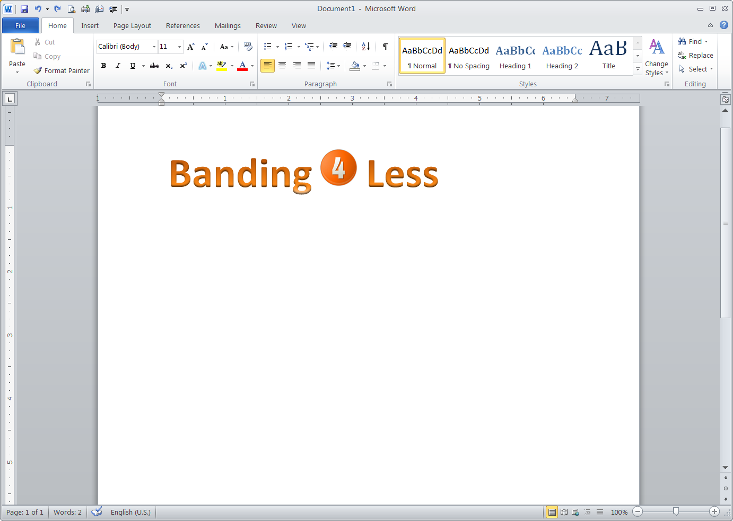

Credit Application for a Business Account
Business Contact Information
Company name:
Phone: | Fax: | E-mail:
Billing company address:
City: |  | State: | ZIP Code:
Date business commenced:
Sole proprietorship: | Partnership: | Corporation: | Other:
Business and Credit Information
Delivery business address:
City: |  | State: | ZIP Code:
How long at current address?
Telephone: | Fax: | E-mail:
Bank name:
Bank address: |  | Phone:
City: |  | State: | ZIP Code:
Type of account: | Account number:
Savings
Checking
Other
Business/trade references
Company name:
Address:
City: |  | State: | ZIP Code:
Phone: | Fax: | E-mail:
Type of account:
Company name:
Address:
City: |  | State: | ZIP Code:
Phone: | Fax: | E-mail:
Type of account:
Company name:
Address:
City: |  | State: | ZIP Code:
Phone: | Fax: | E-mail:
Type of account:
Agreement
- All invoices are to be paid 30 days from the date of the invoice upon approval of credit.
- Claims arising from invoices must be made within seven working days.
- By submitting this application, you authorize Banding4Less to make inquiries into the banking and business/trade references that you have supplied.
- Attach Reseller’s exemption form if needed
Signatures
Print Name:_____________________Title:___________________ |  | Signature:__________________________ Date:_________

