SNAAz 2018 Annual Conference

Saturday, February 24th, 2018

Set-up begins at 7:00am

Registration opens at 8:00am

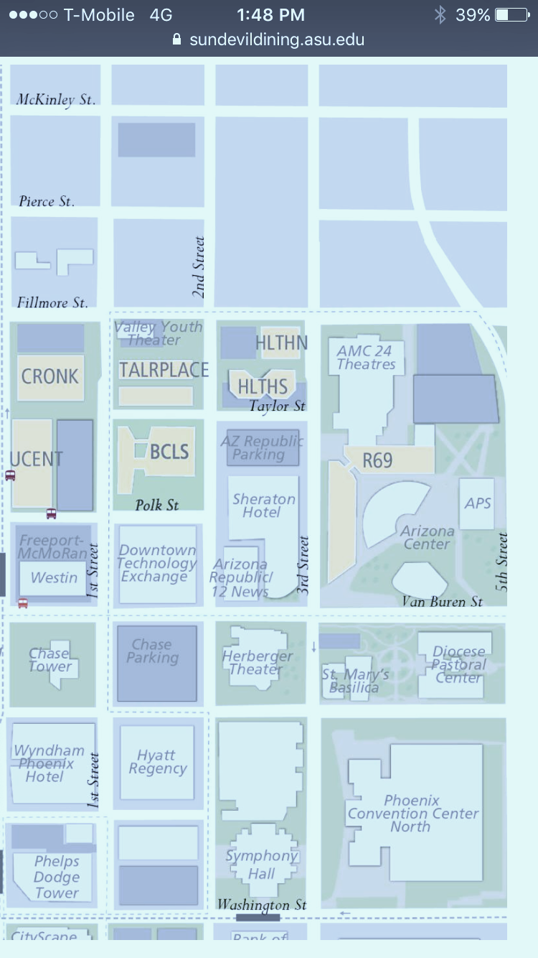

**Turn south on 7th Street from Interstate 10 Exit 145A**

***SNAAz Conference***

***Free Underground Parking***

*Vendor & Exhibitor unloading only. Park underground where shown.*

**Driving Directions to Conference**:

From Interstate 10, take exit 145A and turn south onto 7th St.

Proceed south for approximately 7 blocks to Fillmore. Turn right on Fillmore St. and proceed to 3rd St.

At corner of Fillmore and 3rd St. turn left and proceed 1 block south to Taylor St.

Turn right at Taylor. Entrance to ASU underground parking is 500 yards ahead on the right.