WELCOME TO THE SPRING YAK CLASSIC
APRIL 6-7, 2024

PITA Daily Fee of $4.00 will be charged on your 1st event of each day.

Saturday, April 6, 2024 Shooting starts at 9:00 a.m.

Event #1 Roger Hanna Memorial 100 16 yard Targets

4 classes (A-B-C-D) $60 class winner, $30 Sub Jr, Jr, Lady, Vet, S. Vet.
Entrance…………………………………………………………………………….$40.00
WSPITA Fee ……………………………….……………………….….…………..$ 3.00
OPTIONS: Class Purse (Each class shooting for its own money. 1 pay each 7)…..….....$10.00
Lewis Class (3 classes) 60/40………………………………….……….……$12.00

Event #2 100 Handicap Targets

3 yardage groups 19-21.5, 22-24.5, 25-27 $180/110/70 each yardage group
Entrance………….……………………………………………………………….$40.00
WSPITA Fee ……………………......……………………..…………..…….……$ 3.00
OPTIONS: WSPITA MAGNUM ……………………...…..……………..……………..$14.00
Yardage Purse (19-21.5, 22-24.5, 25-27) 1 pay each 7 …………….….….. $10.00
25 Options ($2.50 on each 25, Divided 60/40)……………………….…… $10.00
50 Options ($3.00 on each 50, Divided 50-30-20)…………...………….... .$ 9.00
Lewis Class (3 classes) 60/40…………………………………………..…...$12.00

Event #3 50 Pair Doubles

4 Classes (A-B-C-D) $60 each class winner
Entrance……………………………………………………………….……….….$40.00
WSPITA FEES…………….………………………………………….…….…….$ 3.00
OPTIONS: Class Purse (Each class shooting for its own money. 1 pay each 7)…….….$10.00
Lewis Class (3 classes) 60/40…………………………………………..…..$12.00

We would like to thank Tom Rogers and the
Roger Hanna Memorial for their donations.
A big thanks to all the volunteers and all the shooters.

Yakima Valley Sportsmen’s Ass.
P.O. Box 1542
Yakima, WA 98907

Big WSPITA Magnum both Days
$3,300.00 Guaranteed Money Home of the Big Yak Blanket Shoot
WWW.YVSA.net

Pre squad at Presquad.com Spring Yak

The Burnout Pit will serve breakfast and lunch

This is an invitational tournament, and the management reserves the authority to reject, refund, or
disqualify any contestant who, in its judgment, interferes with the conduct, accuracy, or sportsmanship of the shoot. Likewise, the management may exercise the right to change or modify
this program in whole or in part.

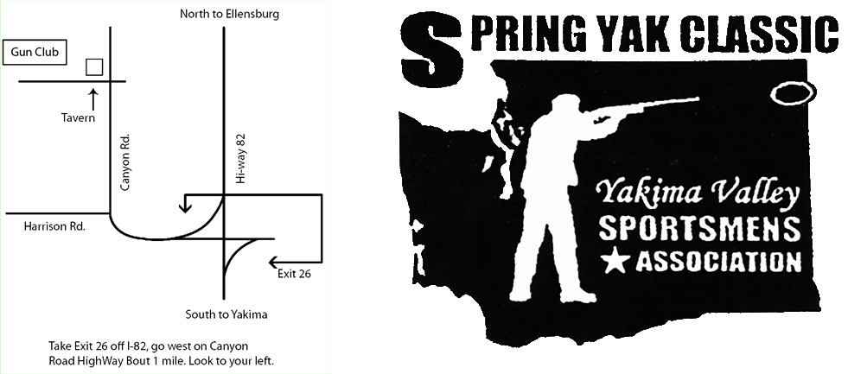
2024

