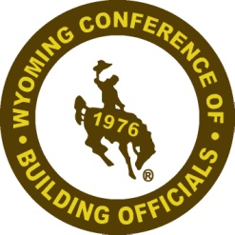
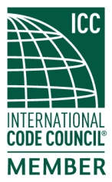
Wyoming Conference of Building Officials

2019 Spring Meeting
May 1st – 3rd, 2019
Ramkota Hotel and Conference Center
Casper, WY

President: Ken Rogers
City of Gillette (307) 686-5260
ken@gillettewy.gov

Vice President: Jason Gutierrez, PE
Natrona County (307) 235-9435
Jgutierrez@natronacounty-wy.gov

Secretary: Tom Scranton
Wilson & Associates (307) 632-1776
tscranton@hotmail.com

Treasurer: Billy Nunn
Teton County (307) 733-3959 x8415
bnunn@tetonwyo.org

Director: Matt Allred
Town of Guernsey (307) 836-2335
matt@togwy.us

Director: Kevin Bare
City of Sheridan (307) 674-5941
kbare@sheridanwy.net

Director: Byron Mathews
City of Cheyenne (307) 637-6311
bmathews@cheyennecity.org

Past President: Keith Bowar
Campbell County (307) 682-1970
krb08@ccgov.net

Schedule of Events

Wednesday, May 1st

1:00 p.m. – 5:00 p.m.: “IRC Administrative Provisions”, Pat Vandergriff

Thursday, May 2nd

8:00 a.m. – Noon: “IRC Chapter 3, Design Provisions”, Pat Vandergriff
Noon – 1:00 p.m.: Lunch provided by WCBO in Hotel restaruant
1:00 p.m. – 5:00 p.m.: “IRC Chapter 3, Design Provisions” (cont.), Pat Vandergriff

Friday, May 3rd

8:00 – Noon: Business Meetings – WCBO, WAFM, WYAPT

PLEASE VISIT WITH OUR PARTNERS & SPONSORS
DURING BREAKS AND LUNCH HOUR.

