+ FIRST CONGREGATIONAL CHURCH
An Open and affirming congregation of the
United Church of Christ, Saugus, Massachusetts
Service of Worship 10:00 a.m.
10th Sunday after Pentecost, July 29, 2018
*Indicates for those who are able to, please stand.
Bold print indicates congregational response.
NCH = New Century Hymnal (black cover)
HOP = Spiral bound cover

Greeter & Usher is Betty Neth.
Scripture Reader is Betty Neth.
Coffee Hour Hosts are Richard Warbin & Steve Rich.
Deacon of the Month is Mike Mascovitz.

PRELUDE Rebecca Harrold
WELCOME & ANNOUNCEMENTS Rev. Martha Leahy
LIGHTING THE PEACE CANDLE “Surely the Presence” HOP 74
Surely the presence of the Lord is in this place;
I can feel his mighty power and his grace.
I can hear the brush of angel’s wings,
I see glory on each face;
surely the presence of the Lord is in this place.

CALL TO WORSHIP, (“God, we’re here!”):
L: We gather to worship God and to give God thanks for all good gifts.
P: Give us this day our daily bread.
L: We come hungry for the Word that always satisfies.
P: Give us this day our daily bread.
L: We want to fill our souls with the Light of Christ.
P: Give us this day our daily bread.
L: As we are fed, we will in turn, feed others.
All: Give us this day, and all days, the Bread of Life.

*OPENING HYMN: “Now Thank We All Our God” HOP 28

*PRAYER OF CONFESSION, UCC Worship Ways (“God, we’re sorry): Great Provider, we recognize today that widespread hunger is no longer acceptable. You have given us the means to feed all people, yet we are sometimes selfish. While we overfill our bellies with food, others are crying out for crumbs from our tables. Forgive us. Cultivate within our hearts abundant generosity, and plant within us a spirit of simplicity and balance in body and soul. Amen.

CHORAL RESPONSE: “Thy Word” HOP 92

Thy word is a lamp unto my feet and a light unto my path. (2x)

*ASSURANCE OF PARDON, UCC Worship Ways (“God forgives us”), in unison: Generous God, we are so grateful for your forgiveness and love. Though at times we fail to be generous, your generosity toward us is never-ending! By sending Christ and the Holy Spirit to your people, you have extended generosity beyond measure. For this, we are truly grateful. Amen.

*GLORY TO GOD “Holy, Holy, Holy” NCH #277
Holy, holy, holy, God the Almighty! Early in the morning we praise your majesty./ Holy, holy, holy! Merciful and mighty/ God in three persons/ blessed Trinity!

SCRIPTURE: John 6:1-15 (SP754, LP1655)
SP=Small print Bible; LP=Large Print Bible

MESSAGE: “Feeding Thousands” Rev. Martha Leahy

PRAYER INTRO: “Sanctuary” HOP 135

Lord, prepare me to be a sanctuary/pure and holy,

tried and true./With thanksgiving, I’ll be a living

sanctuary for you.

PASTORAL PRAYER & LORD’S PRAYER
Our Father, who art in heaven, hallowed be thy name.
Thy kingdom come, thy will be done, on earth as it is in heaven. Give us this day our daily bread; and forgive us our trespasses, as we forgive those who trespass against us; and lead us not into temptation, but deliver us from evil. For thine is the kingdom, the power and the glory forever. Amen.

PRAYER RESPONSE: “Take My Life & Let it Be” HOP 129 Take my life and let it be/Consecrated Lord, to thee./ Take my hands and let them move at the impulse of thy love/ At the impulse of thy love.

OFFERTORY INVITATION, (“God, we give back”), in unison: Jesus asked, “Where shall we buy bread for all these hungry people?” Today his words call us to provide enough food for the bodies and souls of everyone who is in need. We gather our gifts in response to this great demand. Amen.

OFFERTORY
*DOXOLOGY: NCH #778 lyrics; NCH 780 tune
Praise God from whom all blessings flow;
Praise God all creatures here below;
Praise God for all that love has done.
Creator, Christ and Spirit, One. Amen.

*PRAYER OF DEDICATION FOR OUR GIFTS & PLEDGES, UCC Worship Ways (“God bless our gifts”), in unison: Holy God, we humbly bring our gifts at your altar today. Please bless them and use them to fill empty stomachs and empty hearts. May our offerings be multiplied to abundantly nourish all people. Amen.

*CLOSING HYMN: “For Everyone Born” HOP 80, v1-2-3

*COMMISSION AND BLESSING (“God, we will try”), in unison: God of Plenty, as we have been fed this day, inspire us to go and offer food and comfort to all who are seeking you. Help us sustain this household of faith as a beacon of hope and healing. Amen.

BENEDICTION (“God, please bless us”), in unison:
L: We end our worship service, having given God thanks for all good gifts.
P: God gave us this day our daily bread.
L: We came hungry for the Word that always satisfies.
P:God gave us this day our daily bread.
L: We wanted to fill our souls with the Light of Christ.
P: God gave us this day our daily bread.
L: As we have been fed, we will, in turn, feed others.
All: God gives us this day, and all days, the Bread of Life.

*CHORAL BENEDICTION:
“Sent Forth by God’s Blessing” NCH76

POSTLUDE Rebecca Harrold

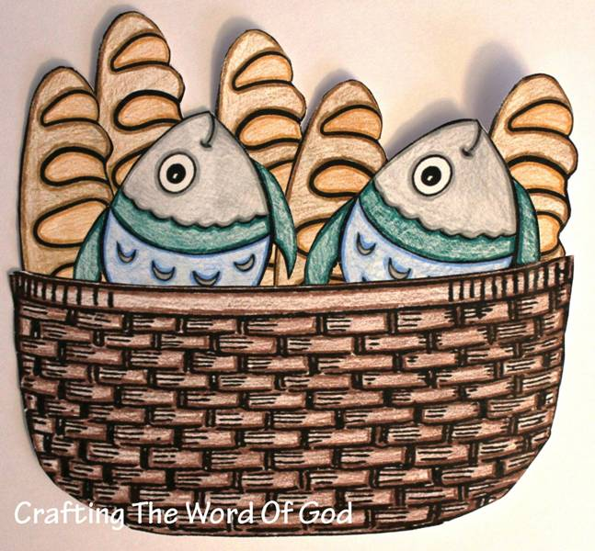
CraftingthewordofGod.com

“Feeding Thousands”
10th Sunday after Pentecost
July 29, 2018
First Congregational Church, United Church of Christ
300 Central Street, Saugus, MA 01906
Rev. Martha Leahy, Pastor
Office 781-233-3028 Cell phone 617-763-7354
Carolyn Davis, Secretary
Rebecca Harrold, Music Director
E-mail address: uccsaugus@verizon.net
Website: http://1stchurchsaugus.org
Facebook: https:www.facebook.com/uccsaugus
Healing Circle: https://facebook.com/healingcirclesaugus

Chill out in the heat of summer with

Friday, July 27
6:30-8PM

Community Hall
First Congregational Church UCC
300 Central Street, Saugus Center
6:30-8:00 p.m.

Get your Christmas on!

*Enjoy Decorated Trees, Lights, Carolers, Christmas cookies, Fudgicles (a cool alternative to hot chocolate) & More
*Enter to Win Raffle Prizes
*Play ‘Pin the Heart on the Grinch’
*Compete in the ‘Best Christmas T-Shirt’ Contest
*Visit Santa
*Best of All, Give a Gift:
Bring your donations of backpacks & school supplies for Saugus students for the start of school in the Fall.

Raffle proceeds will go toward our Christmas Eve musical offerings.
Find us on Facebook www.facebook.com/uccsaugus,
on the Web http://1stchurchsaugus.org,
by Email uccsaugus@verizon.net or by Phone 781-233-3028

Jesus Feeds the Five Thousand
John 6:1-21

6 Some time after this, Jesus crossed to the far shore of the Sea of Galilee (that is, the Sea of Tiberias), ² and a great crowd of people followed him because they saw the signs he had performed by healing the sick. ³ Then Jesus went up on a mountainside and sat down with his disciples. ⁴ The Jewish Passover Festival was near.
⁵ When Jesus looked up and saw a great crowd coming toward him, he said to Philip, “Where shall we buy bread for these people to eat?” ⁶ He asked this only to test him, for he already had in mind what he was going to do.
⁷ Philip answered him, “It would take more than half a year’s wages to buy enough bread for each one to have a bite!”
⁸ Another of his disciples, Andrew, Simon Peter’s brother, spoke up, ⁹ “Here is a boy with five small barley loaves and two small fish, but how far will they go among so many?”
¹⁰ Jesus said, “Have the people sit down.” There was plenty of grass in that place, and they sat down (about five thousand men were there). ¹¹ Jesus then took the loaves, gave thanks, and distributed to those who were seated as much as they wanted. He did the same with the fish.
¹² When they had all had enough to eat, he said to his disciples, “Gather the pieces that are left over. Let nothing be wasted.” ¹³ So they gathered them and filled twelve baskets with the pieces of the five barley loaves left over by those who had eaten.
¹⁴ After the people saw the sign Jesus performed, they began to say, “Surely this is the Prophet who is to come into the world.” ¹⁵ Jesus, knowing that they intended to come and make him king by force, withdrew again to a mountain by himself.
Stop by on Founders Day for

Saturday, September 8
10:00 am - 1:00 pm

On the Lawn at
First Congregational Church UCC
300 Central Street, Saugus Center

Bring your dog, cat, bird, iguana, fish, or any pet at all for a blessing.

Visit the Animal Craze Petting Zoo from noon to 1:00 p.m.

Learn about the Heifer Project & how your donations can help buy animals needed by struggling families all over the world: goats, sheep, chickens, bees, even water buffalo!

Take home a free Heifer calendar which shows ways we can “Fill the Ark” with donations big & small.

Find us on Facebook www.facebook.com/uccsaugus, on the Web http://1stchurchsaugus.org,
by Email uccsaugus@verizon.net or by Phone 781-233-3028

Kindness Rocks
An Art-Making Project for Kids
At First Congregational Church UCC
300 Central Street, Saugus Center

Wed, Aug. 1, 10-11:30 AM
Thurs., Aug. 2, 1-2:30PM

Will you help spread some kindness in the world?
It’s easy with Kindness Rocks!

What is a Kindness Rock?
It is a beach rock painted with a positive saying like
“Make a Wish,” “You Are Beautiful,” “Peace,”
or whatever saying you can think of.

We invite kids to join us for two days of creating Kindness Rocks which we hope will spread around town and make someone’s day brighter.

Who doesn’t need a kind word now and again?

Two sessions:
Wednesday, August 1, 10-11:30 a.m. for grades 1-5*
Thursday, August 2, 1-2:30 p.m. for grades 6-12

*A parent, guardian, or caregiver is required to stay for the Wednesday session with their child.
Older students may earn community service hours by volunteering to help the younger ones.
Sessions are free of charge and all art supplies are provided.

RSVP on Facebook www.facebook.com/uccsaugus, on the Web http://1stchurchsaugus.org,
by Email uccsaugus@verizon.net or by Phone 781-233-3028

