- Go to McGraw Hill’s My Bookshelf (https://myebooks.mheducation.com/) and sign in. If you don’t have an account, you will have to create one.
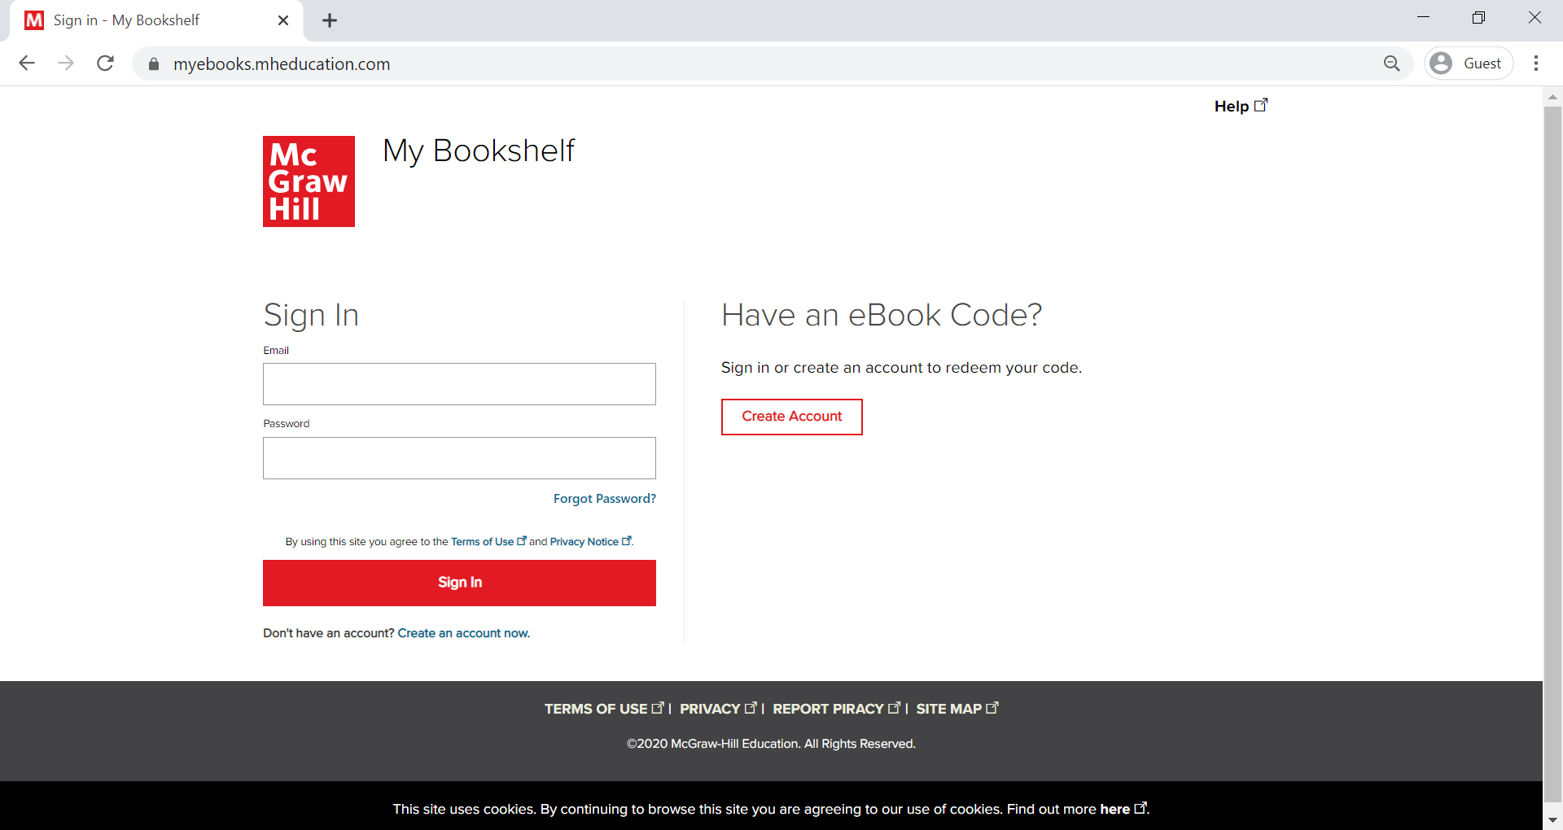

- Click “Redeem Code”
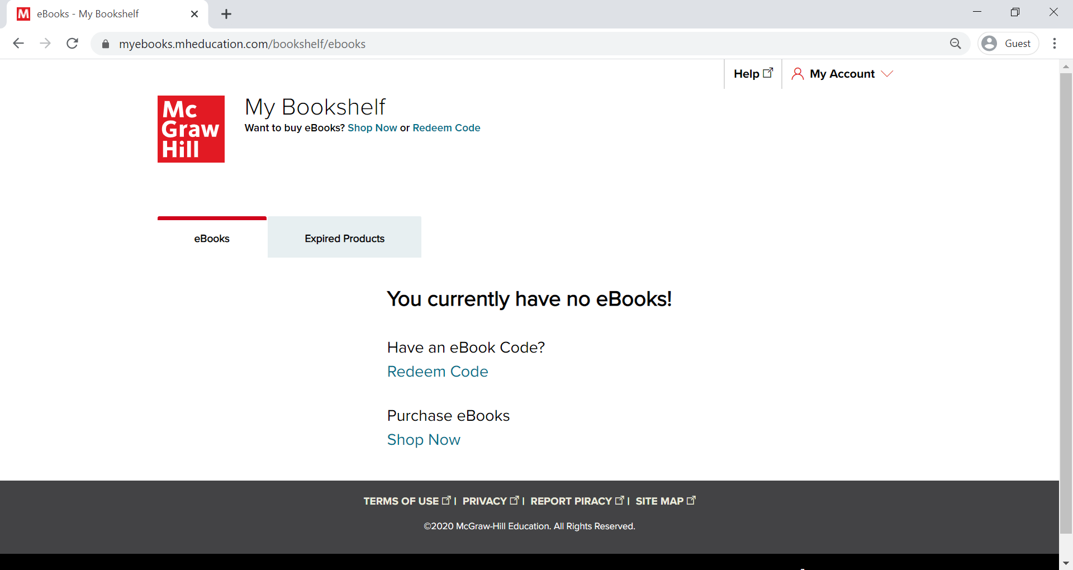

- Enter the access code (BX0U-QP4F-BG1B-XY0I-T90S) and click “Next”
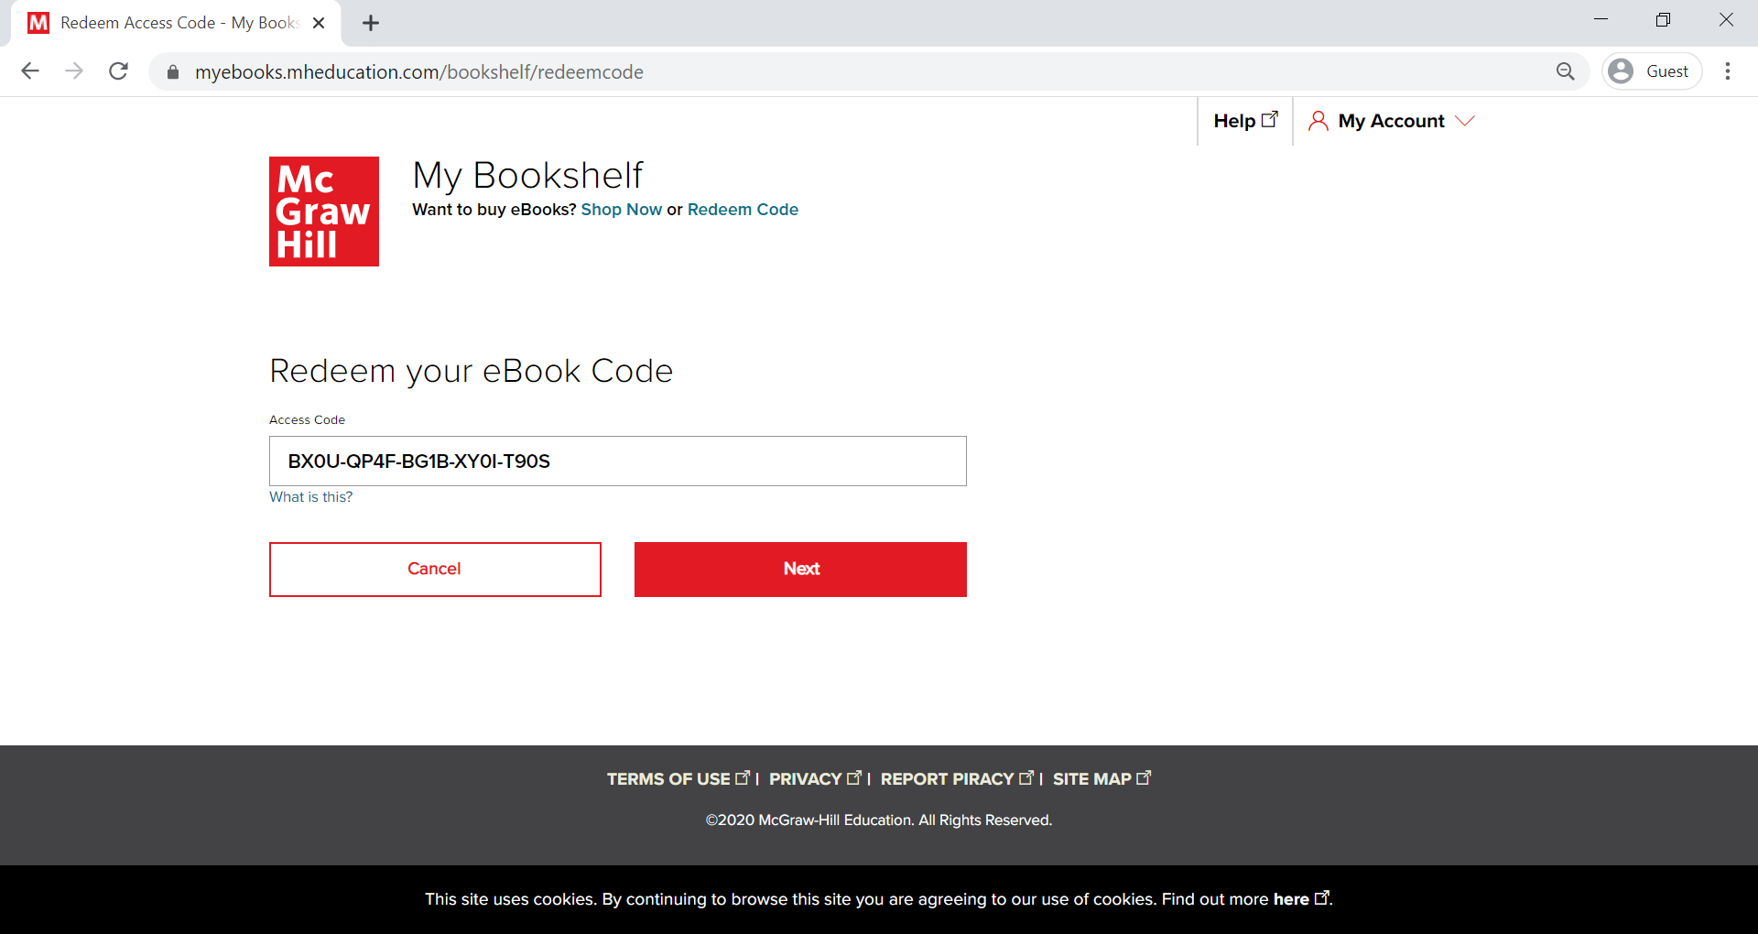

- Click “Confirm and Submit”
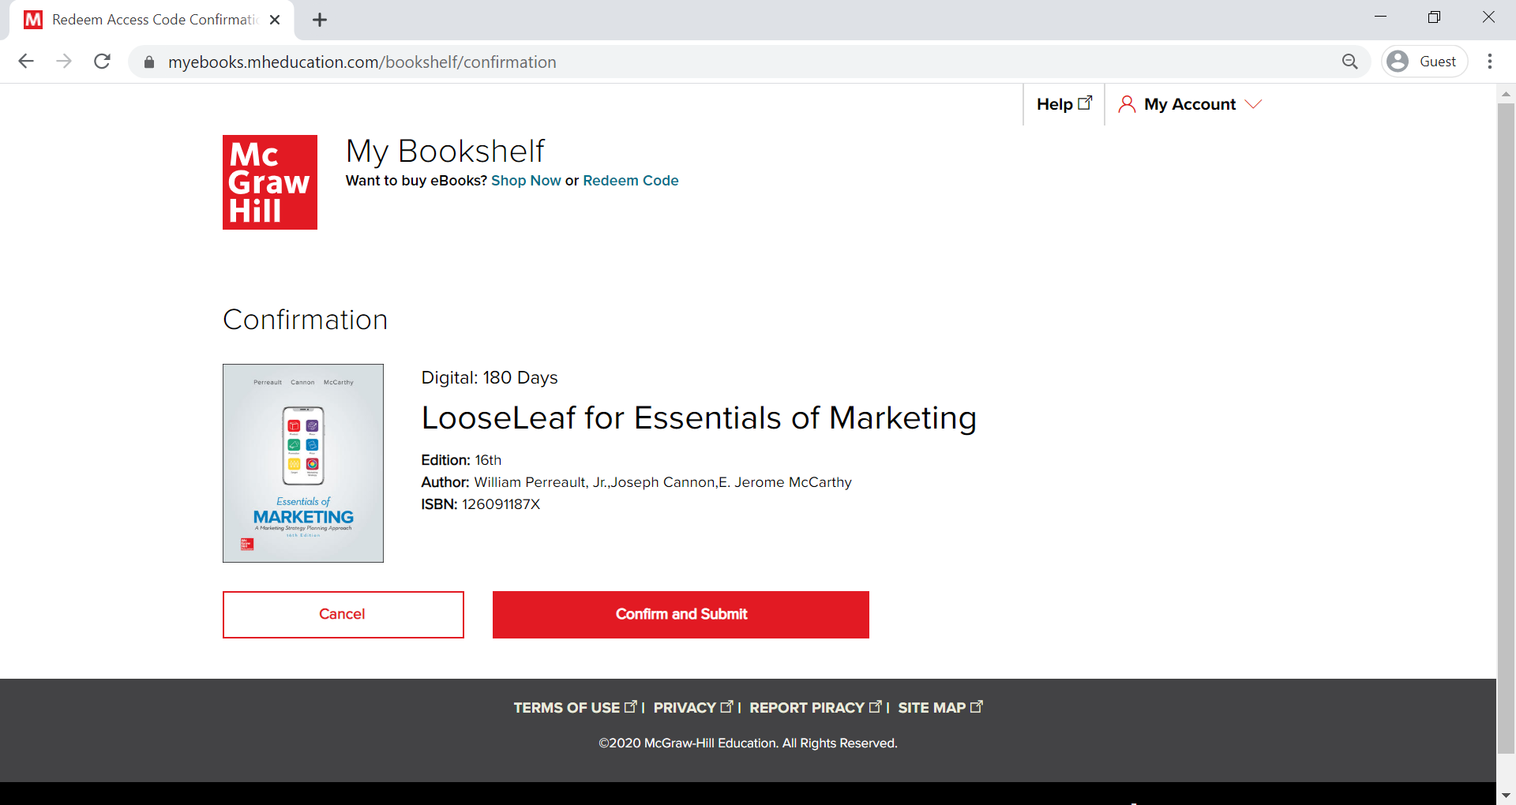

- Click “Access eBook” to access the ebook. You will have access for 180 days.
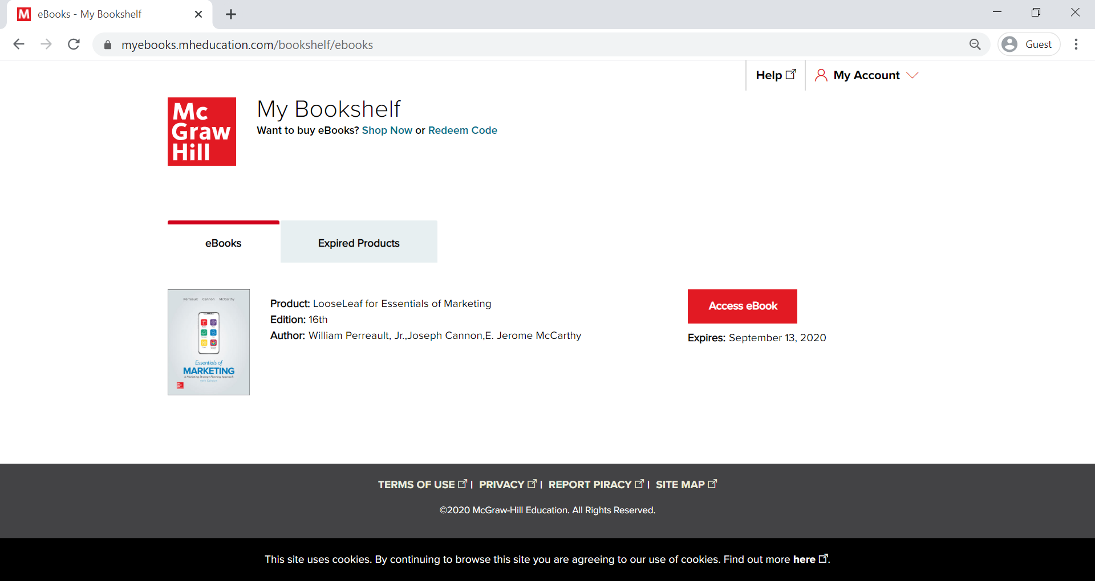
The ebook can also be accessed through McGraw Hill’s ReadAnywhere app (https://www.mheducation.com/highered/explore/readanywhere.html), available on both iOS and Android devices.

