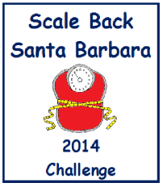
How to be a Scale Back “Weigher”
(Anyone who is willing to help can be a “Weigher”.)
Start  1. 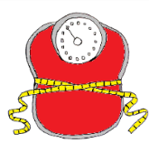  Weigh-in participants.  2.  Record the date, name of each participant and their weigh-in weight on an Unofficial Registration Form and keep it for your private records.  3.  Then, E-mail just the name of your team and the total number of participants you weighed-in  to  ScaleBackSB@gmail.com. | Finish  1.  Weigh-out participants.  2.  Record the date, name of each participant and their weigh-out weight on an Unofficial Registration Form and keep it for your private records.  3.  Then, E-mail just the name of your team and the total number of pounds your participants lost  to  ScaleBackSB@gmail.com.

Unofficial
Participant Weigh-In/Weight-Out Registration Form
(Keep this form for your PRIVATE records.)
Weigh-in challengers between January 20 – February 2, 2014 or anytime during the challenge. Weigh-out challengers between March 31 – April 13, 2014.
(Name of your team _______________________________________________)
 | Date In | Date Out | Name | Starting  Weight | Ending  Weight | Weight Lost
1
2
3
4
5
6
7
8
9
10
 | Date In | Date Out | Name | Starting  Weight | Ending  Weight | Weight Lost
11
12
13
14
15
16
17
18
19
20
21
22
23
24
25
26
27
28
29
30

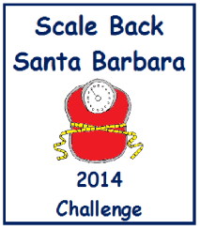
How to Register
Official Registration Information
Send the following information to
ScaleBackSB@gmail.com
Register: E-Mail the following information to ScaleBackSB@gmail.com anytime during the challenge.
1. Name of your team Example: Buff Bodies 2. Number of participants Example: 3 Participants
Finish: E-Mail the following information to ScaleBackSB@gmail.com at the end of the 10 week challenge between March 30 and April 13, 2014.
1. Name of your team Example: Buff Bodies
2. Total Number of pounds lost Example: 18 Pounds
Name of Weigher (Optional) _______________________________________________________
E-Mail (Optional) ________________________________________________________________

