HIP HOP FRIDAY NIGHT

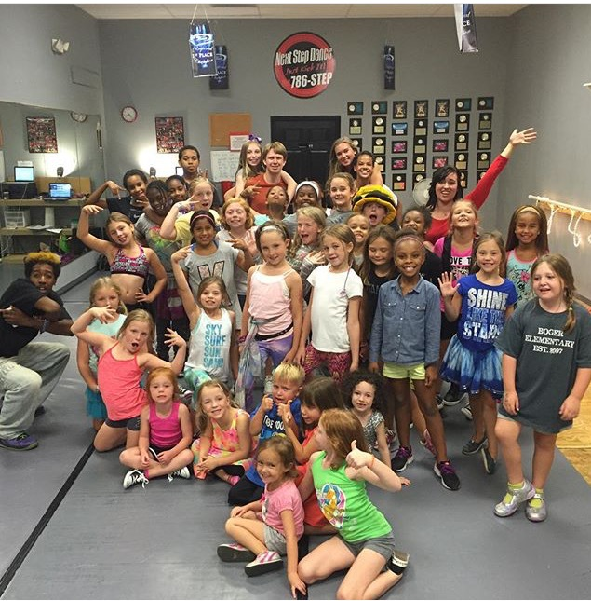

Our HHFN schedule is out! $10.00 per person and you don’t have to dance here to join us. 6:30-8:30pm with food, fun, & prizes! Check out our new months.

**Friday, September 15, 2017**

**Friday, October 20, 2017**

**Friday, January 5, 2018**

**Friday, February 9, 2018**

**SUMMER CLASSES**

**PRIVATES**

**OPEN CLASSES**

**We have it all!**

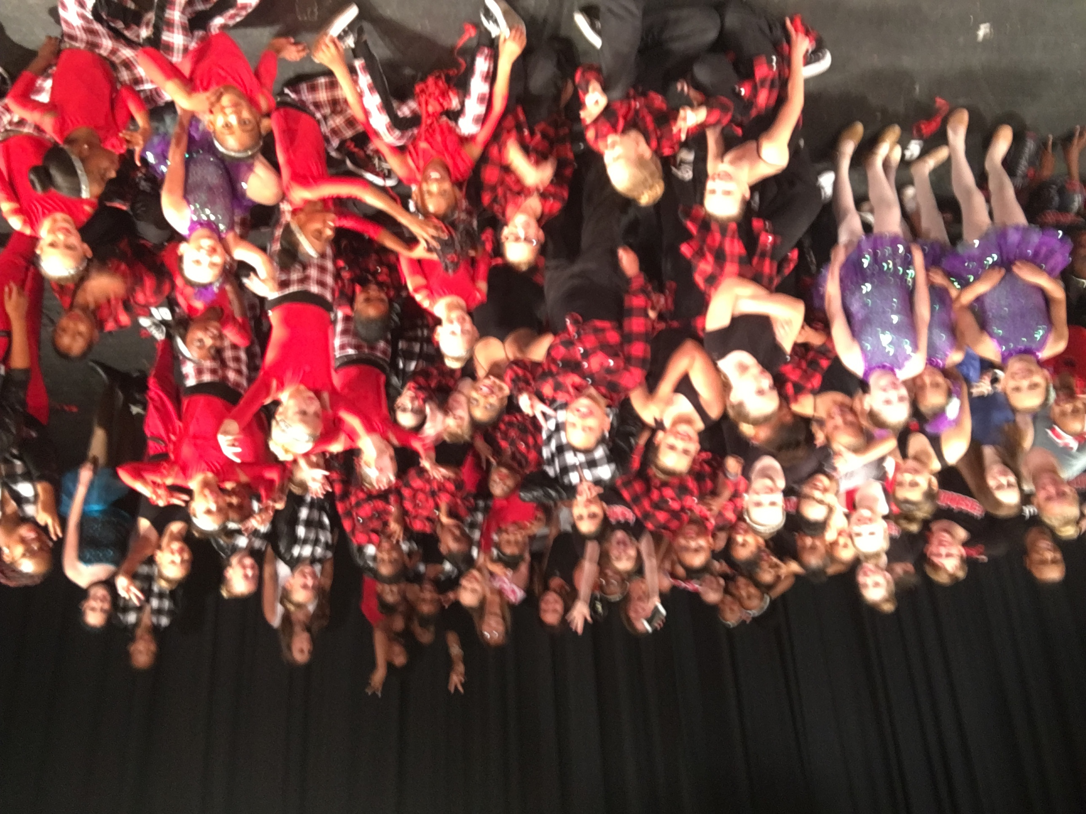

Do you know someone that has a child you feel would benefit from dance? We are aware that it is important to keep children busy these days with everything going on in our world. Follow this link to find out more.

http://www.coreyanthony.org/dance-scholarship-interest-form.html



C:\Users\Stephanie\Pictures\Microsoft Clip Organizer\j0416014.wmfC:\Users\Stephanie\Pictures\Microsoft Clip Organizer\j0416014.wmfC:\Users\Stephanie\Pictures\Microsoft Clip Organizer\j0416014.wmf

**#motivation** C:\Users\Stephanie\Pictures\Microsoft Clip Organizer\j0416014.wmf

Find a place you **TRUST** and then try **TRUSTING** it for a while.

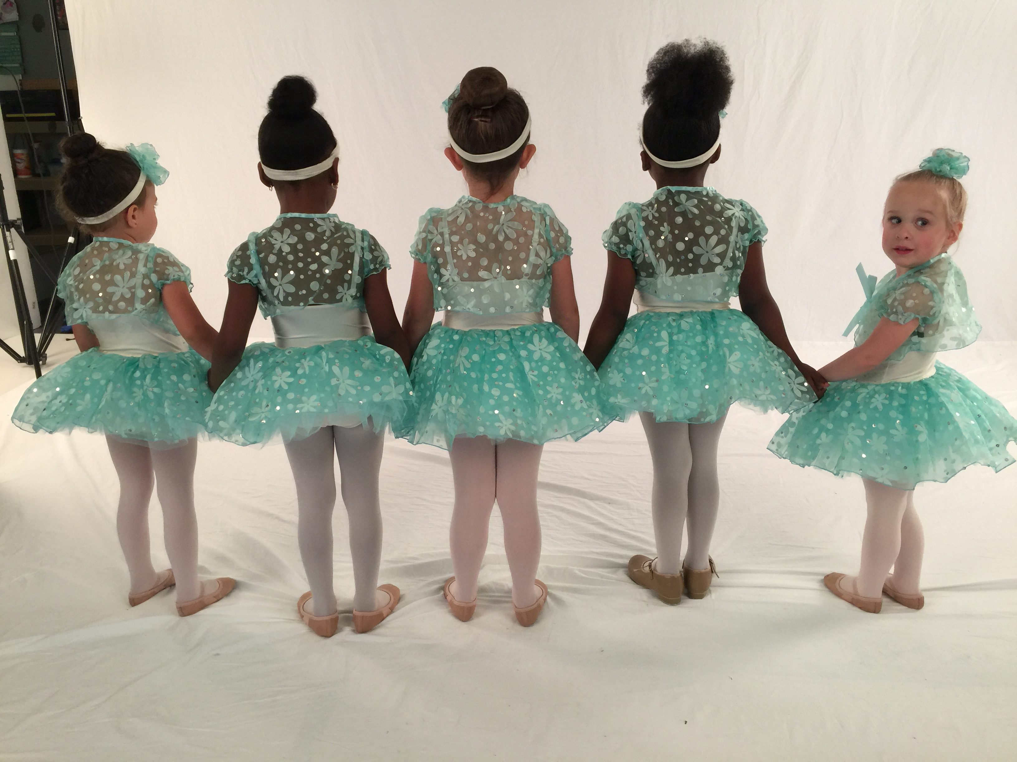

**#weretrending**

**Fall classes begin on Monday, August 21, 2017 at Next Step Dance. The 2017 season continues with added classes and new mirrors! Check out our online registration for easy access enrollment and payment. Or stop by at our early Open House on August 12th from 10:00am-12:00pm. Or you can check us out on Thursday, August 17th from 4:00-7:00pm. Our teachers will be there to assist in choosing classes and introducing you to our studio! #joinourdancefamily**

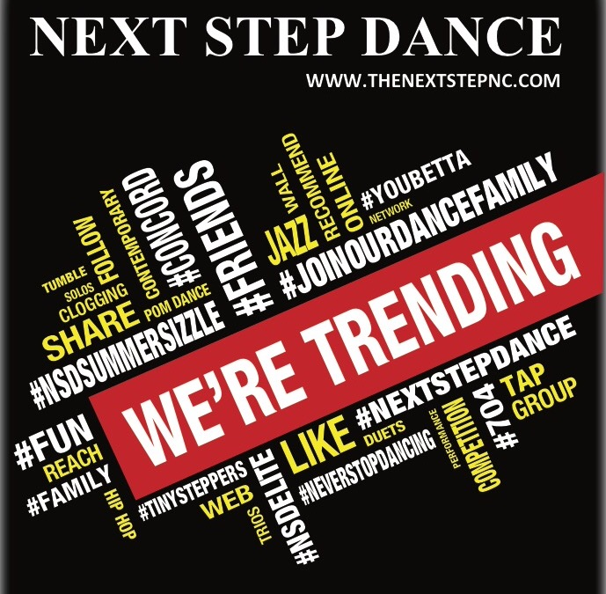

C:\Users\Stephanie\Pictures\Microsoft Clip Organizer\j0416014.wmf C:\Users\Stephanie\Pictures\Microsoft Clip Organizer\j0416014.wmf

Steppin’ into Summer 2017 with Next Step Dance

[**www.thenextstepnc.com**](http://www.thenextstepnc.com)

**7712 Sossamon Lane, NW Concord, NC 28027 (704) 786-7837 nsdcalendar@gmail.com**

**OPEN HOUSE THIS MONTH!**

We love to say, “It is time to think about fall 2017! Join us Saturday, August 12, 2017 to celebrate our next dance season! From 10:00am-12:00pm we will open the studio for free dance classes, tours of the facility, informational sessions with our teachers, prizes, and of course registration. Bring your friends with you to check us out and see what our dance family is all about at Next Step Dance.

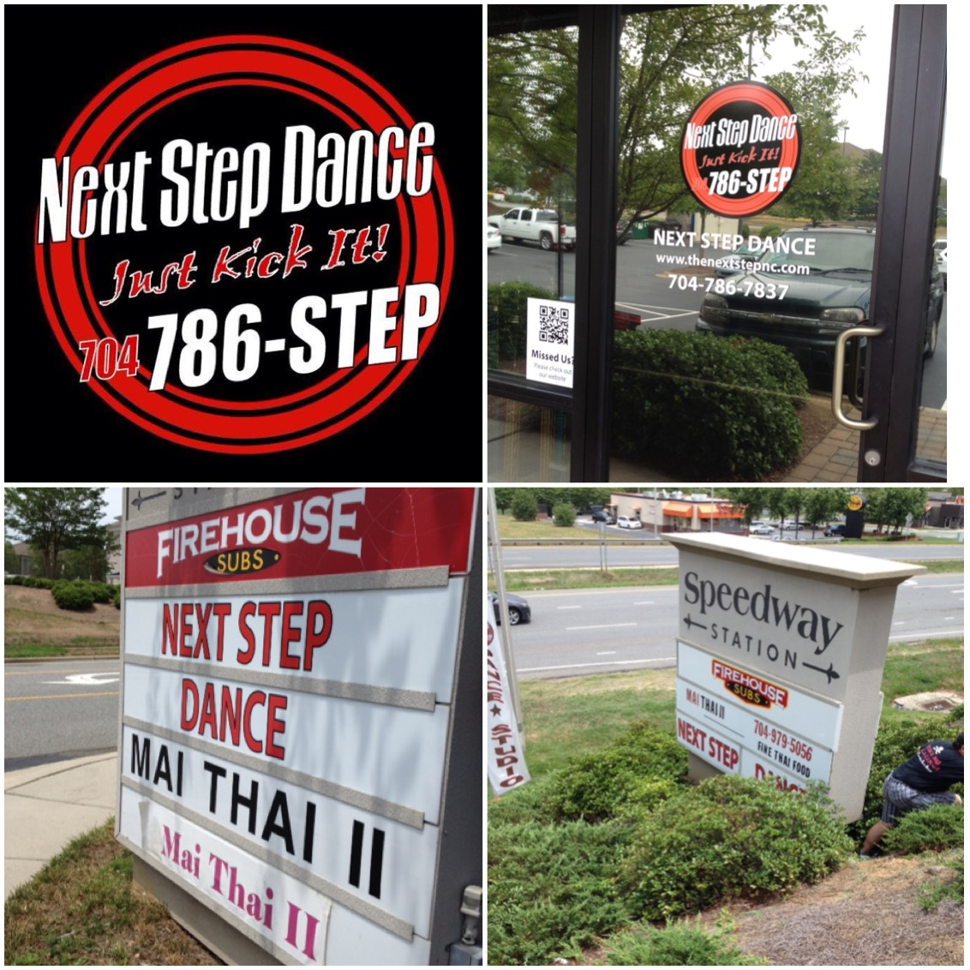

**SAVE THE DATE** C:\Users\Stephanie\Pictures\Microsoft Clip Organizer\j0416014.wmf

July 5th- Summer classes begin

August 9th-Competition placements begin

August 12th- Open House 10:00am-12:00pm

August 17th- Open House 4:00-7:00pm

August 21st-Fall classes begin at the studio

August 30th – Cabarrus Charter Classes begin

September 5th- Kings Keep Classes begin

September 5th-HPCCDC Classes begin

September7th- Kids R Kids Classes begin

Shoe orders take approximately 1-week for delivery and some we have in stock!

REMEMBER TO JOIN US ON

Facebook, Twitter, & Instagram!