**JSB Capital Management, LLC**

**Pro-active Wealth Management**

March 16, 2022

**What To Expect for the Rest of This Year**

Today the Federal Open Market Committee (FOMC) voted to raise their short-term administered interest rate (known as the Fed Funds Rate) by 0.25% as expected. That means the overnight, short-term borrowing rate for large banks is between 0.25% and 0.5%. This represents the first interest rate hike by the FOMC since 2018 and it comes on the heels of consistent, month-over-month increases in every measure of inflation.

In addition to the rate hike, the Fed statement also signaled that the Fed could soon announce and implement a plan to shrink its **$9 trillion** asset portfolio. When The Fed increases its balance sheet (buys bonds on the open market), more money flows into the economy thereby stimulating it.

The central bank ended its long-running asset-purchase stimulus program last week. Most observers of The Fed expect the Fed-Funds rate to rise to at least 1.875% by the end of this year, according to the median of 16 Fed officials, then to around 2.75% by the end of 2023 and to hold rates there in 2024. That implies a total of seven quarter-percentage-point increases this year and another three or four next year. Chairman Powell confirmed these estimates during his press conference following the announcement.

Fed officials face three important questions as they consider their next moves.

* First, how quickly do they need to raise rates to an estimated “neutral” level that neither speeds nor slows growth?
* Second, has that neutral level increased as rising inflation sends real, or inflation-adjusted, borrowing costs lower?
* And third, when might the Fed need to raise rates above neutral to deliberately and forcefully slow growth?

Federal Reserve Chair Jerome Powell

**What is Inflation and How is It Measured?**

The graph below shows a primary inflation indicator (the Consumer Price Index or CPI) over the last 40-plus years since the last highly inflationary period which ended in the early 1980’s. The shaded (grey) areas indicate recessionary periods. Notice the historical relationship between above average, elevated levels of the inflation measure and the occurrence of recessions immediately following it.

With the [quantitative easing policy](https://fred.stlouisfed.org/graph/?g=Kac5) (QE) maintained throughout the covid-19-induced recession finally ending, the [federal funds rate is expected to rise](https://www.federalreserve.gov/newsevents/pressreleases/monetary20211215b.htm) consecutively to at least 1.9 percent this year, 2.8 percent in 2023, 2.1 percent in 2024, and 2.5 percent in the “long run”.

Mortgage-backed security and bond purchases have been reduced by [$10 billion and $20 billion a month](https://www.federalreserve.gov/newsevents/pressreleases/monetary20211215a.htm), respectively, and the goal to expedite the conclusion of the program by March 2022 has been achieved. While this course of action is likely to somewhat mitigate the problematic inflation push, it may lead to a myriad of detrimental effects to other facets of the economy. More on that subject later in this analysis.

With today’s modest 0.25% interest rate hike, The Fed is certainly signaling their awareness that something needs to be done urgently about run-away inflation before the economy potentially enters into the dreaded “Stagflation” period that characterized the late 1970’s and early 80’s. However, The Fed is currently way behind the “inflation expectation” curve as illustrated by the graph below:

Notice the significant gap between the current rate of inflation (CPI as measured by the red line) and today’s minor rate hike (the Fed Funds blue line). Clearly much more needs to be done to lower inflationary pressures and numerous rate hikes will certainly be required. Currently it appears that The Fed is way behind in raising rates and they may have to aggressively raise rates at their next meeting in May, and beyond.

The question becomes: will The Fed raise rates so quickly and to such an extent that the economy enters a recession? At this point it looks like a 50/50 proposition.

**Why is The Fed Raising Interest Rates Important to Investors?**

The Fed-Funds rate, the overnight rate on lending between banks, influences virtually all other consumer and business borrowing costs throughout the economy. This includes rates on mortgages, credit cards, saving accounts, car loans and corporate debt. Raising rates typically restrains spending, while cutting rates encourages more borrowing.

Fixed income securities (commonly called “bonds”) generally have between very short maturities (one month) to very long maturities (30 years). The very short maturities react to the actions of The Fed (specifically the Federal Reserve Open Market Committee or FOMC) when **they set short-term borrowing rates**, currently set at between 0.25% and 0.50% as of today. Longer-term maturities are largely a function of **inflation expectations** and are set by market forces of supply and demand. Below is a graphic representation of these data points on the maturity spectrum and it is known as the “**Yield Curve**.” It typically starts off on the short term (lower rates) and slopes upward to long-term (higher rates).

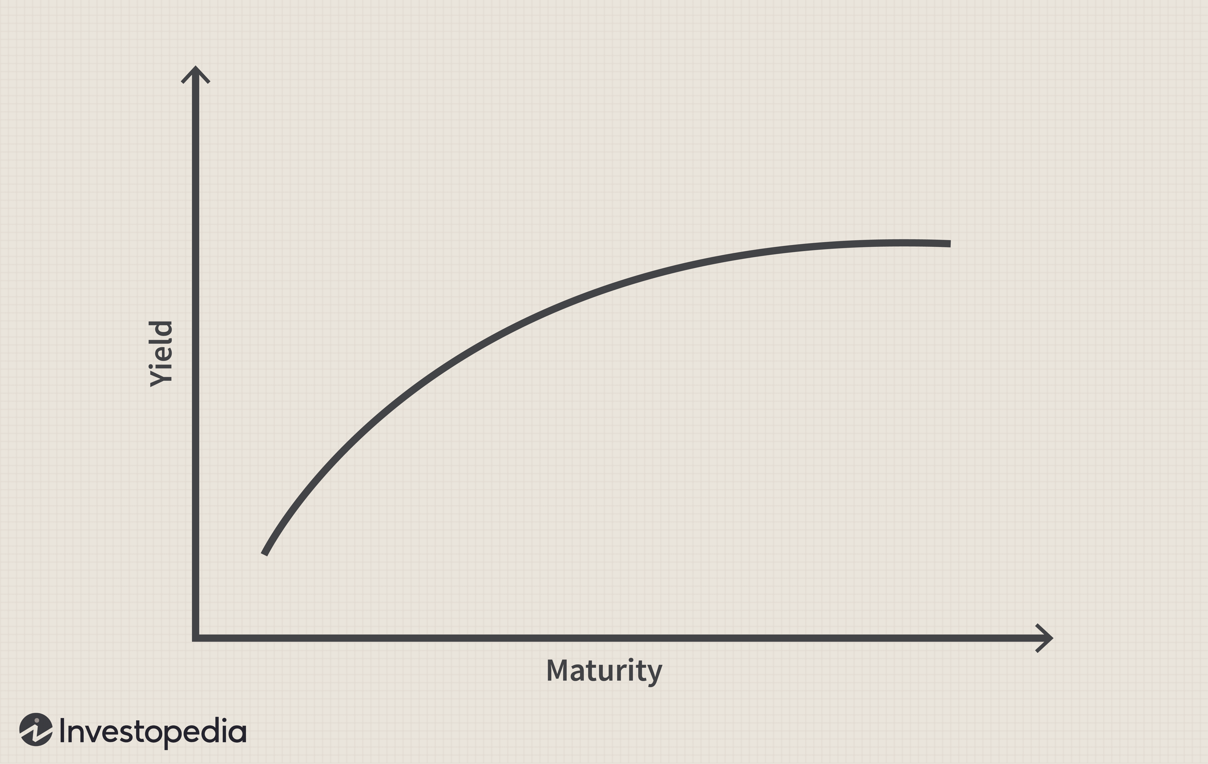

The difference between two important and distant points on the yield curve is very significant and it is carefully monitored and calculated frequently by economists. The chart below shows the calculated difference between the very short-term rate and the benchmark 10-year U.S. Treasury note over time, which is known as ‘the yield curve spread”:

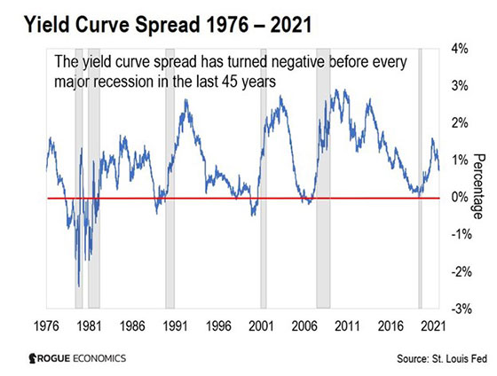

What is **significant** is the **difference** between the FOMC controlled rates (short-term) and the market influenced rates (10-year note) because it is historically very accurate in predicting economic recessions (7 out of the last 7, see above).

Right now, the difference is **less than 0.4**%. If the difference drops below zero, we’re certainly headed for an economic recession.

**What Does This Mean for The Rest of This Year (and Beyond)?**

The war between Ukraine and Russia is a significant factor here, at least psychologically. Energy (oil, coal and gas), food (wheat, corn), and metals (palladium, copper, aluminum and titanium) are all affected by the course and the outcome of the conflict.

Russia exports fertilizer to the rest of the world. Ukraine exports a significant amount of grains. It also exported 8.2 million tons of corn to China in 2021, according to the *Wall Street Journal.* That’s 30% of China’s total corn imports. Combined, Russia and Ukraine account for more than 25% of world wheat exports.

In addition, Europe gets over 33% of its natural gas from Russia and over 25% of its oil. According to most reports, the gas is still moving through pipelines. Global refiners aren’t buying Russian crude oil at the moment, but unfortunately China is happy to buy all the oil Russia can send it. The continuous contract for Brent Crude Oil jumped to a more than 10-year high of $139/ barrel recently but has dropped back to around $98 today which is still very elevated.

These are huge moves. The price increases globally will be with us for awhile and a miniscule quarter point raise now and again a few times later this year will do little to calm the forces of inflation for now.

**Could the current situation create the environment for a Recession?**

To start, the aforementioned contractionary monetary policies (higher rates) will presumably slow GDP growth, wage growth, and possibly even job creation over the course of their implementation over the next two years. Following today’s announcement, the Federal Reserve [adjusted its real GDP forecasts](https://www.federalreserve.gov/monetarypolicy/files/fomcprojtabl20211215.pdf), lowering its 2023 estimate to 2.4 percent. To add to this, wage growth is likely to slow as well, as a reaction to both a slowed economy and inflationary pressures being moderated. Additionally, unemployment is predicted to perk up in 2022 in comparison to its previous valuations.

What’s more, interest rate hikes will most certainly have strong effects on many Americans’ fiscal behavior. The upcoming interest rate increases will [pull the prime rate up](https://fred.stlouisfed.org/graph/?g=KacO), thus furthering the burden of credit card holders and other loan holders paying interest. We should also anticipate a rise in fixed and variable mortgage rates significantly increasing the cost of taking out loans on the purchase of property.

On top of that, car loan rates are also likely to increase, which may worsen already tense conditions for those looking to purchase a vehicle. Similar to fixed mortgage loans, there is not a perfect positive correlation between interest rates and car loan rates. However, a strong relationship is still observed. Used car prices reached [all-time highs in 2021](https://fred.stlouisfed.org/graph/?g=K9ij) (very inflationary), and following the final disbursement of stimulus checks, consumption [expenditures on durable goods starkly dropped](https://fred.stlouisfed.org/graph/?g=K9dn).

In the final analysis, while contractionary monetary policy may be necessary to combat the recent rise of inflation, the sheer number of adverse effects of these actions remind us why we should try to avoid these situations altogether.

**The Strategy for the Next Year or More**

There are two predominant themes and strategies for the foreseeable future:

1. Prepare the portfolios for persistent **inflationary pressures** that are likely to be with us for at least the remainder of this year.
2. Focus on constructing portfolios that emphasize **Capital Preservation**.

For the last six months or so the portfolios have undergone a shift from certain growth -oriented investments to investments that either increase in value as inflation persists, or investments that are structured to increase their cash flows (dividend payments) upwardly in response to higher interest rates. They do this by tying their future interest payments to various, adjustable interest rate securities such as the 10-year U.S. Treasury note.

Capital preservation strategies include swapping the more growth-oriented stocks (higher risk and higher volatility) to a category called “preferred stocks” that are not only much more stable and less volatile, but also provide relatively high annual dividend payments (ranging between 6.5% and 8%, for example). Also, certain low volatility sectors such as consumer staples (food, clothing, etc.) and public utility stocks provide significant down-side protection during economic stress. The chart below shows the performance of all the sectors of the economy during high inflationary periods. We want to own the sectors that have consistent, positive upward spikes in the chart.

In summary, the era of persistently low interest rates is over and the economic stimulus that has been provided by The Fed for the last several years is being systematically withdrawn. We have anticipated this, and we are prepared to responsibly shepherd the portfolios through the environment we find ourselves in over next few years.