COMMITMENT TO COMMUNITY

200 Hour Yoga Teacher Training

Certified by Yoga Alliance

INFORMATION PACKET

NAME:__________________________________________________________

Breathe Life Sangha’s 200-hour Teacher Training Program is a foundational program

History

Breathe Life Sangha was founded out of two separate studios, The Breathe Life Yoga Studio created by Regina Pietersen in 2015 and Sangha Yoga which was instituted in May of 2016. This merger brought together teachers from two lines of schools, creating a unique environment with an all inclusive attention on asana, anatomy, and sequencing, along with a heavy influence in philosophy, spiritual growth, and self discovery. The lineage of yoga from the founder of Breathe Life Sangha is a combination of Sivananda, Hatha, Yogaworks, Iyengar, Karma, and Bhakti. The curriculum is in compliance with Yoga Alliance guidelines and we are a Registered Yoga School (RYS).

Program Description

The Breathe Life Sangha 200 hour Yoga Teacher Training (YTT) exceeds the minimum standards set forth by Yoga Alliance. There will be contact and non-contact hours, written homework, reading, physical practice and application. Contact hours are earned through attendance and non-contact hours are in the form of written homework, reading, self-inquiry, and self-study.

School Facility:
Breathe Life Sangha
673 Batchelor St.
Toms River, NJ 08753

Mission Statement

Commitment to community. Being of service to those passing through our doors so they, in turn, can be of service to others. As teachers or students, we strive to honor and respect each person's individual path and live our lives, as best as we humanly can, in accordance with the eight limb path. We embody the yoga of compassion, humility and service.

Philosophy

The concept of sangha, or community, is one of the foremost concepts in yoga philosophy. We all come to yoga looking for something. We can be lone seekers in the world, but ultimately we need each other to succeed. We at Breathe Life Sangha Yoga aim to provide a place of community that is a very special part of what we offer at our studio. If accepted into our program, you are an integral part of our community and we welcome you warmly. We are honored you have chosen our school and trainers to guide you on your journey of self-discovery – which is something we hold sacred. We are committed to you, the student, to give you a comprehensive training program as best a 200 hour training can do and provide you with a safe and nurturing environment where you can grow as yogis and teachers. We will provide you with all the tools of knowledge you need in an environment that encourages your in-depth study of yoga and that will allow you to blossom in your personal practice and ability to comfortably and knowledgeably instructs others in a class setting. Trainees will be provided the knowledge to teach classes in yoga asanas (postures) and yoga philosophy for a variety of levels to attempt to meet the needs of ALL of our students. We are dedicated to offering a space to support and empower our students and community. From the newcomer to the advanced yogi, as a yoga studio, we offer something for everyone, all levels and needs. It is our aim to provide our teachers with a quality training and education. We seek to make everyone feel welcome where you can thrive and grow in a supportive community. We promote an environment where there is no judgement. We want everyone to feel safe and comfortable. We look forward to continuing this time honored tradition of passing the knowledge of yoga directly from teacher to student! Namaste.

At Breathe Life Sangha, we believe that every single person has the tools they need inside and we are here as your guides to help you uncover your inner best self. We will provide you with a safe space to learn, grow, explore in order to enrich the lives of others and share the gift of yoga.
What you will receive:

Training manual
One year access to online learning to an Anatomy Fundamentals program
Complimentary yoga classes at Breathe Life Sangha for the duration of training.
Workshops that are considered part of the training, will be provided free of charge.

What you will be responsible for:

Journal, notebook, pen/pencils, access to internet via your own notepad device or computer.

Admission Requirements

- 1 year of regular yoga practice (exceptions at the determination of the owners). It is strongly advised that all applicants have one year of regular asana practice and knowledge. If your yoga doesn’t meet this requirement, please include a written explanation and your reasons for applying to the program at this time
- 18+ years of age (exceptions at the determination of the owners)
- Completed application and essay
- Enrollment deposit of $500 by cash or check (non-refundable)
- Full payment required two weeks prior to start date

We will converse mainly through a Facebook Group concerning start date, times, and other pertinent information. Please do not use the group to promote anything or post jokes. This is strictly for informational purposes directly pertaining to the Training Program.

Upon acceptance, applicants must sign the Enrollment Agreement, Liability Release Form, and the Breathe Life Sangha Yoga Teacher Code of Conduct/Ethics.

Advanced Standing

Breathe Life Sangha does not offer advance standing for any previous training or coursework.

Non-Discrimination Policy

We do not discriminate on the basis of age, gender, marital status, national or ethnic origin, sexual orientation, color, race or religion.

Employment

Upon successful completion of the Breathe Life Sangha Yoga Teacher Training program, we will accept a limited number of interns for which you will be given the opportunity to apply for. Opportunities for future employment may arise but are not guaranteed.

Student Conduct

Yoga Teacher Trainees must adhere to the rules and regulations of this program. Students whose conduct reflects discredit upon themselves or this program may be subject to termination. Zero tolerance for use of alcohol or drugs on the premises, before class or in conjunction with any yoga activity. The student must adhere to conduct that will not interfere with the learning process of any other student, the classroom presentation by the trainers/instructors, presentation by visitors, or the progress of the class. Regina Pietersen and lead trainers involved in the training have the right to terminate a student on any of the following grounds:

- Use of alcohol or drugs as above
- Non-conformity of the rules and regulations
- Excessive tardiness
- Unsatisfactory conduct to instructors, visitors, staff, and other students
- Falsifying school records or application package
- Failure to pay fees when due
- Aiding, abetting or inciting others to commit any act that would detract from the normal operation of this training
- Theft

Attendance

Attendance to all classes is required for graduation. If you know you are going to miss a class before the training begins, please notify us during the interview process. If you miss a class you will need to make up the work in a timely manner.

Lectures and other special classes may be made up through individual private instruction. Make-up classes will be charged at $50-80 per hour depending on the trainer assigned or available. Excessive absences is grounds for removal from the program or may jeopardize the student’s ability to graduate.

Tardiness

Please be on time and arrive 15 minutes early to be ready for the start of class. If you arrive after the start of class, you will be considered tardy. Tardiness is a disruption of the class and unfair to the others who arrive on time. Excessive tardiness will be a reflection on your grade and possible chance of future employment. If disruptive, may warrant removal from the program without reimbursement of tuition. A warning will be given. Two or more warnings are grounds for removal from the program.

Leaves of Absence

Leaves of absence are not offered from the Teacher Training Program. If a student needs to discontinue training for any reason, they will be given the opportunity to begin again in a subsequent training program with possible additional costs.

Probation, Dismissal and Re-Admittance

Students who are not fulfilling student conduct codes will receive a written warning. Should a second incident occur, termination from the program will result. The School Director, Regina Pietersen, will make this decision. Students may apply for re-admission to a future class, however, admission is not guaranteed.

Tuition and Fees

Tuition for the Breathe Life Sangha Yoga Teacher Training program is $2900 if registered and paid in full by March 31, 2018. After March 31st, 2018 tuition will increase to $3200. Please make all checks payable to Breathe Life Sangha. Cash is also accepted.

Cancellation and Refund Policy

The student will receive a full refund (less the deposit fee of $500) of the program if the student cancels at least one month prior to the start of the program. As part of this policy, the school will retain a one-time application deposit of $500.

Student Progress

Weekly homework, papers, journals, take home quizzes, exams, a final exam and teaching three public classes will be used to assess the student’s understanding of the material presented. The written exam will cover: Teaching methodology, Anatomy and Physiology, Yoga Philosophy, Yoga Lifestyle and Ethics for Teachers, and knowledge of Sanskrit and Asanas. Scores of 70% or higher are considered as passing.

Students are to keep a journal of their personal asana practice, meditation practice and observations. Students are asked to attend a minimum of two classes per week. Students enrolled in the program are welcome to attend any public class taught.

Should student progress not be satisfactory at any point during the training, students will be notified immediately to schedule a meeting with the Directors to discuss ways to improve performance and past requirements.

Students may continue to attend classes, regardless of their exam performance. However, they will not receive certification unless meeting the requirements stipulated below.

Certification and Graduation

To receive a certificate of completion from the Breathe Life Sangha Yoga Teacher Training Program, students must meet the program requirements as outlined in this agenda. In order to receive a Certificate of Completion, the student is required to have completed all contact hours and non-contact hours. Students must pass the exam, complete all homework satisfactorily, and meet attendance requirements.

Program Curriculum

The Breathe Life Sangha Teacher Training Program includes five program disciplines. The full program consists of approximately 250 hours.

- Techniques, Training and Practice – Consists of learning how to teach and practice traditional yoga techniques including but not limited to asana, pranayama, kriya, mantra, meditation, bandhas, and mudras.
- Teaching Methodology – Consists of the principals of demonstration, observation, assisting, adjusting, instruction, teaching styles, qualities of a teacher, the student’s process of learning, and business aspects of teaching yoga.
- Anatomy & Physiology – Consists of human physical anatomy and physiology (bodily systems, organs, etc.)
- Yoga Philosophy/Ethics/Lifestyle – To include but not limited to the study of ancient yogic texts with class discussion, Ayurveda, koshas, Vayus, and Chakras.
- Practicum – Consists of practice teaching, receiving feedback, observing others teach and assisting.

As defined by Yoga Alliance, a contact hour is a classroom hour in the physical presence of an instructor or faculty member. Non-contact hours are reading and homework assignments as well as any personal practice

Per Yoga Alliance:

Contact Hours
A Contact Hour must take place in the physical presence of a faculty member. Content of Contact Hours must be intended for teacher trainees rather than the general public, specifically:
- The content of these hours advances the education of trainees as demonstrates explicitly through the course syllabus and its Learning Objectives.
- These hours fall into the normal content flow of the overall training entailing discussion, reports submitted by trainees on their experiences, related homework, projects, or the like.
- Faculty for these hours meet Yoga Alliance's faculty qualifications and are designated in the syllabus as training faculty.

Non-Contact Hours
Non-Contact Hours are the number of hours of learning that occur without a faculty member present. All Non-Contact Hours must be relevant to the five Educational Categories. These outside resources should be thoughtfully chosen to support the training.
Non-Contact Hours must be an assigned part of the curriculum and examples of allowable Non-Contact Hours may include:
- Reading, audio/video or Internet resources that are integrated into the curriculum via reports, class discussions, presentations, tests, or the like;
- Webinars on yoga-related topics;
- Written assignments on yoga-related topics that may be counted for all categories except Practicum;
- Group activities including directed discussion, technique practice or teaching practice;
- Attending yoga classes outside of the program with the following stipulations:
  - Each class must be evaluated via a written or oral exercise, and
  - These hours may count toward the Techniques, Training and Practice, Teaching Methodology or Practicum categories.
Examples of unallowable Non-Contact Hours include:
- Personal private practice, and
- Attending classes intended for the general public without entailing discussion, reports submitted by trainees on their experiences, related homework, and the like.

Requirements
Students should wear yoga-appropriate clothing and come to class prepared with books and materials as required per the class syllabus. Students, if need to, should bring their own food and or money for breaks. Food is not provided. No alcohol or drugs are allowed inside the studio. In consideration of others who may have olfactory sensitivities, please refrain from foods with strong odors, i.e. Fish, egg salad. Please pay attention to personal hygiene as we will be working in close proximity to each other. It is advisable to not eat heavy meals before practicing and to remain hydrated.

Non-contact hours will vary due to the rate of learning and interest in a particular topic. However, the completion of these hours will be closely monitored through journaling and homework. These are critical to your successful completion of this YTT program.

Additional requirements

Maintain a regular asana practice, minimum of 20 minutes a day. Each entry shall contain: Date, time and length of practice, and any additional notes or thoughts.
Maintain a regular meditation practice. Each entry shall contain: Date, time, and length of practice and any additional notes or thoughts.
Maintain a daily gratitude journal simply stating one thing that the student is grateful for each day.

Teaching Log

Must teach three full public yoga classes. Breathe Life Sangha will provide class times and space at the studio to teach. The number will be determined by schedule availability.

Books, supplies, and other materials

Supplies may be purchased anywhere. Students will need notebooks for asana practice, meditation, gratitude journaling, pen/pencils. Yoga props will be provided for instruction.

Required Reading List: (not included in tuition)

Yoga Anatomy * Will have online access. Book to be announced
Yoga Toolbox for Teachers and Students by Joseph and Lilian LePage
Bhagavad Gita – any version you wish. Ask trainers for recommendations
The Yoga Sutras of Patanjali – discuss which version at sign-up
Suggested Reading List:
The Key Muscles of Yoga by Ray Long
Others will be announced in the private facebook group for trainees
*Yoga Sequencing: Designing Transformative Yoga Classes by Mark Stephens

Variations in Time

Every training weekend is different with sub-topics explored. The absorption rate of the students and possible weather emergencies may play a factor. We expect to provide you with an excellent training program and have high standards for our teachers. As such, the required time may be extended to ensure everyone’s best chance of success with as much knowledge as any 200 hour training program can give. Please do not expect early dismissal from any of the classes.

Time or Venue Changes

Changes will be avoided if at all possible but should there be a need for time or venue change, students will be notified via FB group, email or phone

Teacher Training School Policies

We consider an applicant to be a student of the Yoga Teacher Training program when they have met the following criteria:
Have successfully gone through the application process (see above)
Have made satisfactory arrangements for payment of tuition
Have signed and handed in a copy of the Student Enrollment Form

Satisfactory Progress

Satisfactory progress is defined as actively participating in all contact hours and levels of the training program and completion of the homework and journaling. In the event a student does not achieve the established criteria for determining satisfactory progress, the student will be notified and given the opportunity to establish criteria via the means outlined in the make-up hours section.

Absence Records

Absences are recorded by attending faculty and assistants and kept with student records in a secure database.

Termination Procedure

Students to be terminated from the program are notified in writing and may appeal to the director of the training within three days of Notice of Termination.

Reinstatement

All students requesting reinstatement may be denied at the discretion of the Program Director, Regina Pietersen. Students applying for reinstatement must attend a meeting with the Program Director and possibly lead trainers. The terms of reinstatement will be established based on the original reason for termination from the program; see student conduct. These terms will be put into a written reinstatement agreement which must be signed by the student and Director. The student understands that the breach of the reinstatement agreement results in termination. All decisions are final.

Student Records

Student records are maintained at Breathe Life Sangha Yoga Studio in the computer and in paper files. The records maintained include the application, exam completion, attendance records, and a copy of the Certificate of Completion. Records will be stored for a period of three years from the date of graduation. Records are private and students may contact Breathe Life Sangha Yoga Studio in writing to obtain records or a replacement graduation certificate. Records will only be sent to the participant. There is a $25 fee for replacement certificates.

Yoga Teacher Training Faculty (may include others and subject to change)

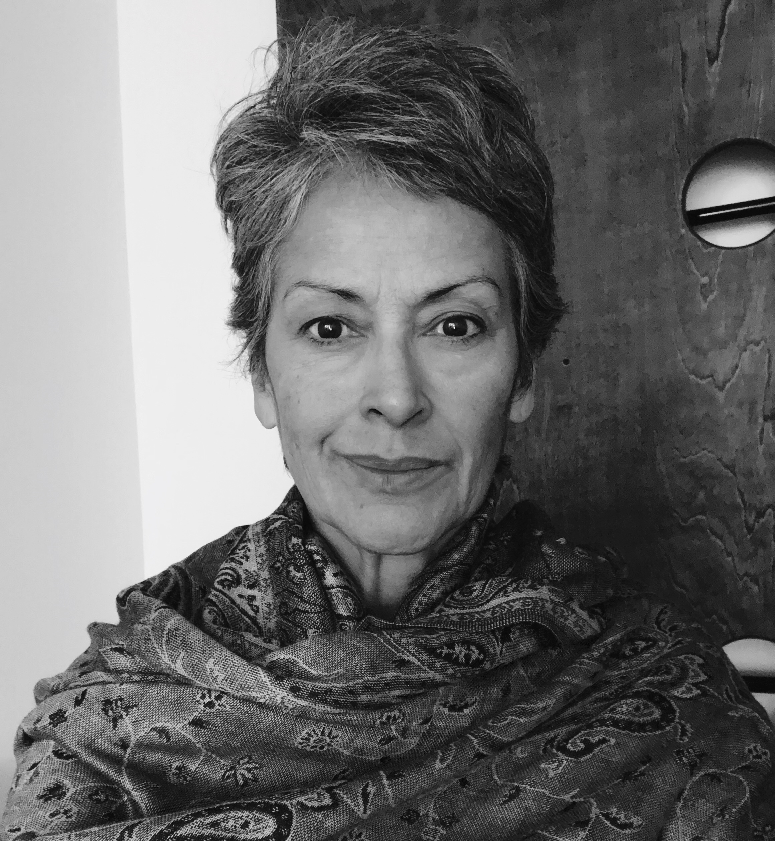
Regina Pietersen, E-RYT200, YACEP (Continuing Education Provider) - Owner of Breathe Life Sangha, Lead Trainer, Faculty Member, Programd Director

Regina Pietersen is an e-RYT200 hour certified yoga teacher and educator, YACEP (Yoga Alliance Certified Continuing Education Provider. Her teachers were Erin Peluso and Joell Lanfrank. Regina is trained in Sivananda, Vinyasa, Bhakti and YogaWorks methods. She also has a certified Yoga Wall Ropes and Slings Instructor by Alison West of Yoga Union in New York and Buddha Body certified by Michael Hayes. She currently offers Beginner, Restorative, Moderate, Vinyasa and All-Level classes to private and corporate clients, as well as group classes. Regina holds a Bachelor of Science degree in Accounting and was working toward a Masters degree in Psychology.

Regina underwent lap band surgery three years ago and lost 80 pounds. In beginning to train for triathlons once again, she thought yoga would help her in cross training as a means of warding off sports related injuries of muscles from overuse in Triathlon training. She also found yoga to be helpful in managing her stress related to attending graduate school, running a business with her husband, having two young children, and a full time job, in addition to training for triathlons. She soon found many other healthful side benefits such as reduced stress, ability to think more clearly, a more positive outlook, and a sense of overall well-being and happiness. She wants to share these benefits with others.

Breathe Life Sangha Yoga Teacher Training Application Form

Name: _________________________________________

Address: _______________________________________

_______________________________________

Cell Phone: _____________________________________

Home Phone:____________________________________

E-mail: _____________________________________ Date of Birth: ______________

Emergency Names |  | Phone | Relationship
1. | ____________________ | ________________ | ________________
2. | ____________________ | ________________ | ________________

Medical History

Briefly describe your physical health history.

Are you currently suffering from any health condition?

Briefly describe your mental health history. Please include any history of disorders, depression or chronic problems. Include any current medications you are taking.

If you are planning a pregnancy during this program year, are you willing to follow the advice from the facilitator regarding your asana practice?

Let us know about you

How long have you practiced yoga?

How many days per week do you currently practice? Please describe it briefly.

What style do you enjoy?

List your yoga history including your primary teachers.

Where do you currently practice and with whom?

Have you ever been injured by your yoga practice? Y/N

Do you have a personal home practice? Y/N

Do you practice meditation Y/N pranayama Y/N inversions Y/N

Are you currently teaching yoga?

What is your interest in participating in this program?

What are your personal expectations for this training?

Describe your food habits and lifestyle.

Describe some of your other interests and hobbies.

List any additional information you would like us to know.

Payment Information

The $500 deposit is due with your application and full payment is required no later than two weeks prior to the start date of the program. Full payment is required by March 31, 2018 to qualify you for the $300 discount. If you are paying in installments, your payment terms will be subject to review and approval of the program director, Regina Pietersen.

_____Paying by check. Please mail the deposit check with your application. You may also include the first installment, or may pay in full. Please include the participant’s name (if other than check holder), street address, and phone number on your check. Make your check payable to Breathe Life Sangha.
_____Paying by cash. A receipt will be given.

Payment Program

This program offers a payment options for those interested.

Please include a non-refundable $500 deposit with your application. This deposit will be applied to your tuition. Total cost for the program after March 31st, 2018 ($2900). Tuition paid in installments, including deposit, is $3200 plus a $25 monthly fee for the term of the installment plan. No penalty for early payment.

The reading material cost is not a part of tuition. Plan the purchase of one (occasionally two) books per month. These are standard yoga texts that you may already own and will serve as reference guides for the training. You will need to bring your yoga mat and manual for each training session. These will be fun and intense sessions! Adequate rest and methodical study throughout the training will be beneficial internalizing the information.

Completed applications can be emailed to info@breathelifesangha.com and deposits and/or applications can be brought in person or mailed to:

Breathe Life Sangha
673 Batchelor St. (Rear)
Toms River, NJ 08753
Program Agreement

It is my understanding that I must fulfill all the requirements set forth by Breathe Life Sangha Yoga Teacher Training Program. I must complete all required contact hours, homework, volunteer time, quizzes, and the practical and written final evaluations in order to receive my letter of completion of the program. The certificate of completion may then be submitted to Yoga Alliance for registration, or for any use to provide proof of completed training hours.

It is my understanding that Breathe Life Sangha and its teaching staff reserves the right to ask me to leave the program at anytime if I behave in any inappropriate way, am unethical, or in violation of the ethical guidelines set forth by Yoga Alliance. In the event of any of these situations, I will not be refunded my tuition. The $500 deposit will be refunded only in the event that you are not admitted to the program. Once your acceptance letter has been mailed/emailed, the deposit is non-refundable. It is my understanding that my deposit is non-refundable, and should I cancel my participation, it must be 30 days prior to the start date, in order to receive a refund of my remaining balance after the deposit is removed. Once the program begins, tuition is non-refundable and also non-transferable, unless under special circumstances, and agreed upon by all parties.

It is my understanding that all materials are under copyright protection and cannot be reproduced by me without permission from the author.

I further agree to all the stipulations in the information package including but not limited to:
Attendance, tardiness, completion of assignments/quizzes/tests.
Maintaining a home practice, and attending a minimum of two classes a week at Breathe Life Sangha (if you do not live near the studio, you may go to another studio and have them sign proof of attendance to a class there). You agree to teach at least three public classes before graduation.
You agree to no texting in class, phones are off.
You agree to not eat during class time unless otherwise allowed and will keep your area neat and free of clutter
You agree to observe silence when entering and assist in keeping the studio clean and neat.
You agree to be sober and not under the influence of any drugs.
Parking is on the side of the school or towards the back.
You will be mindful of when other people are speaking, and listen.
You agree that you have read and understand the rules for termination.

I have read and accept the above terms and requirements: ____Yes ____No
Initials here to verify my review and acceptance of the terms and requirements of the program:______
Breathe Life Sangha Teacher Training
Agreement and Liability Release

I, ________________________________________(print name) understand that yoga includes physical movement as well as an opportunity for relaxation, stress reduction, and a release of muscular tension. As in the case of any physical activity, the risk of injury, even serious or disabling is always present and cannot be entirely eliminated. If I experience any pain or discomfort, I will listen to my body, adjust the posture, and ask for support from the teacher. Yoga is not a substitute for medical care. I affirm that I alone am responsible to decide whether to practice yoga. I and my heirs hereby agree to irrevocably release and waive any claims that I have now or hereafter may have against Regina Pietersen, Breathe Life Sangha, and all such hosts, instructors, organizers and participants.

I have carefully read this agreement and the entire contents of the Breathe Life Sangha Teacher Training Agenda and fully understand its contents. I have signed this release freely and voluntarily. I am fully aware of this risk and hereby release Breathe Life Sangha and its teachers from any and all liability, negligence, or other claims arising from, or in anyway connected with, my participation in yoga teacher training or yoga classes/workshops and other activities. My signature further acknowledges that I shall not now or at anytime in the future bring any legal action against breathe Life Sangha and its teachers; and that this waiver is binding on me, my errors, my spouse, my children, my legal representatives, my successors, and my assigns.

Signature:_______________________________________ Date: _________________

Printed Name:____________________________________

Breathe Life Sangha Teacher Training Agenda Release

I have read, understand and agree to the terms and conditions for application, admission and participation in the Breathe Life Sangha Teacher Training Program. Breathe Life Sangha reserves the right to make changes to this agenda including class times, locations, and guest teachers as the program evolves.

Address:_______________________________________________________________

Email:______________________________________Cell:_______________________
Photography Release

I hereby grant Breathe Life Sangha permission to use my likeness in a photograph, video, or other digital media (“photo”) in any and all of its publications, including web-based publications, without payment or other consideration. I understand and agree that all photos will become the property of Breathe Life Sangha and will not be returned. I hereby irrevocably authorize Breathe Life Sangha to edit, alter, copy, exhibit, publish, or distribute these photos for any lawful purpose. In addition, I waive any right to inspect or approve the finished product wherein my likeness appears. Additionally, I waive any right to royalties or other compensation arising or related to the use of the photo. I hereby hold harmless, release and forever discharge Breathe Life Sangha from all claims, demands, and causes of action which I, my heirs, representatives, executors, administrators, or any other persons acting on my behalf or on behalf of my estate have or may have by reason of this authorization.

I HAVE READ AND UNDERSTAND THE ABOVE PHOTO RELEASE. I AFFIRM THAT I AM AT LEAST 18 YEARS OF AGE , OR, IF I AM UNDER 18 YEARS OF AGE, I HAVE OBTAINED THE REQUIRED CONSENT OF MY PARENTS/GUARDIANS AS EVIDENCED BY THEIR SIGNATURES BELOW. I ACCEPT:

Print Name: _________________________________________

Signature: __________________________________________ Date: __ / __ / __

