**RECITAL 2019**

**June 8, 2019**

**Start inviting friends now!**



**FUN FEBRUARY 2019**

**During the month of February, we pick a fun event each week to have some fun! Let’s do it!**

February 4th-7th is **Crazy Sock Week**

February 11th-14th is **Crazy Hair**

February 18th-21ST is **Spirit Week**

February 25th-28th is **Pajama Week**

GET READY TO BRING **F*U*N**

TO FEBRUARY!

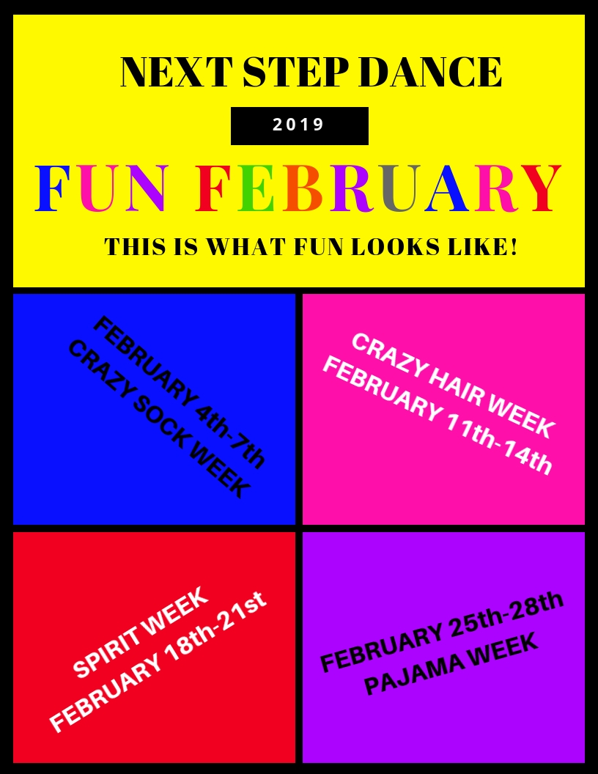

C:\Users\Stephanie\Pictures\Microsoft Clip Organizer\j0416014.wmfC:\Users\Stephanie\Pictures\Microsoft Clip Organizer\j0416014.wmfC:\Users\Stephanie\Pictures\Microsoft Clip Organizer\j0416014.wmf

**#class of the month** C:\Users\Stephanie\Pictures\Microsoft Clip Organizer\j0416014.wmf

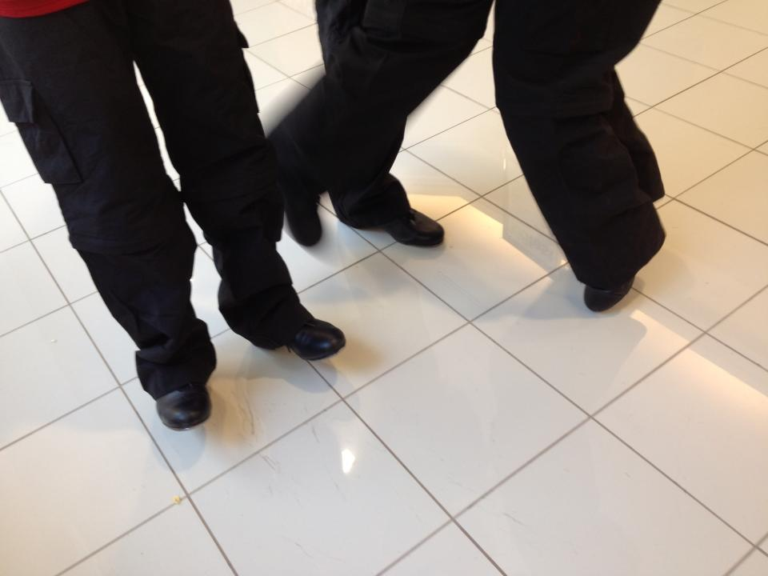

***TAP CLASSES***

One of the most exciting sounds to hear coming from the studios are the rhythmic sounds of students tapping. Whether it is warm-up or a combination, with music or acappella those shoes are singing a song!



**2019 SUMMER CLASSES LAUNCH MARCH 1ST**

Our 2019 **Summer** Classes will be online soon. Check out what is happening for summer in our TWO 4-week sessions! Don’t just take a class this **summer**, sign-up for FUN! All of our classes will not only teach technique but there will be themes for your dancer to choose from in each of our sessions. If you are age 2 & up and are interested in recreational or competition classes there is something for you at Next Step Dance. Refer family and friends and share in their excitement of dance when you receive a credit to your dance account! This is a perfect time to try something different and see if it is something you might want to add to your fall schedule. We will have a **summer** registration table in the lobby the first week of March (4th-7th) for early registration with some **summer** saving discounts! And during that week all the dancers can wear their favorite **summer** gear. So let’s get started on some **summer** fun.

 

Steppin’ into **FEBRUARY 2019** with Next Step Dance

[**www.thenextstepnc.com**](http://www.thenextstepnc.com)

**7712 Sossamon Lane, NW Concord, NC 28027 (704) 786-7837 nsdcalendar@gmail.com**

**OPEN HOUSE**

Thinking ahead to summer activities or even Fall 2019? Have a friend or relative interested in dance? Have a younger sibling that will be old enough for our Tiny Steppers program? Find out schedules and all the important stuff at our Open House on Saturday, May 18th, 2019 from 10:00am-1:00pm. There will be classes to tryout and some surprises too. Bring your friends and learn more about Next Step Dance and what is happening with not one but our TWO summer sessions and our for fall ’19.

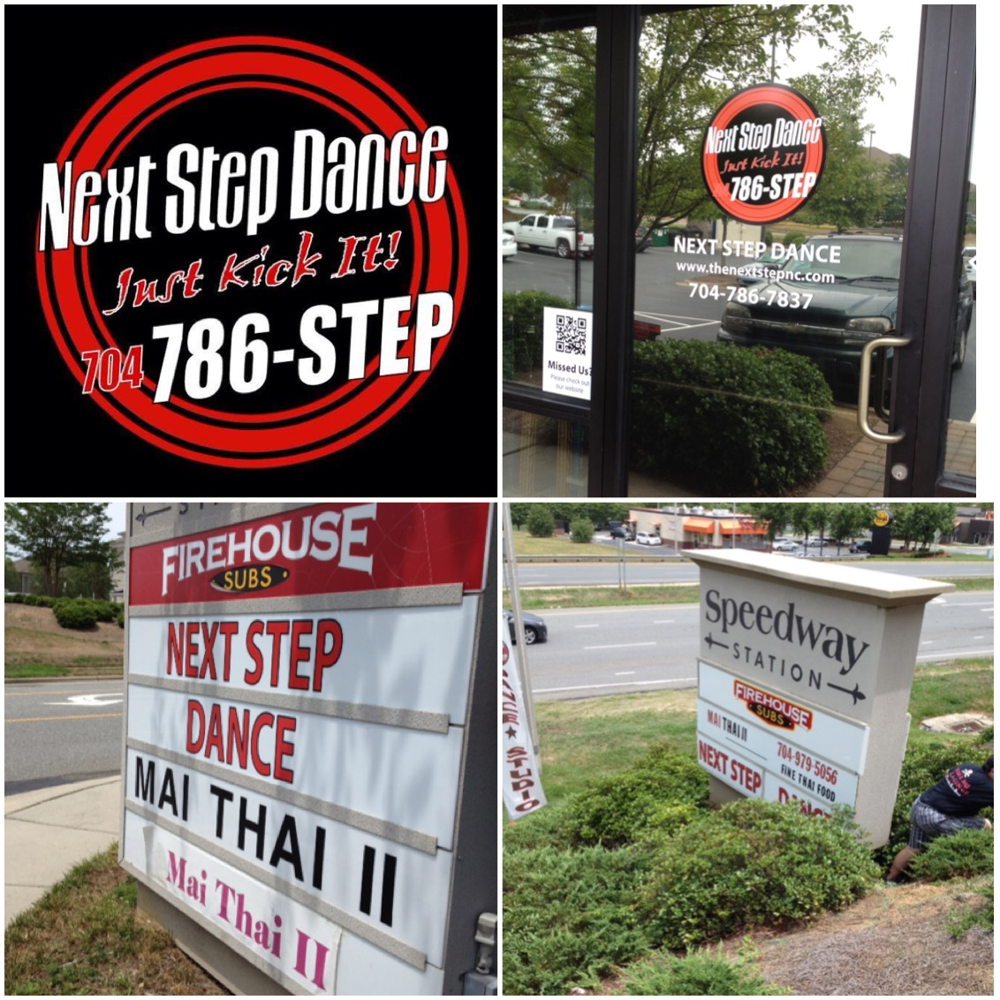

**SAVE THE DATE** C:\Users\Stephanie\Pictures\Microsoft Clip Organizer\j0416014.wmf

February 11th-14th Parent Appreciation

February 14, 2019

Don’t forget your Valentine!



Shoe orders take approximately 1-week for delivery and some we have in stock!

REMEMBER TO JOIN US ON

Facebook, Twitter, & Instagram!