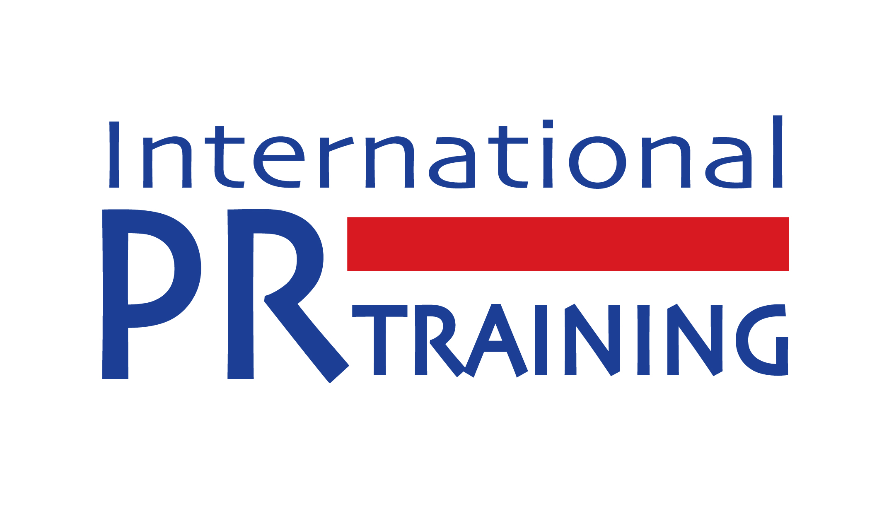

REGISTRATION FORM

Please email this form to info@prtraining.sg

Course Title: ________________________________________________________________
Course Date: ________________________________________________________________

Contact details for booking administration
Name
Company or Organisation |  | Dept.
Address
City – Postcode
Country
Telephone
Email

Please enter the details of the participants for the course.
Participant 1
Name
Job Title
Tel: DID or Mobile No.
Email

Participant 2
Name
Job Title
Tel: DID or Mobile No.
Email

Agreement
I have read and agree to the details of the Registration Form and the terms and conditions appended below.

Course Fee per participant: S$ ___________ Total amount payable: S$ __________________

Name: _________________________ Signature: _____________________ Date: ___________

Methods of payment

You may make payment via any of the following methods:

- Electronic bank transfer via PayNow to International PR Training Pte Ltd, UEN: 201117909H
Bank Account: DBS 015-903-036-9

- Crossed cheque or bank draft made payable to International PR Training Pte Ltd and mail it together with your completed registration form to:
International PR Training Pte Ltd, 16 Raffles Quay #41-01, Hong Leong Building, Singapore 048581.

- Via bank transfer to DBS Bank Account No. 015-903-036-9. At the same time, please scan and email your registration form to info@prtraining.sg.

- For overseas participants, please pay via telegraphic transfer to:

Company: International PR Training Pte Ltd
Account No.: 015-903-036-9
Bank: DBS Bank (Thomson Branch)
Bank Code: 7171 Branch Code: 015
Bank Address: 6 Shenton Way DBS Building Singapore 068809
SWIFT Code: DBSSSGSG

Please note that all payments must be received at least 3 days before the course starts otherwise admission may be denied.

No refund policy. If you are unable to attend, a substitute participant may be accepted at no extra charge. We do not refund course fee for any cancellation upon registration and payment.

The company reserves the right to make any amendments and/or changes to the course programme, venue, topics and trainers if warranted by circumstances beyond our control.

If you have any questions, please call +65 91503701 (Monday – Friday; 9.30am – 6pm).

