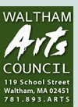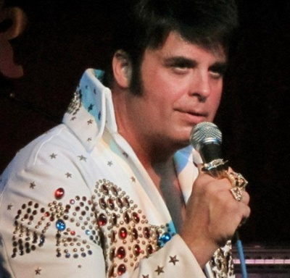
www.walthamarts.org
Everett W. Erwin, Jr. President

March 25, 2017
The Waltham Arts Council and Bill Walsh Scholarship Committee will be holding a Tribute to Elvis on Sunday May 21st as a fundraising event. The Waltham Arts Council and Bill Walsh Scholarship Committee provides an annual scholarship to a student from Waltham High School continuing on in the Arts. All of the funds raised from this event will be used to support the Waltham Arts Council's work in our local community.
We're in the process of collecting merchandise for the event, and I'm asking your assistance in making this event a success. By donating an item, you'll be making a tax deductible contribution that will help Waltham Arts Council and Bill Walsh Scholarship Committee continue to help make life better for students in need, right here in our community.
Additionally, you'll benefit from exposure of your company's name to those who attend the event. Donors will be listed on the event program, and the merchandise you give will be on display through the event. As a donor, you'll be invited to attend the event, so you'll be able to meet prospective customers and even possibly find a few bargains of your own.
Won’t you consider donating an item to support the continued work of the Waltham Arts Council and Bill Walsh Scholarship Committee? You may reach me at 617-513-8451.

Sincerely,
Brenda Carlson, Chair
Waltham Arts Council and Bill Walsh Scholarship Committee

