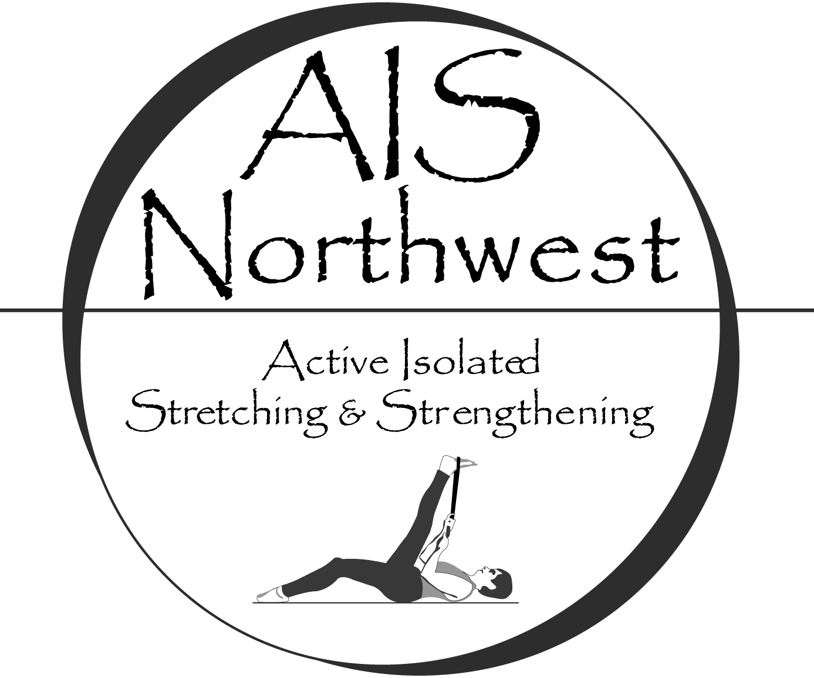

Introduction to Active Isolated Stretching

May 3rd, 2018

Anamosa, IA

Active Isolated Stretching (AIS) is a dynamic technique that stretches muscles, tendons, and fascia, specific to anatomical planes of movement. It remodels the body using gentle, rhythmic movements that avoid triggering the myotactic reflex, which causes a contraction in the tissues being stretched. Utilizing the principles developed by Aaron Mattes, this unique stretching modality restores joint mobility, reduces muscular/fascial tension and improves circulation. The simple yet profound difference is holding the stretch for only 2 seconds. Repeated, active muscle contractions along with gentle stretches create a venous/lymphatic pump, decreasing inflammation and combating disease. Dysfunctional movement patterns are exposed and retrained; unfavorable postural habits shift.

In this introductory, basic-level class you will gain an understanding of the system as a whole. The material presented in this course will cover the essential stretches needed to counteract some of the compromising effects of gravity on posture. These fundamental stretches will be covered in detail so that you can implement them in your practice immediately. Course content is geared towards healthcare professionals and athletic trainers.

Instructor: Joshua Morton, LMT, MAISS, MMLT
CE Contact Hours: 4 hours (NCBTMB, BOC)
Tuition: $100; 2 weeks prior to class, $125 thereafter.

Bonus Discount: If you attend this class and then register for a full 12 or 16-hour AIS seminar within two years time, you will be eligible for $50 discount. Contact the AIS Northwest office at aisnw@comcast.net / (360) 738-9800 to verify eligibility for this discount.

Materials: A handout of the stretches covered in class will be provided.

Day/Time: Thursday 6 pm -10:15 pm (15-min break)
Cancellation/Refund Policy: Carlson College of Massage
Day/Time: Thursday Mar 3rd 5:00pm – 9:15pm (15 min break)
Location: 11809 Co Rd X28, Anamosa, IA 52205
Registration/Info: Carlson College of Massage
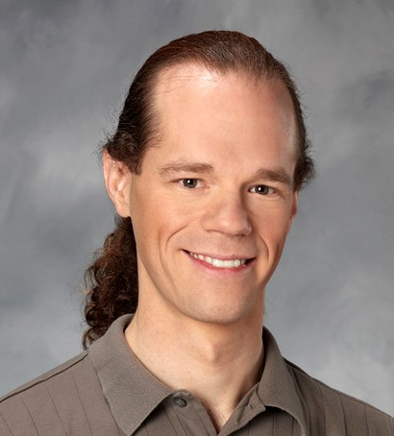 | Joshua Morton, LMT, MAISS, MMLT - Co-owner/Master Instructor with AIS Northwest, LLC. Joshua has over 2000 hrs. training with Aaron Mattes, the creator of Active Isolated Stretching and over 15 years teaching AIS. Joshua is one of the leading AIS practitioners and instructors internationally. Joshua offers students in-depth experience and expertise in a supportive learning environment. (#MA00008567). | 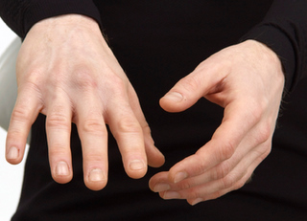
AIS Northwest, LLC is approved by the Board of Certification, Inc. to offer continuing education for Certified Athletic Trainers.
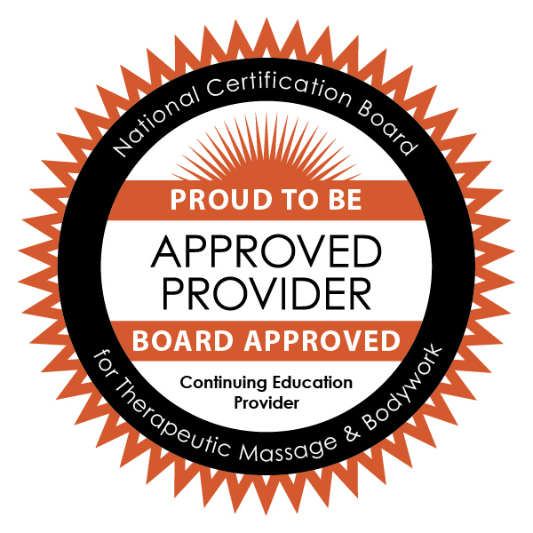AIS Northwest is approved by the National Certification Board for Therapeutic Massage & Bodywork (NCBTMB) as a continuing education Approved Provider (Provider ID: 451194-09).

