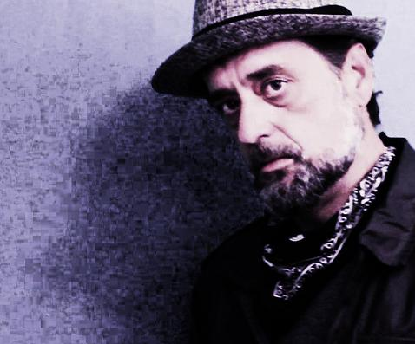
https://twitter.com/HollowBodyEXP
https://www.facebook.com/hollowbodyexperience/
https://www.instagram.com/hollowbodyexperience/
https://www.youtube.com/channel/UCBLGFCDpf1Vt8z4WJIddG8A
https://open.spotify.com/artist/5oBMAnWlim9Z5HhIS9stRU?si=ingZMfFhTTGBrEN2tQBUFA

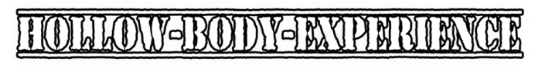

Artist: HOLLOW BODY EXPERIENCE
Album: THE 2ND HAND OF SILENCE
Single: "So Heavy"
Release Date: February 5th 2021

After fronting 3 bands & recording 8 albums; Jason Ochsner has returned with a natural approach to his songs. His new project, Hollow-Body-Experience, is a long awaited concept of selected acoustic versions of his catalog, as well as the introduction of his newborns. Featuring foot-drum & harmonica accompaniment, Jason highlights his passion for guitar, music & songwriting.

Featuring: Jason Ochsner on Guitar, Vocals, Foot-drums & Harmonica.

The new album: the 2nd hand of silence *officially releases on February 5th 2021

For more info about Jason: https://www.hollowbodyexperience.com/our-services.html

To listen to “So Heavy”: https://www.hollowbodyexperience.com/epk.html

EPK: https://www.hollowbodyexperience.com/epk.html

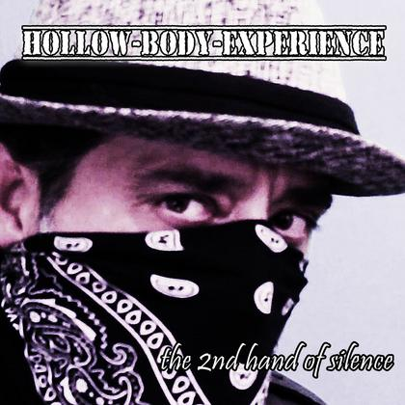

Due to covid -19
All touring & show schedules are subject to the restrictions & limitations of the current pandemic.
In honor optimism, Hollow Body Experience is currently seeking/booking National show opportunities throughout 2021.

Past Dates - 2020 Show Dates:
January 19th @the Top - Richmond, VA
June 21st @the Top - Richmond, VA
For a complete list of past shows:
https://www.hollowbodyexperience.com/shows.html

