How do I… view my benefits statement?

You can access your benefits information by selecting the “Benefits” option on the menu panel.
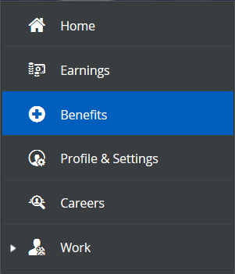
You will then select “Current Elections” from the options at the top of the screen.
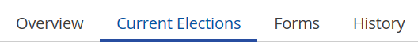
You can view a list of your current benefits, along with their costs and dependents/beneficiaries.
Note: You will see employee and employer paid amounts.
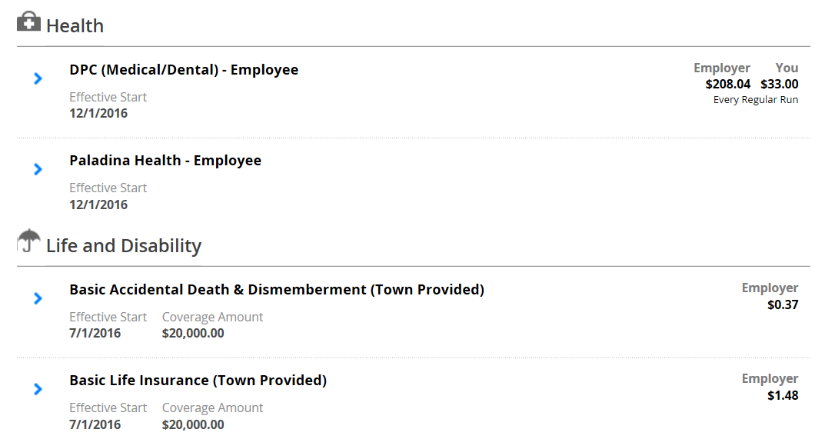

To view additional details about any benefit, click the arrow next to the name.
