Pistol Range News
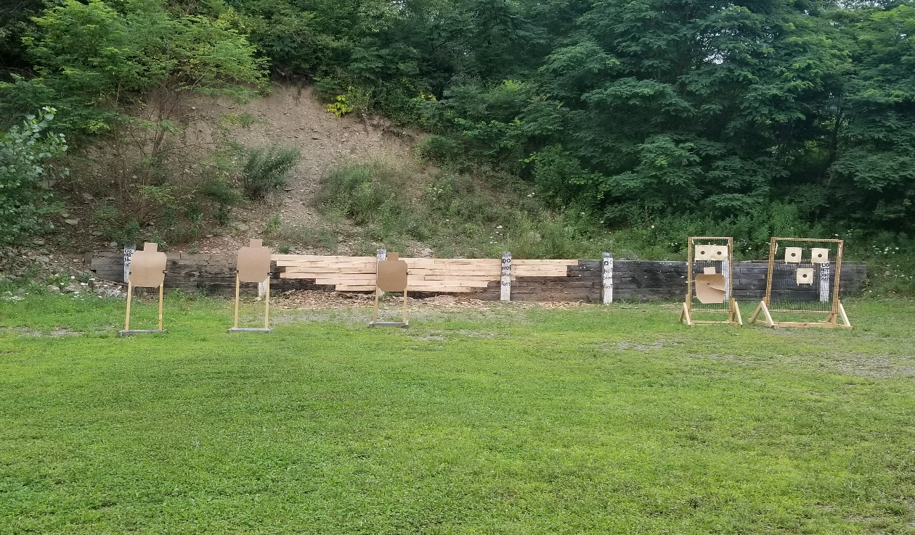
The Pistol Range backstop has been repaired recently, much of the damage to it is thought to have been caused by a couple things:
- Stapling targets to the actual backstop wall. In many cases, we would find 3-4 targets stacked up in the same area. This maximizes/concentrates the damage done to the wall, at least with those shooters that are a good shot
- Use of rifles and shotguns on the pistol range. As is clearly marked on the range, it is for Pistols ONLY. We have seen shotgun shells, and rifle shells left on the pistol range, and have seen obvious shotgun damage to the wall
In order to try and keep the repaired backstop in better shape, please adhere to the following rules when using the pistol range
- Pistols Only, use of rifles or shotguns is strictly prohibited
- Do Not staple targets to the wall, please use the numerous target stands we have left out on the range. Including two new target stands where you can use clothes pins to easily hang your targets. There are also silhouette target stands and we usually leave some of those targets on the bench that we have previously used at pistol shoots, they are there for your use.
- Please move the target stands around before you shoot, this will help keep the wall in better shape by spreading out the impacts
- Please make sure the target stands are not placed directly in line/in front of the vertical posts. If those are damaged, it will be a lot of effort to repair those.
Thank you for your anticipated cooperation in keeping the pistol range in good working order, and have fun using it.
Thank you to all that had a hand in getting the backstop repaired, I hate to name names as I always miss someone, but there were several people involved, and their assistance is greatly appreciated.
If you have any questions, or see a problem developing at the pistol range, please contact me as needed. Steve Leven 585-749-4127

