D R A F T
EYEMED
Work Packages WORK PACKAGE 2 (WP2)
COMMUNICATION, DISSEMINATION

WP1 Project Management and Coordination
WP2 Communication / Dissemination
WP3 Content
WP4 EU Pilots
WP5 MENA Pilots
WP6 Evaluation / Exploitation

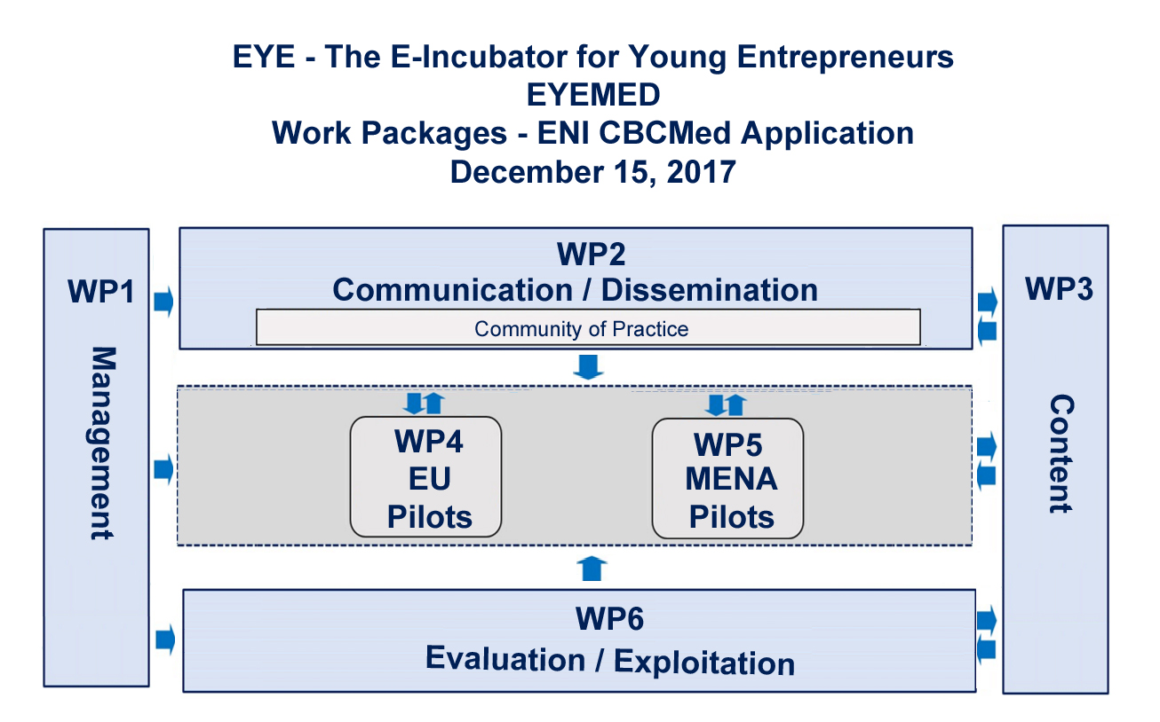
WP2 Partners:
WP Manager: Partner PP1 - Global Skills Network – GSN / EU Pilots Coordinator
All Partners

WP2 – Communication / Dissemination

A well-established Communication and Dissemination Strategy is a key component for EYEMED, since it will allow the maximum possible outreach of the project and the dissemination of the outcomes of the projects to all relevant stakeholders, that is, target groups, beneficiaries and local actors, as well as to an external audience within the broader fields of education and training, back-to-work and career promotion schemes and distance learning, as well as industry and business segments and public administrations. Communication will be focused on activity primarily concentrated on digital outreach such as a website, participation in social media platforms and media placements while dissemination and exploitation will be accomplished primary through events and collateral material.

The overall objective of the Communication / Dissemination Plan will be to raise the awareness about the outcomes of the project and the developments that have been achieved within EYEMED. The planning goal will be to support the EYEMED mission by developing, implementing and evaluating marketing and communications to internal and external targeted stakeholder audiences.

This work package shall ensure that the project objectives, activities and methodologies developed within the project are widely promoted to audiences defined by the Communication and Dissemination Plan on a Mediterranean Region, pan European and international level.

While all partners in the EYEMED Consortium participate in WP2, the Steering Committee will hold the overall responsible for drafting the Communication and Dissemination Plan, in which there will be a detailed strategies followed by all partners, and will have the following main objectives:

- Develop a cohesive and practical strategy that will ensure that all relevant information and outcomes of the project will have the maximum possible outreach at the Mediterranean Region, European and International levels.
- Involve all partners in dissemination activities and optimize the effective usage of different modes of promotion and diffusion.
- Identify all the possible stakeholders and classify them in different groups, according to their requirements and expectations from the project outcomes.
- Serve as a forum for discussion and solutions for issues surrounding the mission of the project – that is, combating unemployment and underemployment in the Mediterranean Region through entrepreneurship.
- Maximize the number of relevant stakeholders that participate in any promotion and networking events of the project, such as training, seminars and workshops as well as any conferences sponsored by the EYEMED consortium.
- All partners will contribute in identifying all the possible stakeholders in their countries or regions where the WP4-WP5 pilots will take place and give feedback to the Steering Committee for the drafting of the plan.
- Involve all partners in communication activities and optimize the effective usage of different mechanism for the effective exchange of information.
- Identify all those mechanisms that can maximize the exposure of the project to the largest possible audience, such as newspapers and local media outlets as well as social media.
- Develop an after-life Dissemination plan that will ensure the maximum possible project outreach after the official end of the project.

Roles and Responsibilites: In common with all partners, each will also input into WP2. The work package manager, in conjunction with the project’s Steering Committee and with input from all consortium partners, will create specific Communication and Dissemination Plans for each partner, ones that are culturally and linguistically appropriate to the areas in which the EYEMED project will take place. The work package manager will be supported by the EYEMED Steering Group at the outset of the project, which will meet periodically over the lifetime of the project and will be responsible for organising all activity, including the project’s events such as the kickoff meeting and the project’s final conference. In common with all partners, each will also input into WP2, and regular communication between the partners, primarily through bi-monthly meetings through the Community of Practice, will ensure the co-ordination of activity.
Activities:
- Development of Communication and Dissemination Plan: This task is devoted to development of effective strategies and coordination of these activities within the project consortium partners. The aim of this task is to identify and structure the activities leading to the promotion of the project’s activities and results.
- The plan shall define the target groups from the countries/regions in which the pilots take place;
- Roles and responsibilities as well as human capital will be assigned for each deliverable.
- Measurable criteria of the communication, dissemination and exploitation efforts shall be selected in order to effectively evaluate each activity or deliverable.

The Communication and Dissemination Plan shall define principles to be followed by all partners in order to avoid confusion and misconceptions and to foster the quality of outputs.
- Communications Sub-Plan: Identifies the different messages to be addressed to each target group and external audiences as well as the methods employed, and the expected outcome of sponsored activities.
- Dissemination Sub-Plan: This task foresees the elaboration of a shared plan for a de-centralised, but coordinated, dissemination of all activities and outputs of the project. It will include guidelines for dissemination to be used by Partners. Provides an overview of the dissemination strategy, activities, and materials the project intends to use over the lifetime of the project with the goal of distributing the project’s results as widely as possible.
- Realization of Communication, Dissemination and Exploitation Plans: All activities shall be monitored and recorded during the project execution.

- The Community of Practice will be scheduled to meet bi-monthly (every two weeks) to updated the group of progress made on EYEMED’s various fronts. These meetings will serve as a monitoring function to assure the pilots are on track, on time, and on budget. The proceedings are transcribed to contribute to reporting documentation as well as provide input to the process of evaluating the progress of, and the results achieved in, this project in a manner which allows comparison with other projects supported with EU funds.

Deliverables:

- Identity: In developing a Communication Plan, a project logo will be designed and included in all hard copy material produced for the project as well as in any digital communication. This will help define EYEMED as a brand, which is essential for marketing outcomes, especially digital marketing campaigns such as email and social media campaigns, as well as offline marketing activities through diverse communications vehicles and products such as newsletter, reports, maximizing the use of multimedia channels, etc.

- Community of Practice: The project will have produced valuable documentation, material and reporting templates that can be used in similar training project and sector outcomes. EYEMED is expected to create a professional network and Community of Practice (COP) for those working to reduce youth unemployment and underemployment, as well as identify new opportunities for collaboration in both regional and international contexts. EYEMED partners will be convened through the COP, a virtual meeting place where they can share experiences, technical knowledge or skill associated with undertaking the project’s tasks. resources and mentorship in improving their professional capacities in the provision of services to their clientele and/or training to their students, as well as access a shared repertoire of communal resources (research, methodologies and artefacts, curricula and material, shadowing, etc.) that members have developed over time.

This Community of Practice also serves to convene the group on a regular basis to monitor the progress made through EYEMED, envisioned as a 32-36 month programme, to create a sense of joint enterprise and identity by being organized around common goals, objectives and envisioned outcomes. The EYEMED COP is designed to share a repertoire of ideas, commitments and memories and foster relationships that will last beyond the life of the project.

- Marketing: a range of marketing collateral will be developed, as set out in the plan, including hard copy and digital outputs for campaigns, press releases and email marketing templates as well as proper social media promotions in a blend of different methods most useful to the project in terms of outreach to our targeted groups and external audiences.

- Website: a website will be designed and launched, available in English, Arabic and the languages of the regions in which the pilots are undertaken. It will be designed to be the dynamic centerpiece of EYEMED’s external communication mechanism, created to be multi-dimensional and to serve a variety of needs. Its main purpose is to serve as a content curation platform where we can give the young entrepreneurs a place to hang their portfolios of the business or ventures created through EYEMED and gain exposure. Secondarily, such a site could add value as:
- an introduction to EYEMED and its mission and vision
- a vehicle for telling the project’s various success stories
- a source for capturing interest in project replication
- a tool for galvanizing around the issues of youth unemployment and underemployment
- an informational repository

The website requires a constant ongoing flow of information as well as ancillary communications products (covered separately) to fulfill the intended functions. Because of the complexity of the website, the variety of messages we are trying to convey, and the density of the information offered, it is necessary to support certain aspects with their own platforms (covered separately under the topics of ancillary sites and social media). Some informational needs occur only occasionally while others require monthly, weekly or even daily updates. Ongoing content management including minor additions, deletions and updates to informational content is required, carried out under the responsibilities of a webmaster. This is inclusive of news, events, descriptions of initiatives sponsored under the project, storytelling – including focus on success stories. The web strategy will be focused on combining creative design with rock-solid technology include mobile connectivity for the development of a professional website for the project. This component will be outsourced as a sub-contract.

- Ancillary sites: Ancillary sites such as blogs and social media streams repeat information posted on the foundation’s website and hosted externally, such as on a popular blogpost like WordPress or Blogger. These are hosted separately so our messages aren’t lost on the EYEMED’s main site, to gain cross-linking SEO benefits, and also to increase exposure by offering it on a different platforms. Updates to the informational content of the site and minor additions and deletions can be handled by the aforementioned webmaster.

- Social Media: Today it is no longer acceptable to have a single website with static content as an organization’s vehicle for information and outreach. With advances in technology communications have become dynamic, fluid, and responsive. People are constantly connected to a stream of information, guided not only by personal choices but also heavily influenced by friends and peers. Participation in social media platforms is not only mandatory for effective communications today, but it also offers potential unlike any other media. With opportunities to follow, share, like, repost, and link, social media offers exposure for the foundation that can grow exponentially with each new person it reaches.

Content on social media sites is distinct from, yet complementary to the information found on the proposed EYEMED website (www.eyemed.com); it should never be just a repeat of information found on the main site. It serves as adjunct to website and its purpose is to pique interest, start conversations, develop a following and drive traffic to the main website. There are many different social media platforms, each with its own distinct flavor and audience. We do not intend to try to have a presence on each and every one, as that would be an onerous task. Instead we intend to have a presence on platforms targeted for specific criteria, with information that is tailored to its audience and to present a particular aspect of the message the EYEMED wishes to convey. These will include Twitter (@eyemed_cbc), Facebook and Instagram. By engaging in the most prominent social media platforms that are appropriate to our cause, we will be able to create a following and make them aware of EYEMED’s goals and achievements. Additionally, video is becoming the most effective mechanism for storytelling, and we are confident that the five pilots supported by EYEMED will have plenty to say. Therefore, we will also create YouTube and Vimeo channels for posting videos contributed by our partners.

By utilizing a single integration platform such as Hootsuite combined with outputs in the form of a blog, content development and campaign executions, we will be able to perform data analytics such as social monitoring. A Community Manager will be recruited to coordinate social media outputs.

- Events:
- The Communications Plan is contingent on all partners participating in the Community of Practice during scheduled meetings, which will take place twice a month.
- Train the Trainer workshops are a hybrid form of training. Pre-moiblity, partners will engage in distance learning about the iPortal operability and applications. They will come together for the kick-off meeting to be held in Lisboa.
- Networking meetings will take place through the Community of Practice twice a month with the contribution of all partners to promote an exchange of information and data among EYEMED members;
- A final project conference held in Brussels shall be organized informing about the project results, impact and future activities. The target audience shall include public and private back-to-work entities, other relevant enterprises such as training institutions and organizations, research institutions, policy and decision makers, business and industry clusters, and experts in the fields from which SMEs and entrepreneurial endeavors result, from across the Mediterranean Region.

