Why is Backpack Safety so Important?

- Kids wear their backpacks on a daily basis, so the loads it creates can influence their development.

- Improper use of backpacks can cause musculoskeletal problems that can carry on into adulthood.

- Backpacks that are too heavy can cause bad posture as well as spine and muscle injury.

- Children are more at risk to these issues because they are still growing and developing.

- Over time the body compensates for any load it carries which can result in rounding of the shoulders, distortion of the natural spinal curvatures, irritation to joints, and a shift in the natural center of gravity creating reduced balance.

Is your child’s backpack hurting their spine?

For more information

References:

American Academy of pediatrics:
www.aap.org
Backpack Safety America:
www.backpacksafe.com

American Chiropractic Association:
www.acatoday.org/Patients/Health-wellness-Information/Backpack-Safety

University of Pittsburg Medical Center:
www.UPMC.com

Backpack Safety Tips
4 Things to Remember about Backpack Safety

- Choose the right backpack
Choosing the right size backpack is the most important part of safety. If you have a bunch of extra space your child is going to fill it.

- Load it Right. A backpack should never be more than 5-10% of the child’s body weight. If the pack forces the user to bend forward it’s a sure sign that it is overloaded. Heavier items should be loaded closest to the child’s back

- Lift it right. To pick up the pack face it, bend at the knees keeping a straight back, and lift with the legs.

- Wear it Right. Always use both shoulder straps and have the pack fit snug. Not too loose or tight. It shouldn’t hang more than 4 inches below the waistline. This will ensure equal loading on the body.
How to Pick the Right Backpack.

- Pick a lightweight material like cotton canvas, polyester or Nylon
- Wide padded shoulder straps to cushion the shoulders and distribute the weight more evenly.
- Padded back to protect from sharp objects and make it more comfortable.
- A waist belt reduces too much movement to keep even weight distribution.
- Multiple compartments allow even weight distribution and organization.

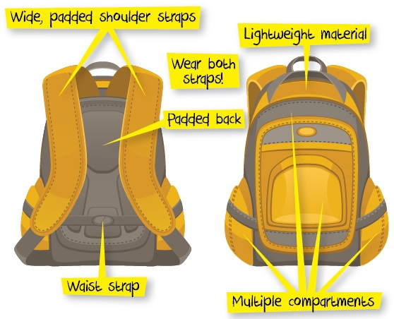

Signs of a bad backpack

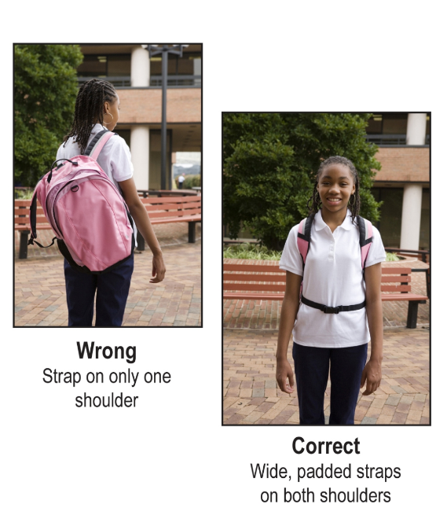
Some kids think using one strap looks cool, but back pain doesn’t look cool.
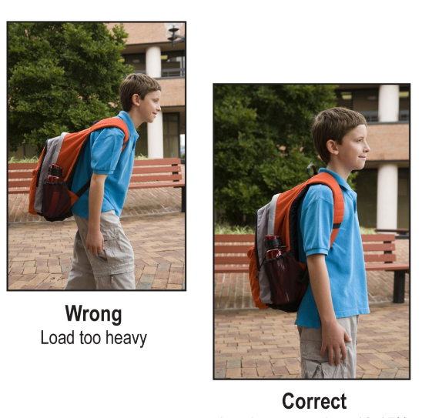
If they are leaning forward it’s a sign that the bag is too heavy

