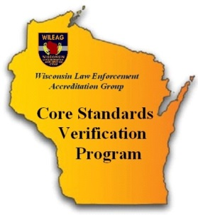
Core Standards
Verification Program

The purpose of the Agency Profile Questionnaire (APQ) is to assist the WILEAG Program Manager and Core assessors by providing a snapshot of your community and agency. Please take a moment to complete the APQ and return the completed questionnaire to the WILEAG Program Manager. Do not hesitate to contact the Program Manager with any accreditation questions or concerns.

Sincerely,

Robert Rosch

Robert Rosch
WILEAG Executive Director
262-468-1008
executive.director@wileag.info

AGENCY INFORMATION

Agency Name:
Agency Address:

Chief / Sheriff (CEO):
Daytime CEO Contact #:
CEO Email:
Accreditation Manager (AM):
AM Contact #:
AM Email:

Agency Size - Full time Employees: Total Sworn Civilian

Agency Size – Part time Employees: Total Sworn Civilian

COMMUNITY INFORMATION

Community Population:
Square Miles of Service Area:
Approximate Land Distribution of the Service Area:

Business / Commercial
Industrial
Residential
Residential Rental
Parks / Public Land
All Other
TOTAL 100%

Does the population of your service area change seasonally? No Yes
If yes, explain:

FUNCTIONS PERFORMED

Function and Standard # | Done by Agency | Under Contract Other Agency | Joint Agreement (MOU) | Not Performed
Hiring / Medical Exams 2.4.5 |  | List Agency: | List Agency:
Part-time Sworn Personnel 2.7.1 |  | List Agency: | List Agency:
Auxiliary Personnel 2.8.1 |  | List Agency: | List Agency:
Search of Prisoners 7.1.1 |  | List Agency: | List Agency:
Lock-Up Facilities 7.2.1 |  | List Agency: | List Agency:
Recruit Training 12.2.3 |  | List Agency: | List Agency:
Field Training 12.2.4 |  | List Agency: | List Agency:
Annual Training 12.2.5 |  | List Agency: | List Agency:

ADMINISTRATION

Please provide a copy of your agency organizational chart or a list / order of your organization’s functions (Word format would be sufficient). Task completed: No Yes

What is your agency’s total authorized budget for the most recent fiscal year? $

