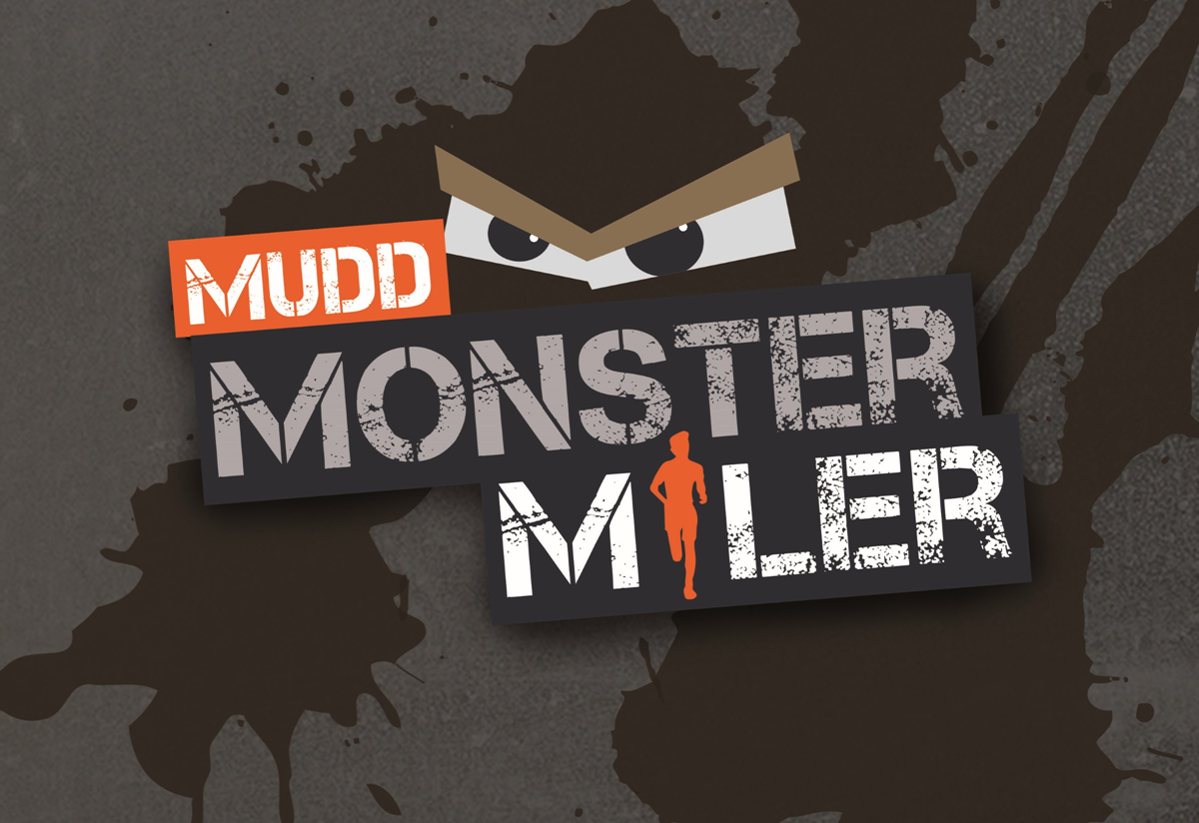
IBC’s Seventh Annual Monster Miler
Saturday August 20th, 2022 at 10:00 am.

Work your way through an obstacle filled, mountainous 5k+ course that will test your strength and endurance. This course is built on the side of Penn View Mountain where there will not only be obstacles, but plenty of mud and a 400 foot elevation climb. We dare you to run it!

Race Starts: 10:00 am (staggered start times according to age groups)

Fee: Race Day: $45.00 per runner or $100.00 per family. Pre-register cost of $40.00 per runner or $90.00 per family and guaranteed a t-shirt if registered by Aug. 13th.

Race Day Registration/Check-in: begins at 9:00 am on Aug. 20th at 1382 Barr Cemetery Road, approximately six miles east of Blairsville Wal-Mart on the north side of Rt. 22. Look for signs beginning at Barr Cemetery Road.

Runner Awards:

Men: Top 3 of each age group: U14, 15-19, 20-29, 30-39, 40-49, 50-59, 60+

Women: Top 3 of each age group: U14, 15-19, 20-29, 30-39, 40-49, 50-59, 60+

We will be offering “The Competitive Flight”. This is open to both males and females of all ages. If want to be challenged by other participants and take home the title of Monster Miler Champion, please be sure to check this category on the registration form.

There will be post race refreshments and a closing ceremony. Evangelist Glen “Shorty” Shank will be speaking for us at the closing ceremony. Shorty is a gifted evangelist with a genuine passion to see others make true, heart-felt decisions for the glory of God. If you have any questions, contact Pastor Rob Ingmire at (724)459-7868.

During registration and all race activities any recommended health precautions as per the state of Pennsylvania will be followed to ensure the safety of all participants and spectators.

