JSB Capital Management, LLC
Pro-active Wealth Management

April 15, 2020
The Path Forward in our New Reality

The Covid-19 Virus – Although it appears the pandemic is starting to peak in the U.S., there is still much we do not know about how contagious or widespread this virus is, or if once someone has it, can they get it again. Is it a seasonal virus like the flu that comes back every fall? Will there be a resurgence if we reduce social distancing? Has “flattening the curve” only meant that this will drag on much longer than otherwise?
The public has been very compliant so far, but as personal financial situations get increasingly dire and heavy-handed bureaucrats push for even more intrusive control over people’s daily lives, people will get increasingly restless. At this time, no one knows quite how to re-open an economy that has been shut down by diktat and has a population that is afraid to get close to each other.

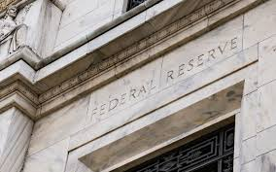

Federal Reserve Actions – Early in the crisis, the Fed cut the Fed Funds rate (the interest rate banks charge each other for overnight borrowing) to 0-.25%. They have since created lending and stimulus programs for virtually every sector of the economy. They have an open-ended program to buy U.S. Treasury securities and agency backed mortgage securities. The Fed re-activated a program from the 2008 recession to support credit to consumers and businesses such as student loans, auto and credit card loans, and Small Business Administration loans. They are also supplying credit to large businesses and purchasing corporate bonds and Exchange Traded Funds (ETFs). They are supplying liquidity to money market mutual funds and municipalities. And, the Fed is providing dollars and doing swaps with almost all foreign central banks. All this is in an effort to keep the global capital markets functioning smoothly.
Today’s Beige Book confirmed that economic activity has contracted sharply. Loan demand is very high and as expected the worst conditions are in the leisure, hospitality, retail and energy sectors. Food and medical demand was up. The outlook is highly uncertain and many more layoffs are expected.
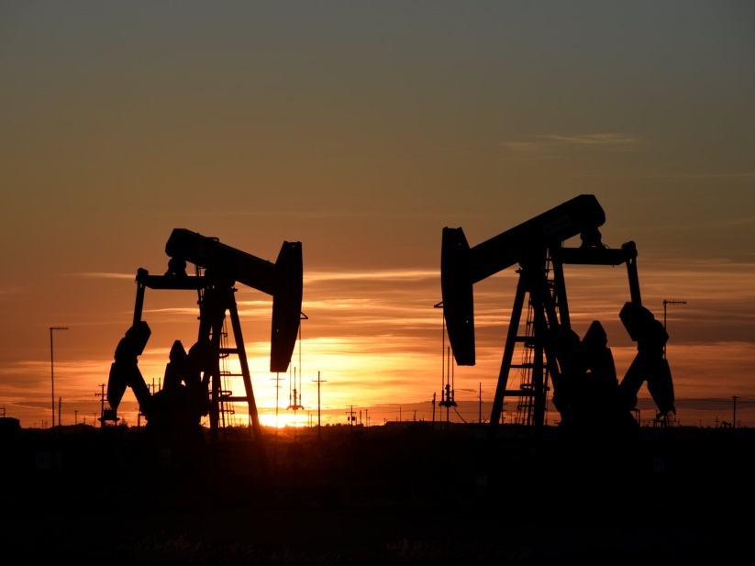

Energy – A squabble between Saudi Arabia and Russia precipitated a sharp drop in oil prices in early February with the intention (a hoped for side effect) of forcing reduced U.S. shale oil production. The concurrent shutdown of global economies after that reduced demand significantly. The result is a huge surplus of oil worldwide. U.S. oil inventories increased a record amount last week and global storage is running out of space. President Trump helped broker a deal with Saudi Arabia, Russia, Mexico and Canada to cut production by 10 million barrels a day, but the agreement doesn’t start until May 1 and if it goes the way of most of these deals, the cut will be less than that. However, low prices are prompting a sharp reduction in operating wells in the U.S. and hopefully, we will get back to a more balanced supply-demand situation. Until then, enjoy the low gas prices.

Looking Forward – First quarter corporate earnings started to be announced this week and are showing the anticipated sharp declines. Most companies are not providing any guidance for earnings going forward or are cutting previous earnings projections due to uncertainty over economic conditions for the rest of the year. JP Morgan is forecasting Gross Domestic Product (the sum of all domestic goods and services produced) to decline 40% through the spring months. The IMF expects global growth to shrink 3% this year. This may turn out to be sadly underestimated.
The market has had a rally off the lows on hopes that the virus has peaked and that we will be able to get back to work quickly. We anticipate that it will take many months before things are back to some semblance of normal and over a year before we get corporate financial numbers that have some meaning for the future. We are not ruling out another test of the March lows. We have compiled a list of solid stocks that we believe will survive and thrive in the new economic reality and will be deploying cash and possibly shifting some hinvestments to this new area as the opportunity presents itself.

We hope you, your family and your friends are riding out this pandemic storm in good health and good spirits. Please contact us if you have any questions.

