INVITATION TO TENDER
FOR THE PROVISION OF FUNDRAISING SERVICES
FOR
THE REGINA SEXUAL ASSAULT CENTRE
DECEMBER 2017

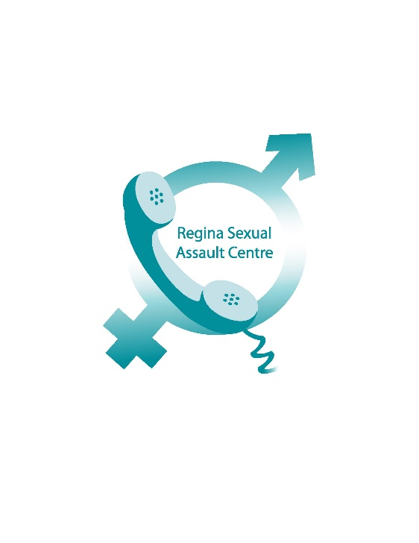

INTRODUCTION
The Regina Sexual Assault Centre (formerly known as the Regina Women’s Community Centre) was established in 1975, with a vision of promoting the equality of women within their own community.
The Centre changed its name in 2013, to better reflect the clients we serve, which include men, families and youth. It is overseen by a volunteer governance board and has three full time counsellors, one administrative assistant, a half time executive director and half time education coordinator. Additionally, a 24 hour crisis line is answered by trained volunteers.
Each year, the Centre sees over 200 new clients, provides approximately 1,200 counselling sessions and engages with over 20 partner agencies in the Regina area. The children’s education program delivers presentations to over 4,000 children each year in Regina schools and community-based organizations. The Centre’s crisis line receives approximately 270 calls per year.
The Regina Sexual Assault Centre is inviting tenders for the provision of fundraising services from fundraising professionals; including appropriately experienced companies and individuals.

OUR MISSION AND VISION
MISSION
We are an inclusive, non-profit organization of trained counsellors and advocates who are dedicated to helping reduce the trauma of inter-relationship violence and sexual assault.
VISION
To reduce the risk of abusive behaviour and sexual violence through education, prevention and support in our community.
VALUES
Confidential – Respectful – Inclusive – Compassionate – Professional – Qualified

STRATEGIC PRIORITIES
To fulfill the organization’s vision and mission, the following strategic priorities have been identified as key to our success:
- Our Valued Employees and Our Work – counselling staff provide qualified, trauma-informed care to any individual who has been impacted by sexual violence. All counselling staff have a Master’s education in either Social Work or Counselling Psychology. We have identified barriers to accessing services, such as language, childcare, transportation, culturally appropriate counselling, incarceration and personal schedules, and the Centre has been working at addressing these barriers.

- Community Focus and Outreach – Staff are engaged in public education, awareness and advocacy, including attendance at community events and public speaking. We have strong relationships in our community with police, health, social services and other counselling and support agencies. Our Kids on the Block children’s education program has been operating since 2015, has seen considerable success and is in the process of expanding outside of Regina to nearby communities.

CURRENT FUNDRAISING ARRANGEMENTS
The Centre receives over 75% of its funding from the Saskatchewan Ministry of Justice. Additional funding has been provided by the City of Regina, Community Initiatives Fund, Justice Canada and through a professional tele-fundraiser.
In order to reduce organizational risk, the Centre wishes to secure increased funding through a professional fundraiser (either a company or organization), who will engage with community residents, businesses and organizations, to drive additional funding to help us achieve our objectives.
WHAT WE WILL PROVIDE
We will provide an introduction to Centre staff, as well as information related to the history of the Centre, statistics, community partners and the work we do.
REQUIREMENTS
The Regina Sexual Assault Centre is seeking a professional fundraiser (individual or company) to increase the Centre’s income. The successful candidate will be expected to:
- Present a professional image of the Centre.
- Operate ethically and in adherence to our Values, in support of our Mission and Vision.
- Network with suitable businesses and individuals.
- Build a database of donating bodies, which will become the property of the Centre.
- Adhere to all municipal, provincial and federal laws and regulations related to fundraising.
- Suggest other revenue streams and, where appropriate and agreed upon, develop those streams.
The successful candidate will be expected to work with the Board and management and this may involve attendance at relevant Board or committee meetings as required.
TERMS OF CONTRACT
The successful candidate will be a service provider, not an employee, of the Centre and will be expected to meet their own employment costs. The initial contract will run up to two years and is subject to ongoing six month reviews by Board and management. If the successful candidate does not achieve agreed-upon targets, the Centre reserves the right to terminate the contract with a 30 day notice and payment of outstanding fees, but without future payments being due.
Candidates should include their standard contract terms and conditions with their tenders.
TENDERS
The tender should include the budget required to provide the service, or the percentage of donations retained and three references from customers with similar fundraising requirements. Candidates/companies should provide the full name and address, nature of the business, point of contact and telephone number in the references.
The Centre is not obliged to accept any of the tenders and is not bound to accept the lowest bid. All information that is provided, or you become privy to, in the tenders will be held as confidential and not disclosed without prior written permission from the fundraiser or the Centre’s Executive Director.
Four copies of the tender should be submitted by mail, or by hand, to:
c/o Lisa Miller
Regina Sexual Assault Centre
1830 MacKay Street
Regina, SK
S4N 6R4

Deadline for submitting tenders is 4:30 p.m., December 20, 2017. Shortlisted candidates will be asked to provide a brief presentation to the Board and management at an agreed upon date in January 2018.

