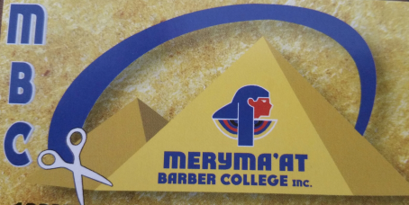
Admissions Application
Date ________/_________/__________
PERSONAL INFORMATION
Full Name: _______________ ________________
Email Address: ____________________________
Address: ______________________________________________ City:_________________________
State: ____________ Zip Code: ___________________________
Phone Number: ________________________
Date Of Birth: ___________________________ Gender: ________________Marital Status___________
How Did You Hear About Us? _______________________________
Why did you choose Meryma’at Barber College?

FUTURE PLANS:
Are you interested in full or part time?

How do you plan to utilize a professional barber license?

What are your hobbies?

DISCIPLANRY HISTORY

Have you ever been convicted of a felony?
If yes, explain:

HIGHER EDUCATION:
College: yes or no
If yes, where?

Any other professional licenses?

Have you ever attended any other barber college? Yes or no

EMPLOYMENT
Are you employed?
Yes or No
If yes, where? And how often?

We will need a copy of your work schedule

Will your employer accommodate your education

Certification
I certify that all information in this application and any supplements or supporting documents is true and/or original. This information has been submitted honestly and that this document and any addendum are the property of Meryma’at Barber College and will be returned to me at my request. I understand that I may be subject to a range of possible disciplinary actions, including admission denial, expulsion, should the information I have certified be false

I certify: YES NO
- I acknowledge that I have reviewed the application instructions. I understand that all offers of admission are contingent upon receipt of all required documentation by Meryma’at barber college as well as the Ohio State Cosmetology and Barber Board.
- Acknowledge
YES NO

- SIGNATURE
By typing your full name in the space below and checking the appropriate box, as the applicant, this denotes your signature and verifies that you are the applicant named on this application.
- I AM THE APPLICANT
YES NO
- Signature :

