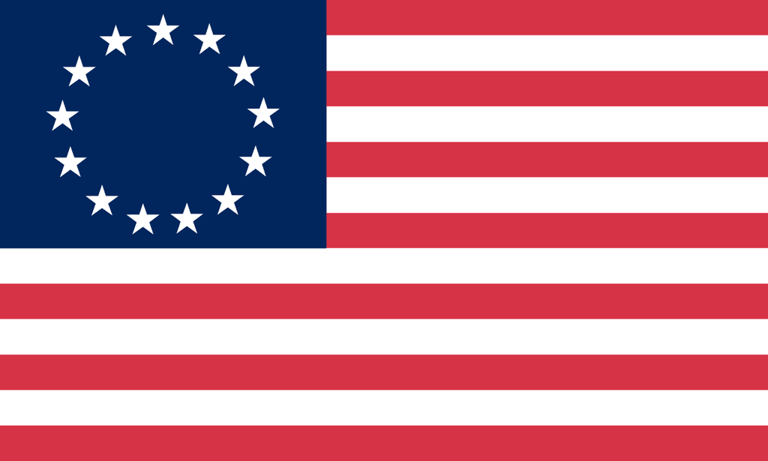U.S. History with Mr. Brown Name _______________________________ Period _____
French and Indian War Book Preview Ch5.3

Directions: Find the answers to the following questions in Chapter 5 sections 1 and 2 only of the text book beginning on page 130.

1) What were the two main French settlements that were along the St. Charles River in Canada?

2) What kind of French priests wanted to convert natives to Christianity?

3) The _____________ trade created economic and military alliances between the Europeans and their Native American trading partners.

4) The seeds of the French and Indian War were planted when British fur traders began moving into the _____________ River valley.

5) The French and Indian War became part of a larger world wide struggle known as the __________ Years War.

6) What General did the British send to the Colonies with 2100 soldiers to fight the French and Indians?

7) On July 9th near Fort Duquesne, Braddock and Washington’s troops were ambushed and slaughtered by_____________________________.

8) What city was the capital of New France?

9) The Battle of ______________________ was the turning point of the French and Indian.

10) What was the name of the treaty that ended the French and Indian War?

11) The Proclamation of 1763 forbade colonists from settling west of the ______________________ Mountains.

