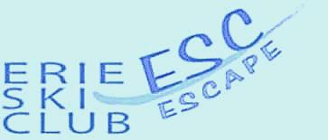 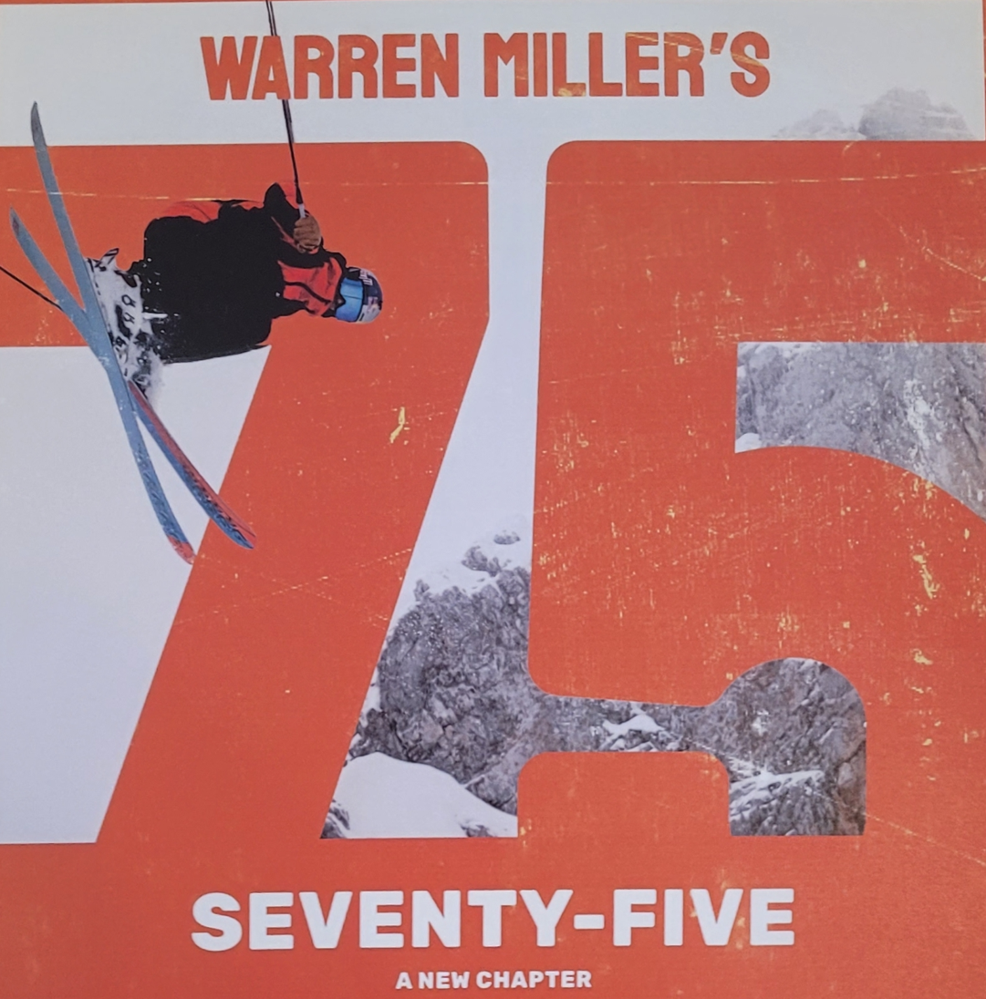

**PRESENTED BY THE ERIE SKI CLUB**

**The Erie Ski Club is presenting Warren Miller’s 75th annual adventure ski film**

**Don’t miss seeing WARREN MILLER 75 on Saturday, November 23, 2024 at the Tom Ridge Environmental Center 301 Peninsula Drive Erie, Pa.**

**All profits will again benefit the Lounsbury Adaptive Ski Program**

**The film features amazing skiers and snowboarders on adventures throughout the United States and worldwide! It is a must-see film for anyone looking to get fired up for ski season!**

**With their paid admission all attendees receive BOGO coupons to Peek'n Peak, Mount Pleasant, and Holiday Valley as well as other ski related discount coupons and a chance to win great door prizes and an entry for national prizes from Warren Miller. Noting, in 2017 a local person entered the contest at the Erie show, and won the top prize of a ski vacation to the famous resort Ski Portillo, in Chile’, South America, after their entry was drawn later from world-wide entries!**

**Doors open at 6:00 PM with many mountain sports related vendors anxious to show you their latest products and services.**

**The Lounsbury Adaptive Ski Program provides lessons on specialized equipment to persons with virtually all disabilities, both physical and cognitive. Each student is instructed individually with full focus their ability, rather than their disability.**

**For more information or to pre-purchase tickets, contact Paul (Vince) Ross** [**vpross56@gmail.com**](mailto:vpross56@gmail.com) **or call 814-873-8287**

**Tickets can also be purchased at the door and are again $15**

**Be at the Tom Ridge Center on Nov 23 2024**