RESOLUTION NO: 22 – 981

A RESOLUTION IMPLEMENTING OHIO REVISED CODE SECTIONS 3735.65 THROUGH 3735.70,
ESTABLISHING AND DESCRIBING THE BOUNDARIES OF THE VILLAGE OF RUSSELLS POINT COMMUNITY REINVESTMENT AREA IN THE VILLAGE OF RUSSELLS POINT, LOGAN COUNTY, OHIO,
DESIGNATING A HOUSING OFFICER TO ADMINISTER THE PROGRAM, CREATING A COMMUNITY REINVESTMENT HOUSING COUNCIL,
AND
CREATING A TAX INCENTIVE REVIEW COUNCIL
AND
DECLARING AN EMERGENCY

WHEREAS, this Council desires to pursue all reasonable and legitimate incentive measures to assist and encourage development in specific areas of the Village of Russells Point that have not enjoyed reinvestment in remodeling or new construction; and

WHEREAS, as required by R.C. § 3735.66, the following exhibits are attached:

Exhibit A, “COMMUNITY REINVESTMENT AREA HOUSING SURVEY FOR THE VILLAGE OF RUSSELLS POINT,” a copy of which is on file with the Zoning Officer, has been prepared for the area to be included in the proposed Community Reinvestment Area

Exhibit B, “COMMUNITY REINVESTMENT AREA BOUNDRY FOR THE VILLAGE OF RUSSELLS POINT,” a copy of which is on file with the Zoning Officer, has been prepared for the area to be included in the proposed Community Reinvestment Area

Exhibit C, “COMMUNITY REINVESTMENT AREA MAP FOR THE VILLAGE OF RUSSELLS POINT,” a copy of which is on file with the Zoning Officer, has been prepared for the area to be included in the proposed Community Reinvestment Area; and

WHEREAS, the survey shows the facts and conditions relating to existing housing and commercial facilities and undeveloped areas in the area, including, amount other things, evidence of deterioration and lack of new construction or repair or rehabilitation of substantial portions of the area; and

WHEREAS, the maintenance of existing structures and construction of new structures in the area would serve to encourage economic stability, maintain real property values, and generate new employment opportunities; and

WHEREAS, the remodeling of existing structures or the construction of new structures in the area constitutes a public purpose for which real property exemptions may be granted.

NOW, THEREFORE, BE IT RESOLVED, by the Council of the Village of Russells Point, Ohio:

SECTION 1: Designation of Area.

That based upon the survey and on this Council’s own knowledge of the facts and conditions existing in the area, this Council hereby finds and determines that the area, to be designated as the Village of Russells Point Community Reinvestment Area, constitutes an area in which housing facilities or structures of historical significance are located, and in which new construction and repair of existing facilities has been discouraged.

SECTION 2: Establishment of Area: Eligible Properties.
That pursuant to R.C. § 3735.66, the area known as Village of Russells Point Community Reinvestment Area is hereby established as described and depicted in the attached Exhibits A and B and C. The Community Reinvestment Area boundaries are established in Exhibit B and the area is approximately depicted on the map in Exhibit C.

Only residential, commercial and/or industrial properties consistent with the applicable zoning regulations within the designated Community Reinvestment Area will be eligible to apply for exemptions under the program established through this Resolution. This proposal is a public/private partnership intended to promote and expand conforming uses in the designated area. As part of the project, the Village intends to undertake supporting public improvements in the designated area as fiscal resources permit.
SECTION 3: Tax Exemptions in the Area.

That within the Community Reinvestment Area, the percentage of any tax exemptions on the increase in the assessed valuation resulting from improvements to commercial or industrial real property and the term of those exemptions shall be negotiated on a case-by-case basis in advance of construction or remodeling occurring and shall be anywhere from 50% to 100% according to the rules outlined in the R.C. § 3765.67. The results of the negotiation of any exception authorized by this Resolution will be set forth in writing in a Community Reinvestment Area Agreement pursuant to and in compliance with R.C. § 3735.671 and the written Community Reinvestment Area Agreement will be approved by Council. For residential property, a tax exemption on the increase in the assessed valuation resulting from the improvements as described in R.C. § 3735.67 shall be granted upon application by the property owner and certification thereof by the designated Housing Officer. Abatement on any increase in assessed valuation is as determined by the Logan County Auditor.

- Commercial or Industrial Facilities: The period of exemption to be negotiated and approved as required by R.C. § 3735.671 shall be as follows:

- Up to, and including, fifteen years, and up to, and including, 100% for the remodeling of existing commercial and industrial facilities and upon which the cost of remodeling is at least $5,000, as described in R.C. § 3735.67, the term and percentage of which shall be negotiated on a case-by-case basis in advance of remodeling occurring.

- Up to, and including fifteen years, and up to, and including, 100% for the construction of new commercial or industrial facilities, the term and percentage of which shall be negotiated on a case-by-case basis in advance of construction occurring.

If commercial or industrial remodeling qualifies for an exemption, during the period of the exception, the applicable percentage of the increase in assessed value of the structure shall be exempt from real property taxation. If commercial or industrial new construction qualifies for an exemption, during the period of the exemption the applicable percentage of the assessed value of the structure shall be exempted from real property taxation.

- Residential Real Property. Within the area, the percentage of any tax exemptions on the increase in the assessed valuation resulting from improvements to or construction of residential real property, as defined in the Ohio Building Code, shall be as follows:

- Five years, for the remodeling of every residential dwelling unit containing not more than two housing units and upon which the cost of remodeling is at least $2,500, as described in R.C. § 3735.67, and with such exemption being 50% for each of the five years, or until such time in which the owner sells or otherwise transfers the property. The exemption shall not transfer to any subsequent property owner.

- Five years, for the remodeling of every residential dwelling unit containing more than two housing units and upon which the cost of remodeling is at least $5,000, as described in R.C. § 3735.67, and with such exemption being 50% for each of the five years, or until such time in which the owner sells or otherwise transfers the property. The exemption shall not transfer to any subsequent property owner.

- Five years, for the construction of dwellings, as described in R.C. § 3735.67, with such exemption being 50% for each of the five years, or until such time in which the owner sells or otherwise transfers the property. The exemption shall not transfer to any subsequent property owner.
Residential exemptions may be granted only for remodeling or new construction commenced after the effective date of this Resolution. If remodeling qualifies for an exemption, during the period of the exemption, the applicable percentage of the increase in assessed value of the remodeling or new construction shall be exempt from real property taxation. If new construction qualifies for an exemption, during the period of the exemption the exempted percentage of the structure shall not be considered to be an improvement on the land on which it is located for the purpose of real property taxation.

SECTION 4: Designation of Housing Officer and Authorization to Serve Notices.

That to administer and implement the provisions of this Resolution, the Zoning Officer is designated as the Housing Officer as described in R.C. §§ 3735.65 through 3735.70 and is authorized and directed to comply with all state laws, including but not limited to:

- Take all actions required of the Housing Officer under those sections; and

- Submit annual reports to the Director of the Ohio Development Services Agency on behalf of this Council in accordance with R.C. § 3735.672.

The Housing Officer is hereby authorized to serve any and all notices on behalf of this Council that may be required under R.C. §§ 3735.671, 3735.673 and 5709.83 in connection with consideration, approval or entering into any agreements under R.C. § 3735.671.

SECTION 5: Application Fee.

That all commercial and industrial projects in the area are required to comply with the State of Ohio application fee requirements of R.C. § 3735.672 (C). The Village hereby waives the annual monitoring fee set forth in R.C. § 3735.671(D).

SECTION 6: Tax Incentive Review Council.

That a Tax Incentive Review Council shall be established pursuant to R.C. § 5709.85 and shall consist of three representatives appointed by the Board of County Commissioners, two representatives of the municipal corporation, appointed by the Village Mayor with Council concurrence, the county auditor or designee and a representative of each affected Board of Education. At least two members must be residents of the Village of Russells Point. The Tax Incentive Review Council shall review annually the compliance of all agreements involving the granting of exemptions for commercial or industrial real property improvements under R.C. § 3735.671 and make written recommendations to this Council as to continuing, modifying or terminating said agreement based upon the performance of the agreement.

SECTION 7: Community Reinvestment Area Housing Council.

That a “Community Reinvestment Area Housing Council” shall be created, consisting of two members appointed by the Village Mayor, two members appointed by the Village Council and one member appointed by the Village Planning Commission. The majority of the members shall then appoint two additional members who shall be residents within the area. Terms of the members of the Council shall be for three years. An unexpired term resulting from a vacancy in the Council shall be filled in the same manner as the initial appointment was made.

The Community Reinvestment Area Housing Council shall:

- Make an annual inspection of the properties within the area for which an exemption has been granted; and

- Hear all appeals in accordance with R.C. § 3735.70; and

- On or before the thirty-first day of March each year, the Community Reinvestment Area Housing Council shall submit to the director of development a written status report summarizing the activities and projects for which an exemption has been granted in that area.

SECTION 8: Authorization to Petition the Director of Development.

That the Mayor is hereby directed and authorized to petition the Ohio Development Services Agency Director to confirm the findings contained in this Resolution in accordance with R.C. § 3735.66.

SECTION 9: Notice to County Auditor and Publication of Resolution.

That the Clerk of Council, being directed and authorized by Council in accordance with Ohio law, shall serve a certified copy of this Resolution on the Logan County Auditor and shall cause a complete copy of the body of this Resolution to be published in a newspaper of general circulation in the Village once a week for two consecutive weeks immediately following its passage.

SECTION 10: Reservation to Re-evaluate.

That the Council reserves the right to re-evaluate the designation of the Community Reinvestment Area annually, at which time the Council may direct the Housing Officer not to accept any new applications for exemptions as described in R.C. § 3735.67.

SECTION 11: Open Meeting.

That the Council hereby finds and determines that all formal actions relative to the passage of this Resolution were taken in an open meeting of this Council, that all deliberations of this Council and of its committees, if any, which resulted in formal action were taken in meetings open to the public, in full compliance with the applicable legal requirements, including R.C. § 121.22.

SECTION 12: Effective Date.

That this Resolution shall take effect and be in force from and after the earliest period allowed by law and upon confirmation by the Ohio Development Services Agency Director of the findings in this Resolution.

SECTION 13: Emergency Declaration.

That this Resolution is hereby declared to be an emergency measure necessary for the immediate preservation of the public peace, health and safety in the Village of Russells Point in order to implement the Community Reinvestment program. This resolution shall go into immediate effect provided that it receives two thirds vote of all members of Village Council on the earliest date allowed by law.

Passed in Council this 16th day of May, 2022.

__________________________________
Robin Reames, Mayor

ATTEST: ___________________________
Jeff Weidner, Fiscal Officer

APPROVED:

Approved as to form this ____day of _____, 2022.

_________________________
Lynnette Dinkler, Esq.
Village Solicitor

EXHIBIT A

COMMUNITY
REINVESTMENT AREA
Housing Survey

Village of Russells Point

April 15, 2022

Purpose and Scope
This report contains a housing survey for the proposed Village of Russells Point Community Reinvestment Area (CRA) in the Village of Russells Point, Ohio. The proposed CRA for the Village of Russells Point contains all of census tract 42; the proposed CRA will be for the entire Village of Russells Point. The purpose of this report is to determine whether the area shown on Attachment E-1 should be designated as a Community Reinvestment Area as defined in the Ohio Revised Code: Sections 3735.65 – 70.
Russells Point struggles to encourage new residential, commercial, and industrial development and has an existing housing stock that is lacking re-investment. While other communities within the Indian Lake Region have experienced population growth and an investment in residential, commercial, and industrial development, a lack of investment in new development exists village wide in Russells Point.
The data provided in the Village of Russells Point Community Reinvestment Area Housing Survey supports the establishment of a CRA by documenting that the area is “one in which housing structures or structures of historical significance area located and new housing construction and repair of existing facilities or structures are discouraged” per Ohio Revised Code Section 3735 (B). The designation of the proposed CRA aims to encourage the revitalization of existing housing stock and the development of new housing.

General Demographic Characteristics
Unless noted, statistical information in this housing survey is based on U.S. Census data estimates and American Community Housing Surveys.
- Population:
Russells Point continues to see a decline in population over the past two decades. The most recent 2020 Census indicates a population decline of 5.1%. Below is historic population information:

Year | Population | Growth/Reduction
2020 | 1320 | (5.1%)
2010 | 1391 | (14.1%)
2000 | 1619 | 7.6%
1990 | 1504 | 30.1%

- Person In Poverty
The Village of Russells Point has seen a decline in population that are below 125% poverty. From 2012 (405) to 2019 (383), the village experienced a decline of 5.43%.

- LMI Percentage
According to the Department of Housing and Urban Development in 2006, 50.39% of households were Low to Moderate Income (LMI). In 2015 58.4% of households were LMI. According to the American Community Survey, this was an increase of 8.01%.

General Housing Characteristics
- Historic Structure:
The Village of Russells Point has one Ohio Historical Marker located at the former site of the Sandy Beach Amusement Park now known as the Russells Point Harbor and Sandy Beach Bridge area.
Nicknamed, “Ohio’s Million Dollar Playground” or “Atlantic City of the Midwest”, the Sandy Beach Amusement Park opened on May 29, 1924. It featured a 200-foot-long roller coaster, a board walk and the Minnewawa Dance Hall. Great names of the “Big Band” era performed and thousands of people came to listen and dance. The development of larger theme parks such as Cedar Point and King’s Island caused the crowds to diminish. The park closed in the early 1970’s. The Sandy Beach Bridge is the lone remnant. In 2015 the Indian Lake Historical Society with the help of many donors that are honored and memorialized in the new harbor path restored the steel arch.
Source: Ohio History Center, Remarkable Ohio.

- Age of Housing Stock
The Village of Russells Point has an aging housing stock. According to the 2019 American Community Survey 5-year Estimates:

- 209 or 18.8% of the existing housing units were built prior to 1939.
- 296 or 26.7% of the existing housing units were built between 1940 and 1969
- 521 or 46.9% of the existing housing units were built between 1970 and 1999
- 84 or 7.6% of the existing housing units were built between 2000 and 2009
- There have been no housing units built after 2009.

- Vacancy and Occupancy Rates
According to the 2019 American Community Survey 5-year estimates there was 1,110 housing units in the Village of Russells Point. The occupancy and vacancy rates are unique as the Indian Lake Region is a resort area.
- 29.6% (328 units) are owner-occupied
- 25% (278 units) are renter occupied
- 36.6% (406 units) are seasonal, recreational, or occasional use
- 8.8% (98 units) are vacant

- Value of Owner-Occupied Housing
The Village of Russells Point has seen an increase in the value of owner-occupied housing. The 2019 American Community Survey 5-Year Estimates report that of the 328 owner-occupied units:
- 16.2% of the units were valued under $50,000
- 41.2% of the units were valued between $50,000 and $99,999
- 24.7% of the units were valued between $100,000 and $149,999
- The remaining 17.9% of the units were valued $150,000 or higher
- The average median value was $88,400

- Condition of Housing
The entire proposed CRA Area contains housing that needs considerable repair. Vacant properties and aging structures continue to deter new investment. While the demand for housing exists, buyers are seeking structures that require little to no improvements, and a location that is not in the vicinity of blighted and unmaintained structures.
As indicated in this study, 45.5% of the houses were built before 1970, many of which were primarily built as resort weekend cottages and fishing cabins on small parcels of land. Over the years, many of these structures were insulated and enlarged to provide for year-round living. In 1959 zoning regulations were adopted by council regulating set-backs to help eliminate compact residential areas. As a result, razing of many structures would not allow for new construction as the lots are non-conforming to current zoning regulations.
The Village conducted a visual survey throughout the area to determine the current condition of structures within the proposed reinvestment area. Structures were classified as:
Good – Structures needing little to no repairs. Fair – Structures in need of minor repair. Poor – Structures in need of major repair or dilapidated.

The table below lists the percentages of structures that fell into each of these categories:
CONDITION | PERCENTAGE OF STRUCTURES
Good | 72%
Fair | 21%
Poor | 7%

Appendix A of this study contains further information and photos in relation to the condition of housing.

- Zoning
The existing Zoning Districts within the Village of Russells Point and the proposed Community Reinvestment Area allow for residential, commercial, and industrial development. Zoning districts are as follows:

U-1
R-1 Low Density Residential
R-2 Medium Density Residential
R-3 High Density Residential
B-1 Service Business
B-2 Local Business
B-3 Central Business
M-1 Light Manufacturing
M-2 Major Manufacturing & Processing

Attachment E-3 shows the current zoning district map for the Village of Russells Point.

Appendix A

On April 6, 2022 an additional survey was completed to further document the distress and condition of structures within the proposed CRA. The descriptions and photos below show that the area is one in which housing facilities appear to need repair or upgrading, and appear to lack recent investments of remodeling or repair. The following units were surveyed:

108 Fairview Ave.
House is vacant. Unit needs sided or painted. Front door and steps need replaced. Remnants of tarp hanging on east side. Foundation in need of repair.

120 Elliott Rd.
Structure is vacant. Windows and gutters need replaced. Missing siding and facia coverings. Roof over garage needs replaced.

134 W. Wilgus
Structure is vacant. Windows need replaced. Gutters are missing. Siding is missing in areas. Exposed untreated eaves and facia boards. The yard contains debris, overgrown landscaping, and trees need trimmed or removed.

301 W. Main St.
Yard contains debris and shrubs need trimmed or removed.

406 Miami Ave.
Structure needs to be sided. Screen door needs replaced. Yard has no landscaping and contains debris.

422 Buckeye Ave.
House and garage need new siding. Gutters are damaged and windows need replace. Roof is patched in several places.

141 Burkhart Ave.
Roof and gutters need replaced. Windows need repaired or replaced.

145 Bristol Circle
Structure needs new roof and facia. Windows and window molding needs replaced. Lean to has exposed rotting wood. Yard is unkept.

154 W. Wilgus
Siding missing in various areas and needs treated or painted. Trees are overgrown and need to be trimmed or removed.

246 Park Ave.
This unit is vacant and windows and doors have been boarded up. Exposed attic siding and facia in need of repair.
348 Westview
Unit has missing facia coverings and windows need repair or replacement. Decking boards appear to be rotting and unsafe.

410 Center Ave.
Roof, siding, and door needs to be replaced.

410 Lake Ave.
Roof, windows and gutters need replaced.

736 S. Orchard Isl. Rd.
Unit is vacant. Roof needs repair. Windows, siding and doors need replaced.

445 Maple St.
Roof and facia need replaced. Exposed rotting wood around windows and structure needs painted.

533 Grand Ave.
Unit is vacant and doors have been boarded up. Windows need replaced. Porch needs replaced. Debris in the yard. Unit appears to have foundation issues as well.

630 Grand Ave. (2 photos)
Unit is vacant. Roof, gutters and windows need replaced. Soffit and facia needs repaired and/or replaced. Concrete block walls need repair and repainted. Concrete patio needs replaced.

447 E. Main St.
This is a vacant business structure. Windows and doors are boarded up. Roof is tarped in various areas and needs to be replaced. Building needs painted.

802 Miami Ave.
Siding is missing in areas. Windows need replaced. Porch, planter and wood posts need removed. Yard contains some debris and landscaping in unkept.

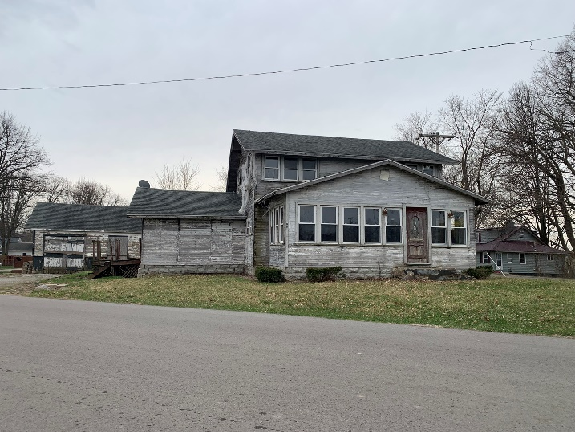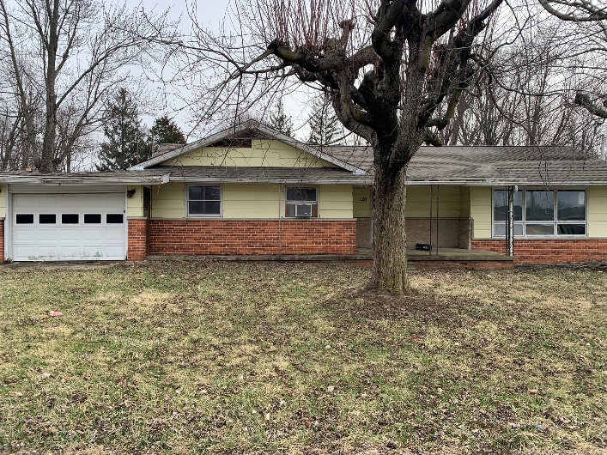
108 Fairview Ave. 120 Elliott Rd.

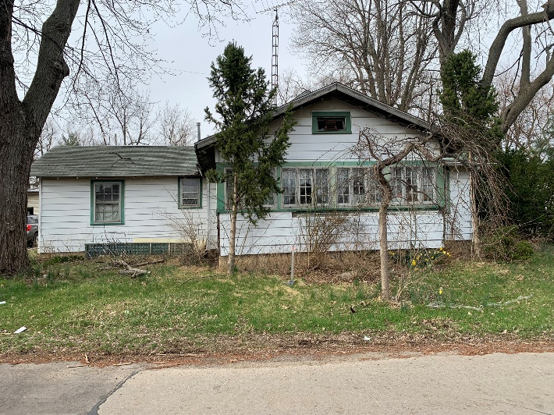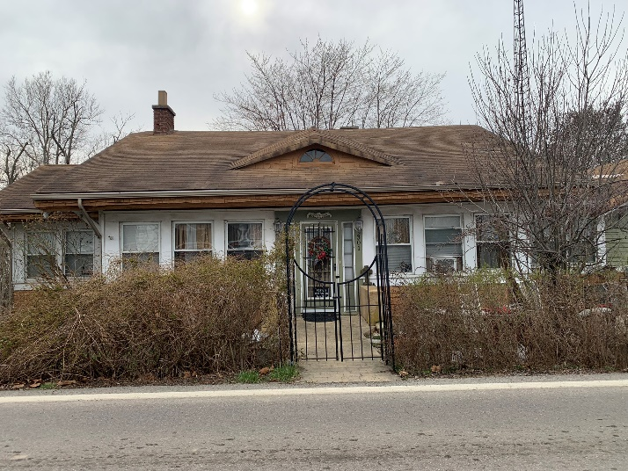
134 W. Wilgus 301 W. Main St.

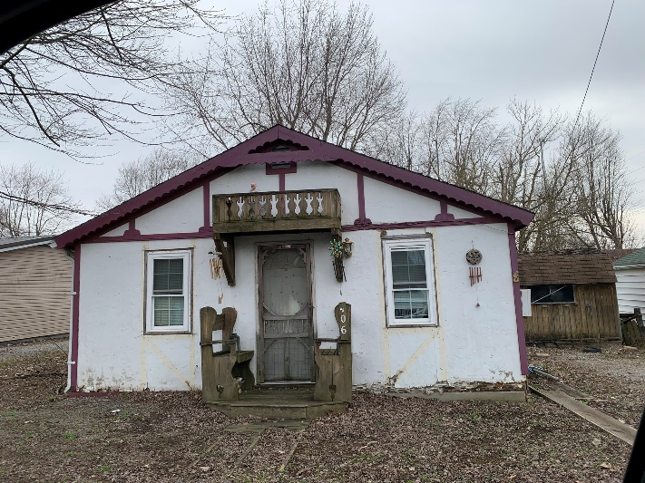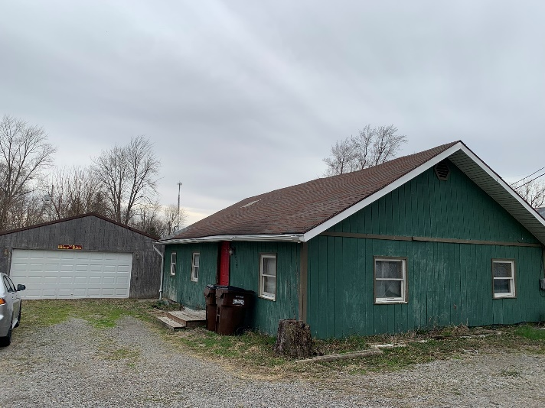
406 Miami Ave. 422 Buckeye Ave.

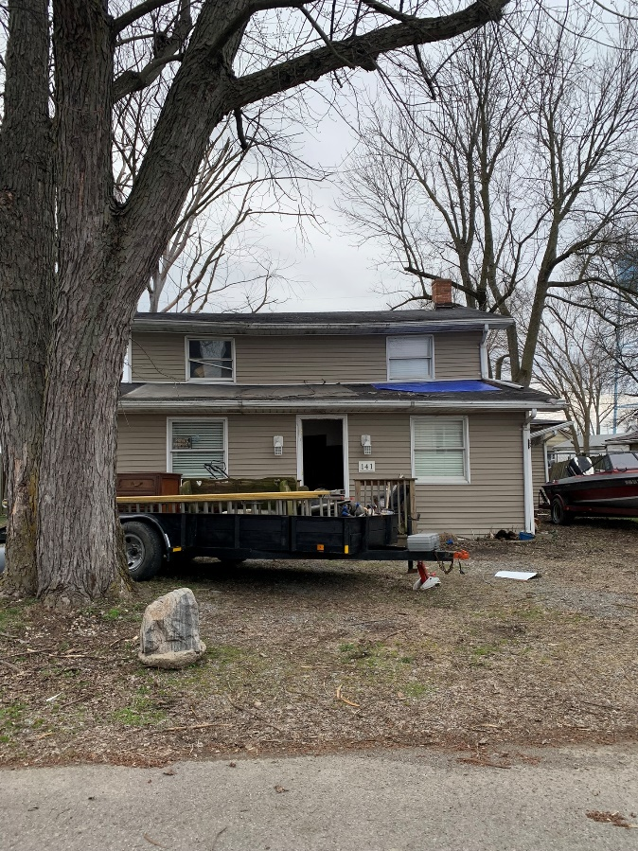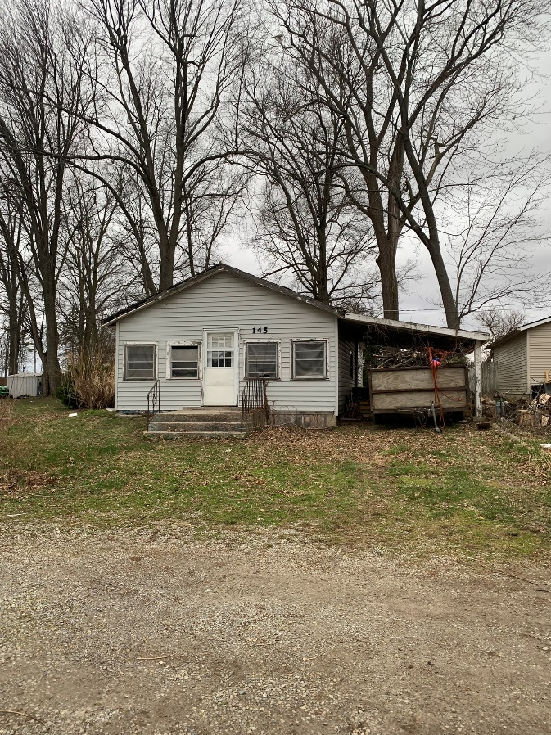
141 Burkhart 145 Bristol Circle

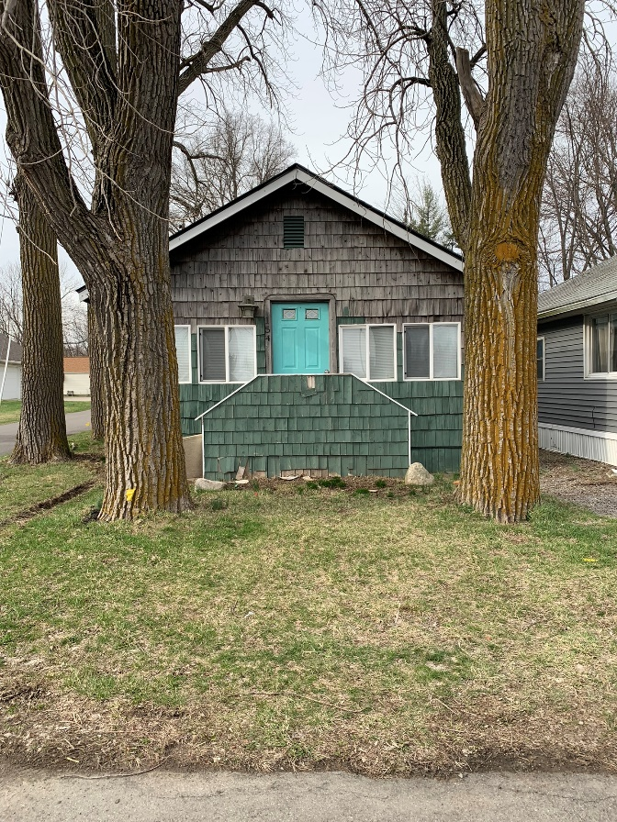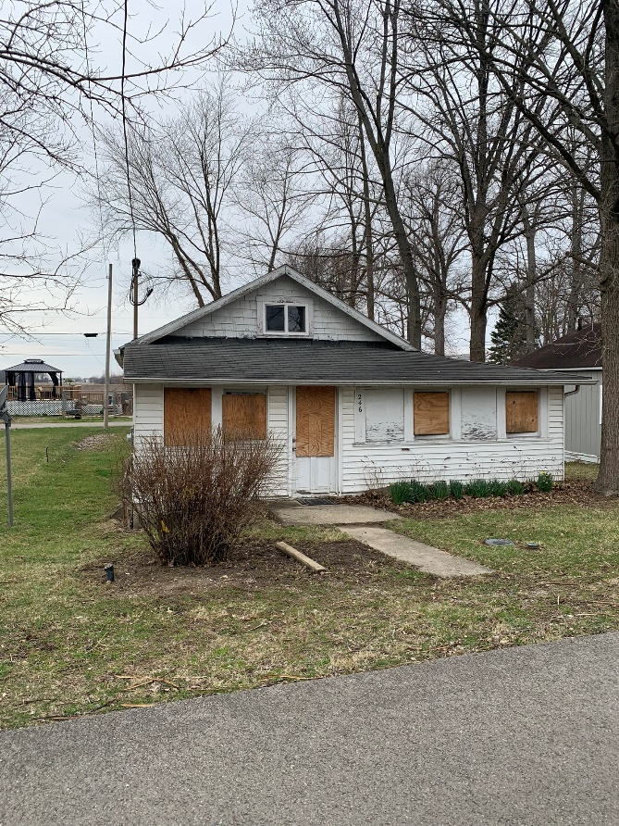
154 W. Wilgus 246 Park Ave.

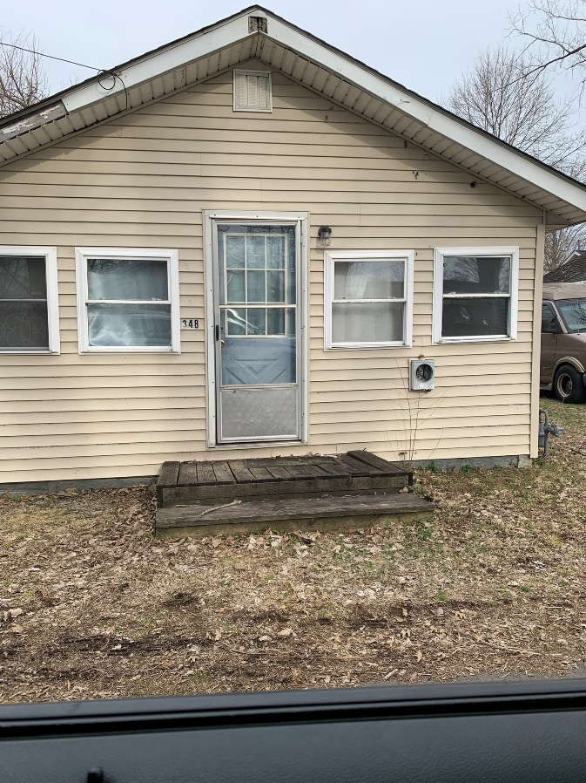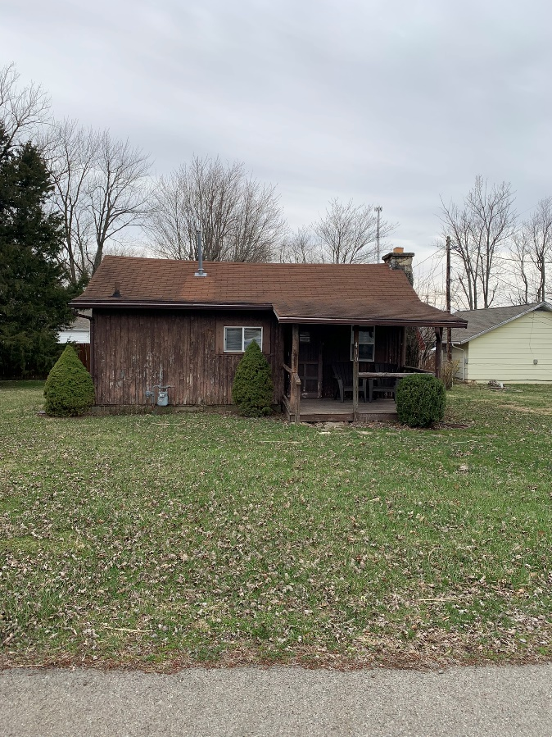
348 Westview 410 Center St.

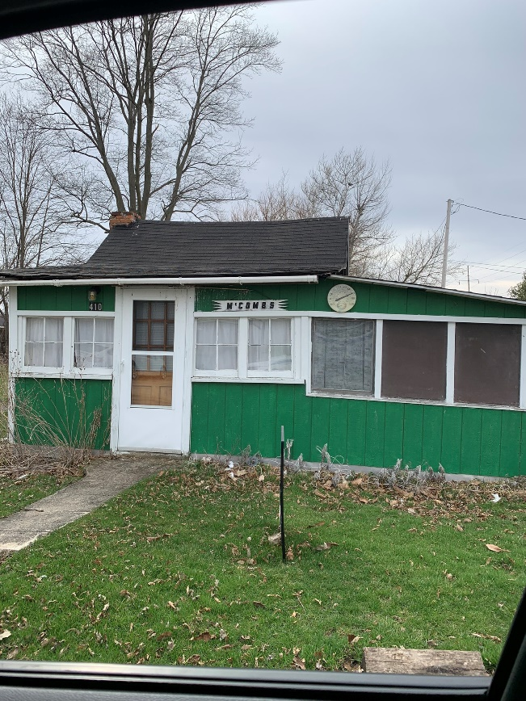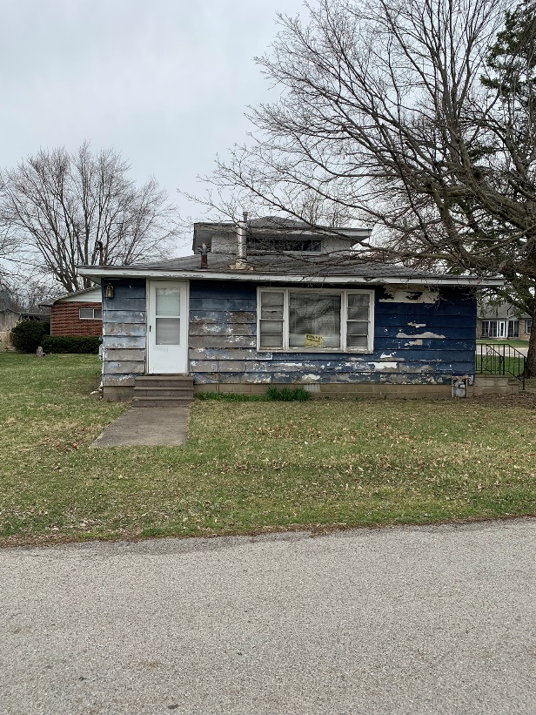
410 Lake Ave. 736 S. Orchard Isl. Road

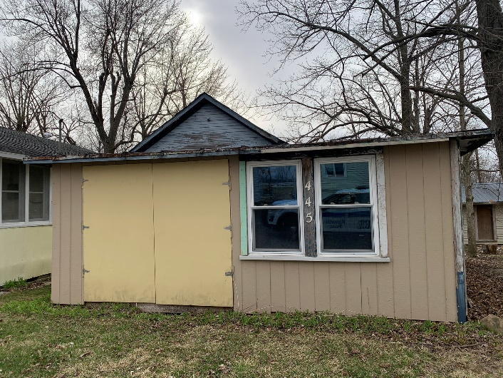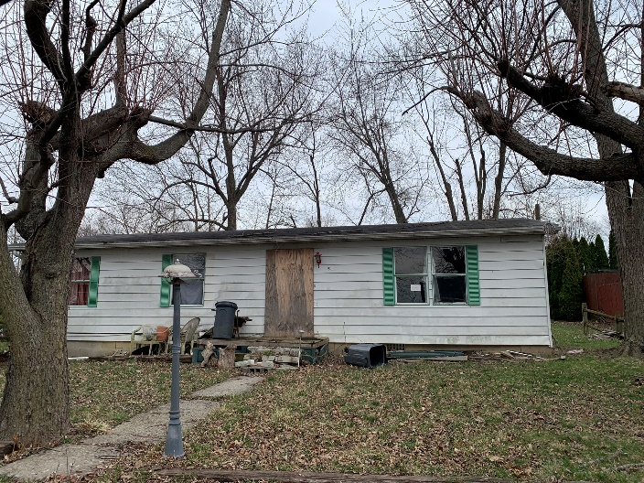
445 Maple 533 Grand

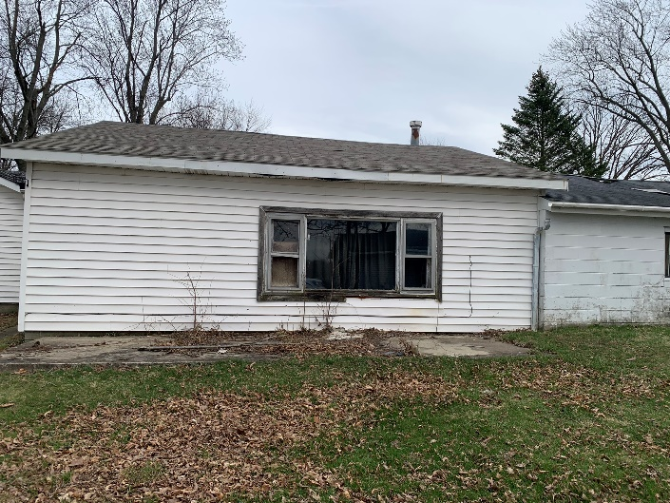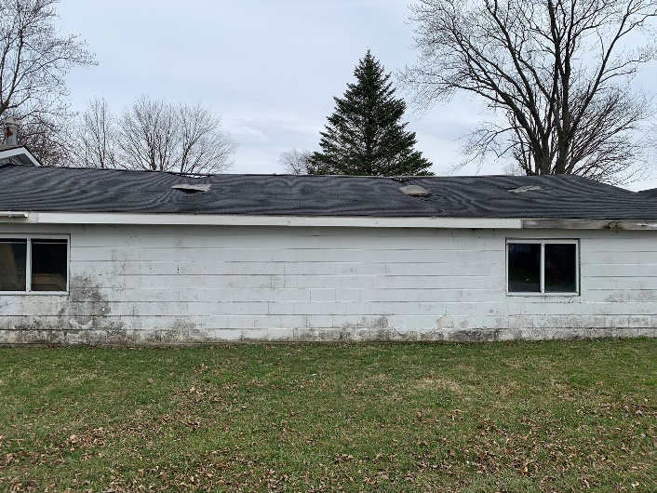
630 Grand Ave. (1) 630 Grand Ave. (2)

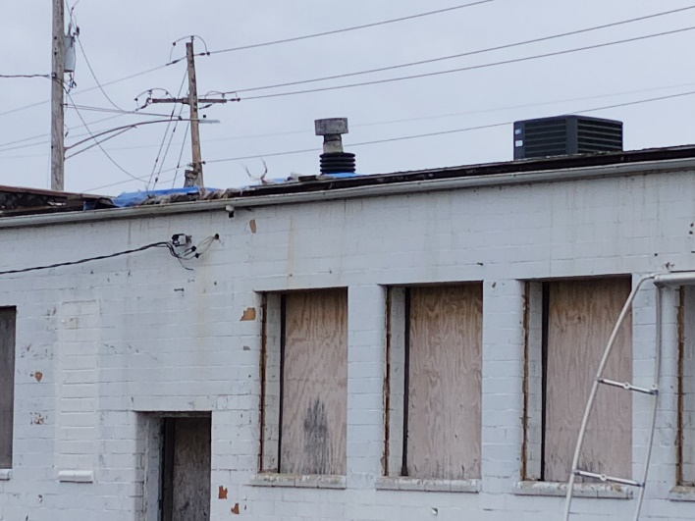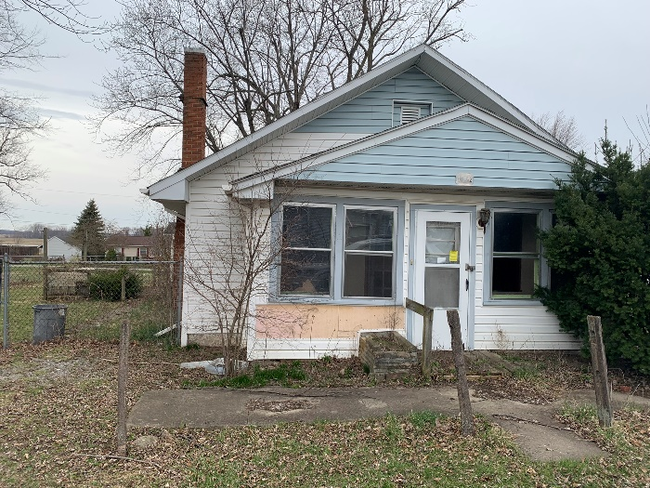
477 E. Main St. 802 Miami Ave

Exhibit B
Description of Proposed CRA Boundary

Northern Boundary:

Starting at the northwest corner of parcel number 52-031-08-06-003-000 traveling east along Main Street to parcel 52-032-05-02-001-000, then southeast to and including parcel 52-032-06-28-006-000. This also includes parcel numbers 52-032-05-13-002-000; 52-032-06-28-001-000; and 52-032-06-28-005-000.

Eastern Boundary:

Starting at the north east corporation limit of parcel number 52-032-06-28-006-000 traveling southwest along west side of SR 708 (Orchard Isl. Rd.) to parcel number 52-032-10-04-002-000; west to include parcel number 52-032-10-04-001-000. Then from parcel number 52-032-10-04-003-004 south to St. Rt. 366 including parcels 52-032-10-05-045-000 and 52-032-10-05-046-000 from where the corporation limit travels southwest to the northeast corner of parcel number 52-032-10-08-005-000; then southwest on the south side of U.S. Rt. 33 to the west side of the Great Miami River to the southernmost part of parcel number 52-032-00-00-016-001.

Southern Boundary:

Starting at the southernmost point of parcel number 52-032-00-00-016-001 heading west along the southern border of parcel number 52-032-00-00-016-000 to St. Rt. 708; then north along St. Rt. 708 to the southern border of parcel number 52-032-13-33-007-001.

Western Boundary:

Starting at the southwest corner of parcel number 52-032-13-33-007-001 heading due north to Elliott Rd. (Twp. Rd. 52) including parcels 52-032-13-33-001-006; 52-032-13-33-001-002; and all parcels to the west side of Lake Avenue. From the southeast corner of parcel number 52-032-09-14-001-000 heading west to the southwest corner of parcel 52-032-00-00-006-000 to the northwest corner of parcel 52-032-00-00-005-000; head east along the northern border of parcel 52-032-00-00-005-000 to the northwest corner of parcel number 52-032-00-00-004-000. From the southeastern point of parcel number 52-032-00-00-002-001 head west to the southwest corner of parcel 52-032-00-00-002-002, then head north along west side to U.S. Rt. 33 (excluding parcel number 51-032-00-00-003-000). At the southernmost point of parcel number 52-032-05-07-012-000 heading northwest along U.S. Rt. 33 to the southwest point of parcel number 52-032-05-07-012-001, then north to Main Street including parcel numbers 52-031-08-06-005-000, 52-031-08-06-004-000, and 52-031-08-06-003-000.

Excluded Properties:

Though surrounded by the incorporated limits of the Village of Russells Point, parcel number 51-032-00-00-003-000 is not incorporated and does not form a part of this CRA.

Exhibit C
Reinvestment Area Map

