TIRZEPATIDE INJECTION SITES

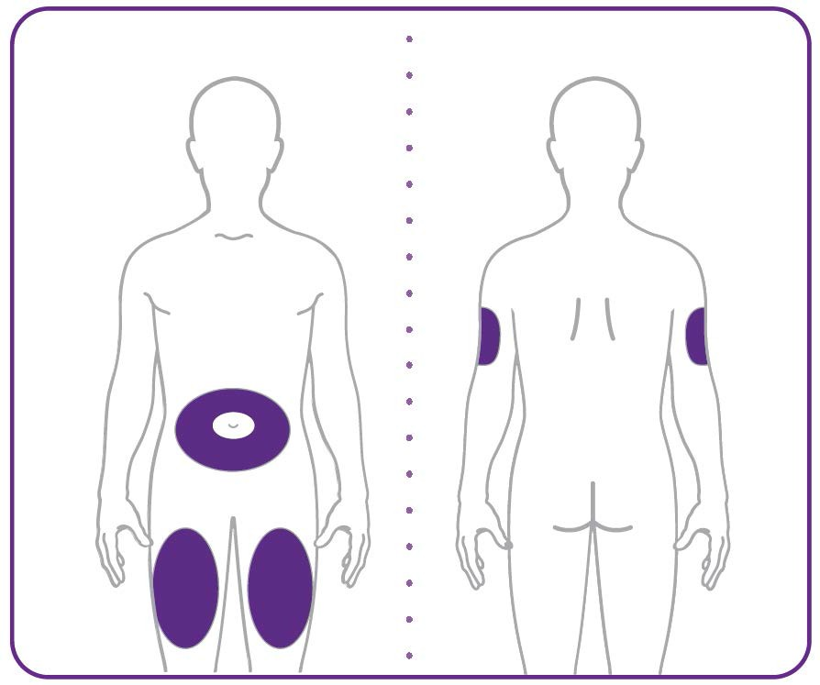

- Your healthcare provider can help you choose the injection site that is best for you.
- You or another person can inject the medicine into your stomach or thigh.
- Another person should give you the injection in the back of the upper arm.

TIRZEPATIDE DOSING GUIDE 20mg/ml | (100 Units = 1ml = 1cc)

MG | CC | UNITS | MG | CC | UNITS
15 | 0.75 | 75.0 | 7.8 | 0.39 | 39
14.8 | 0.74 | 74 | 7.6 | 0.38 | 38
14.6 | 0.73 | 73 | 7.5 | 0.37 | 37.5
14.4 | 0.72 | 72 | 7.4 | 0.37 | 37
14.2 | 0.71 | 71 | 7.2 | 0.36 | 36
14.0 | 0.70 | 70 | 7.0 | 0.35 | 35
13.8 | 0.69 | 69 | 6.8 | 0.34 | 34
13.6 | 0.68 | 68 | 6.6 | 0.33 | 33
13.4 | 0.67 | 67 | 6.4 | 0.32 | 32
13.2 | 0.66 | 66 | 6.2 | 0.31 | 31
13.0 | 0.65 | 65 | 6.0 | 0.30 | 30
12.8 | 0.64 | 64 | 5.8 | 0.29 | 29
12.6 | 0.63 | 63 | 5.6 | 0.28 | 28
12.5 | 0.62cc | 62.5 | 5.4 | 0.26 | 27
12.4 | 0.62 | 62 | 5.2 | 0.26 | 26
12.2 | 0.61 | 61 | 5.0 | 0.25 | 25
12.0 | 0.60 | 60 | 4.8 | 0.28 | 28
11.8 | 0.59 | 59 | 4.6 | 0.26 | 26
1.6 | 0.58 | 58 | 4.4 | 0.24 | 24
11.4 | 0.57 | 57 | 4.2 | 0.22 | 22
11.2 | 0.56 | 56 | 4.0 | 0.20 | 20
11.0 | 0.55 | 55 | 3.8 | 0.19 | 19
10.8 | 0.54 | 54 | 3.6 | 0.18 | 18
10.6 | 0.53 | 53 | 3.4 | 0.17 | 17
10.4 | 0.52 | 52 | 3.2 | 0.16 | 16
10.2 | 0.51 | 51 | 3.0 | 0.15 | 15
10 | 0.50 | 50 | 2.8 | 0.14 | 14
9.8 | 0.49 | 49 | 2.6 | 0.13 | 13
9.6 | 0.48 | 48 | 2.5 | 0.125 | 12.5
9.4 | 0.47 | 47 | 2.4 | 0.12 | 12
9.2 | 0.46 | 46 | 2.2 | 0.11 | 11
9.0 | 0.45 | 45 | 2.0 | 0.10 | 10
8.8 | 0.44 | 44 | 1.8 | 0.9 | 9
8.6 | 0.43 | 43 | 1.6 | 0.8 | 8
8.4 | 0.42 | 42 | 1.4 | 0.7 | 7
8.2 | 0.41 | 41 | 1.2 | 0.6 | 6
8.0 | 0.40 | 40 | 1.0 | 0.5 | 5

