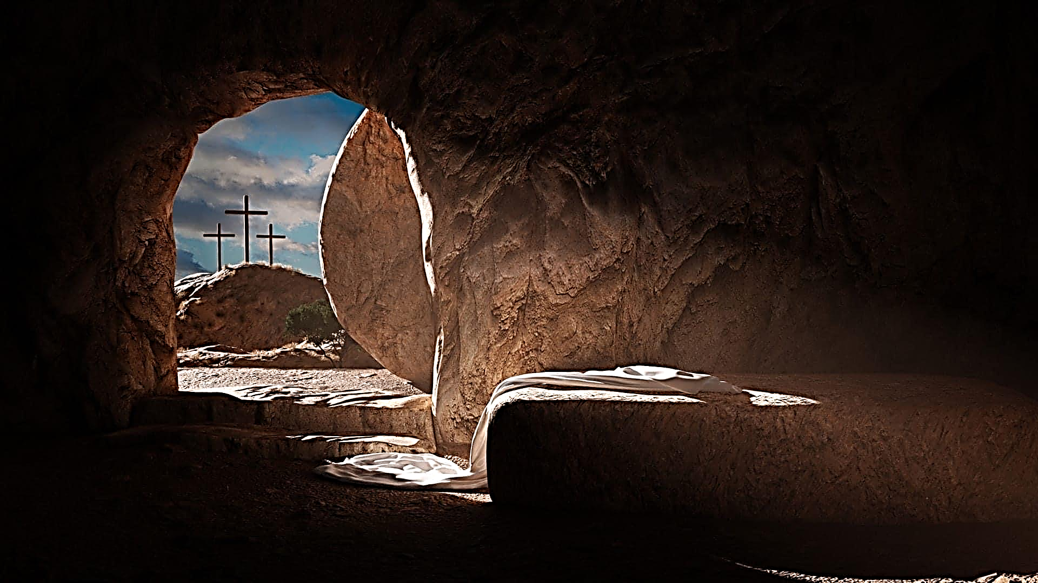

March 31, 2024 – Easter Sunday

Carson City United Methodist Church

March 31, 2024, EASTER Sunday
Call to Worship
Greeting/Announcements
L: He is Risen!!
P: He is Risen indeed!
L: The darkness has been overcome. Jesus Christ has defeated our greatest fear, death.
P: He is risen from the dead, and he is Lord of all, ALLELUIA!
L: Let us shout our praises to the Lord!
P: For God has given us eternal life! ALLELUIA! AMEN.
L: Therefore now, there is no condemnation for those who believe in Christ Jesus.
P: For the Spirit of God who raised Jesus from the dead is living in us, God who raised Christ from the dead will also give life to our mortal bodies because of his Spirit that lives in us.

*HYMN: Christ the Lord is Risen Today UMH 402
*Contemporary Song: You Saved the Day (Phillips, Craig, and Dean)
Opening Prayer: (unison)
Heavenly Father, as we celebrate the resurrection of your Son, our Savior Jesus Christ. Remind us Darkness does not win. Death is not victorious. Christ has Risen! Because Christ lives we too live. Let us truly be disciples of Jesus Christ as we live lives that witness to who you are. We ask these things in the name of our Risen Lord, Jesus Christ. AMEN.

Offering
Doxology UMH 95
Offertory Prayer
Sharing of our Joys and Concerns
Call to Prayer: Turn Your Eyes Upon Jesus UMH349
Pastoral Prayer/ Lord’s Prayer
GOSPEL: LUKE 24:1-12
OLD TESTAMENT: ISAIAH 53:10-12
EPISTLE LESSON: ACTS 2:25-28
Children sing: O Vicrtory
Children’s Church
HYMN: Easter People, Raise Your Voices UMH 304

MESSAGE

*HYMN: Up From the Grave He Arose UMH 322
Benediction

Carson City UMC – Announcements & Upcoming Events:
As a courtesy to others please silence or shut off cellphones
======================================================
Coffee Invite: Join us for coffee after Sun Worship in our Hall.
======================================================
Mom Group update: Starting in April 2024 Mom Group will meet the first Thursday of every month instead of weekly.
======================================================
Sweet Treat Sunday: After worship services on Sun, Apr 21st. Bring your favorite treat and enjoy some fun and fellowship.
======================================================
Noisy Sunday: there will be a loose change offering collected to raise funds for the VBS program on Sun, Apr 28 during Worship Services. By collecting loose change, we can see the power of several little bits making up a whole lot. Let’s make some noise for Jesus.
======================================================
Vacation Bible School: Join the VBS team on Friday, April 5th in the Fellowship Hall for a fun time of making decorations for this summer’s VBS, SCUBA!

The dates for 2024 are Sun, Jul 14th through Thu, Jul 18th from 6:00 pm to 8:30 pm. There are helper sign-up sheets in our Lobby.
======================================================

Tea with Friends: Mon, May 6, 12:30 pm in CCUMC Hall. Potluck. Event is free. Reservations required.
Call Walthagaye @ 989-640-0238.
======================================================
VBS Bake Sale - May 12th
before, during, & after services.

======================================================

Serving & Supporting - CCUMC
Church Council Chair - Phil Krantz 616-734-2341
SPRC Chair - Ed Osborne 989-640-3039
Finance Chair – Aaron Esch 989-235-1200
Board of Trustees Chair – Joshua Severson 815-878-8925
Children’s Ministry – Roberta Kile 616-255-1275
Audio/Video: Pat Monroe 989-285-4134

Prayer Request
Dillan Abell, Cheryl Meyers, Amorena Newman-Wojciakowski, Miranda Selleck, Kathy Hodges, Hank Severson, Bill Heyden, Bob Conley, Beth Gardner, Carol Elliott, Leo McMillan

Nursery Schedule - CCUMC
3/31 Open but no supervision 4/7 Lauren Monroe
4/14 Arianna Esch 4/21 Alex Krantz

For CCUMC

Weekly Attendance | Weekly  Giving | Date
44 | $1308.00 | 03/10
50 | $1978.00 | 03/17
75 | $1003.00 | 03/24

Our Church in Ministry This Week - CCUMC
Mon: P.T. Class 6:30 pm
Tue & Thu: COA Meal 10:00 am–2:00 pm
Tue: A.R.K. 3:00-5:00 pm

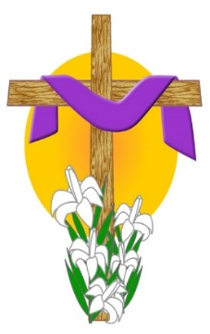

THE BEAUTIFUL EASTER FLOWERS PURCHASED
IN HONOR, OR IN MEMORY OF A LOVED ONE

Roberta Kile in memory of
Esther Mumby & Wally Kile

Larry & Elaine Nalett in memory of
Mother & Dad Nalett & sister Gloria

Judy Evitts in memory of
Bob & Virgina Brooks, John & Ruth Brooks, Bill & Ethel Durbin

Paula Flotka in memory of
George & Gertie

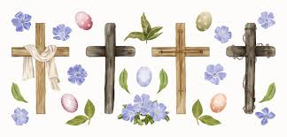

Carson City United Methodist Church
Location: 119 East Elm St., Carson City, MI
Mail: PO Box 298, Carson City, MI 48811
Phone: 989-584-3797 Email: carsoncityumc@gmail.com
Website: carsoncityumc.com
Sunday Worship Service: 10:30 am
Office Hours: Monday-Thursday, 9:00 am-12:00 pm
After hours by appointment
Pastor: Ian McDonald 906-322-5318
Administrative Assistant: Bonnie Seaman 989-763-1674

Weekly Sunday Bulletin now available on our website
at www.carsoncityumc.com

“Risen Jesus, thank You for coming and dying on the cross that I might have life eternal. I worship You”

CCUMC Mission Statement
Disciples of JESUS CHRIST who are LOVED
by God, LOVING God, LOVING Others,
and SERVING this World.

