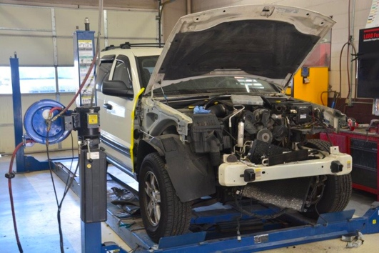

# Program Description

# Special Features

Leadership and work-based learning opportunities available.

A custom paint class is also part of this course.

The Collision Repair program is designed for student interested in auto collision as a career choice. The program curriculum includes Auto Collision Repair and Refinishing, I-Car Live, and various power points and DVDs that will emphasize skills for entry-level jobs including safety, basic repair techniques, paint safety, undercoat/topcoat systems, HVLP spray gun technology, estimating, PDR, and detailing. The instructor and program are ASE / NATEF certified.

The advanced level is designed for students to receive actual hands-on instruction in the repair and refinishing of the automotive body. The students will use the skills they have learned in the previous year and will repair automobiles with the use of estimates and repair orders. The students will develop skills to enter the auto body industry as apprentices upon completion of Collision Repair.

Credits:

Cross credit with some academic courses (including 4th year related math, VPAA, math & science) may be available and will be reviewed on a case-by-case basis with each district’s counseling department.

Articulations:

* Washtenaw Community College
* Wayne County Community College District

Prerequisites:

* Junior status
* Grade of C or better and instructor approval to go on to the advanced level

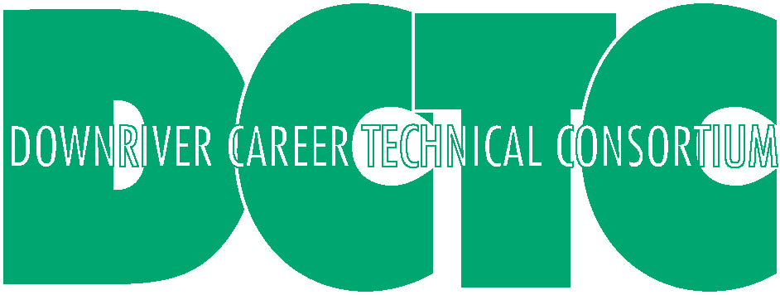

Huron

Collision Repair/

Auto Body

# Credits, Articulations & Prerequisites

John Nasarzewski, Director

22000 Gibraltar Road

Flat Rock, MI 48134

734-782-3194 – Phone

734-782-4175 – Fax

[www.dctc-cte.org](http://www.dctc-cte.org)



This program offers excellent career opportunities for both male and female students.