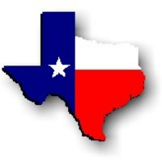Texas History with Mr. Brown Name ____________________ Period _____
Chapter 8.3 Review Life in Colonial Texas

Directions: Use your Study guide to answer the following questions
1) The settlers of colonial Texas were as ______________ as the routes they traveled.
2) Name the six countries mentioned in the study guide, that Texas immigrants came from:

3) A large population of __________________ settled in San Antonio de Béxar and along the Rio Grande.
4) _____________________________ founded one of the first Tejano colonies in Texas.
5) Other powerful Tejanos in colonial Texas were Erasmo, _____________________________, Lorenzo de Zavala, and José Antonio Navarro.
6) Name three African American Texans who helped in the fight for Texas independence:
7) Early Anglo settlers lived in ______________________ homes made from the timber found in the area.
8) The early Texas colonists made their beds from tree moss or _________________________.
9) The colonists faced the challenge of many diseases and few _____________________.
10) The colonists formed ____________________ to help defend their communities against Native attacks.
