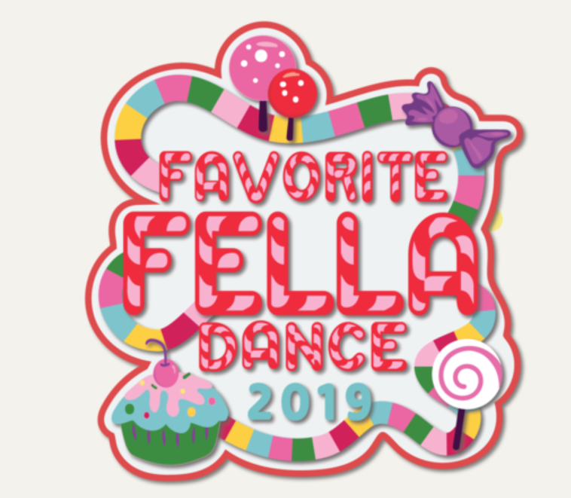
When: April 26th
Where: Valley Middle School
Time: 7pm to 9pm
Cost: $20 per GS/Favorite Fella additional GS $8.00
Come and dance, eat candy and desserts with your favorite fella!
- DJ
- Candy Corsages
- Desserts Galore
- Candy Bar
- Chocolate Fountain
- Patch (Pictured above)
- Applebee’s will have a special offer if the GS and fella decide to go to dinner beforehand (details to come)
- We will have a low fee snack bar for those of you who are sick of sugar and need a soda/water!
- Single Roses will also be available for purchase ($2)

Favorite Fella Dance Registration
Troop #:_______________________________________________
Name:________________________________________________
Fee $20 per GS/Favorite Fella $8 for additional GS
GS/FavFella Count_______ Additional GS_____
Single Rose # ($2 per rose)______
Patches (1per GS/FF)_____
Total:______________________________________________
Checks can be made to Troop 57591
Please mail payment to:
Jennifer Kane
992 Whitney Dr
Apple Valley MN 55124
Any questions please call 651-434-2976 or jjank825@yahoo.com
RSVP Deadline is April 12th 2019.

