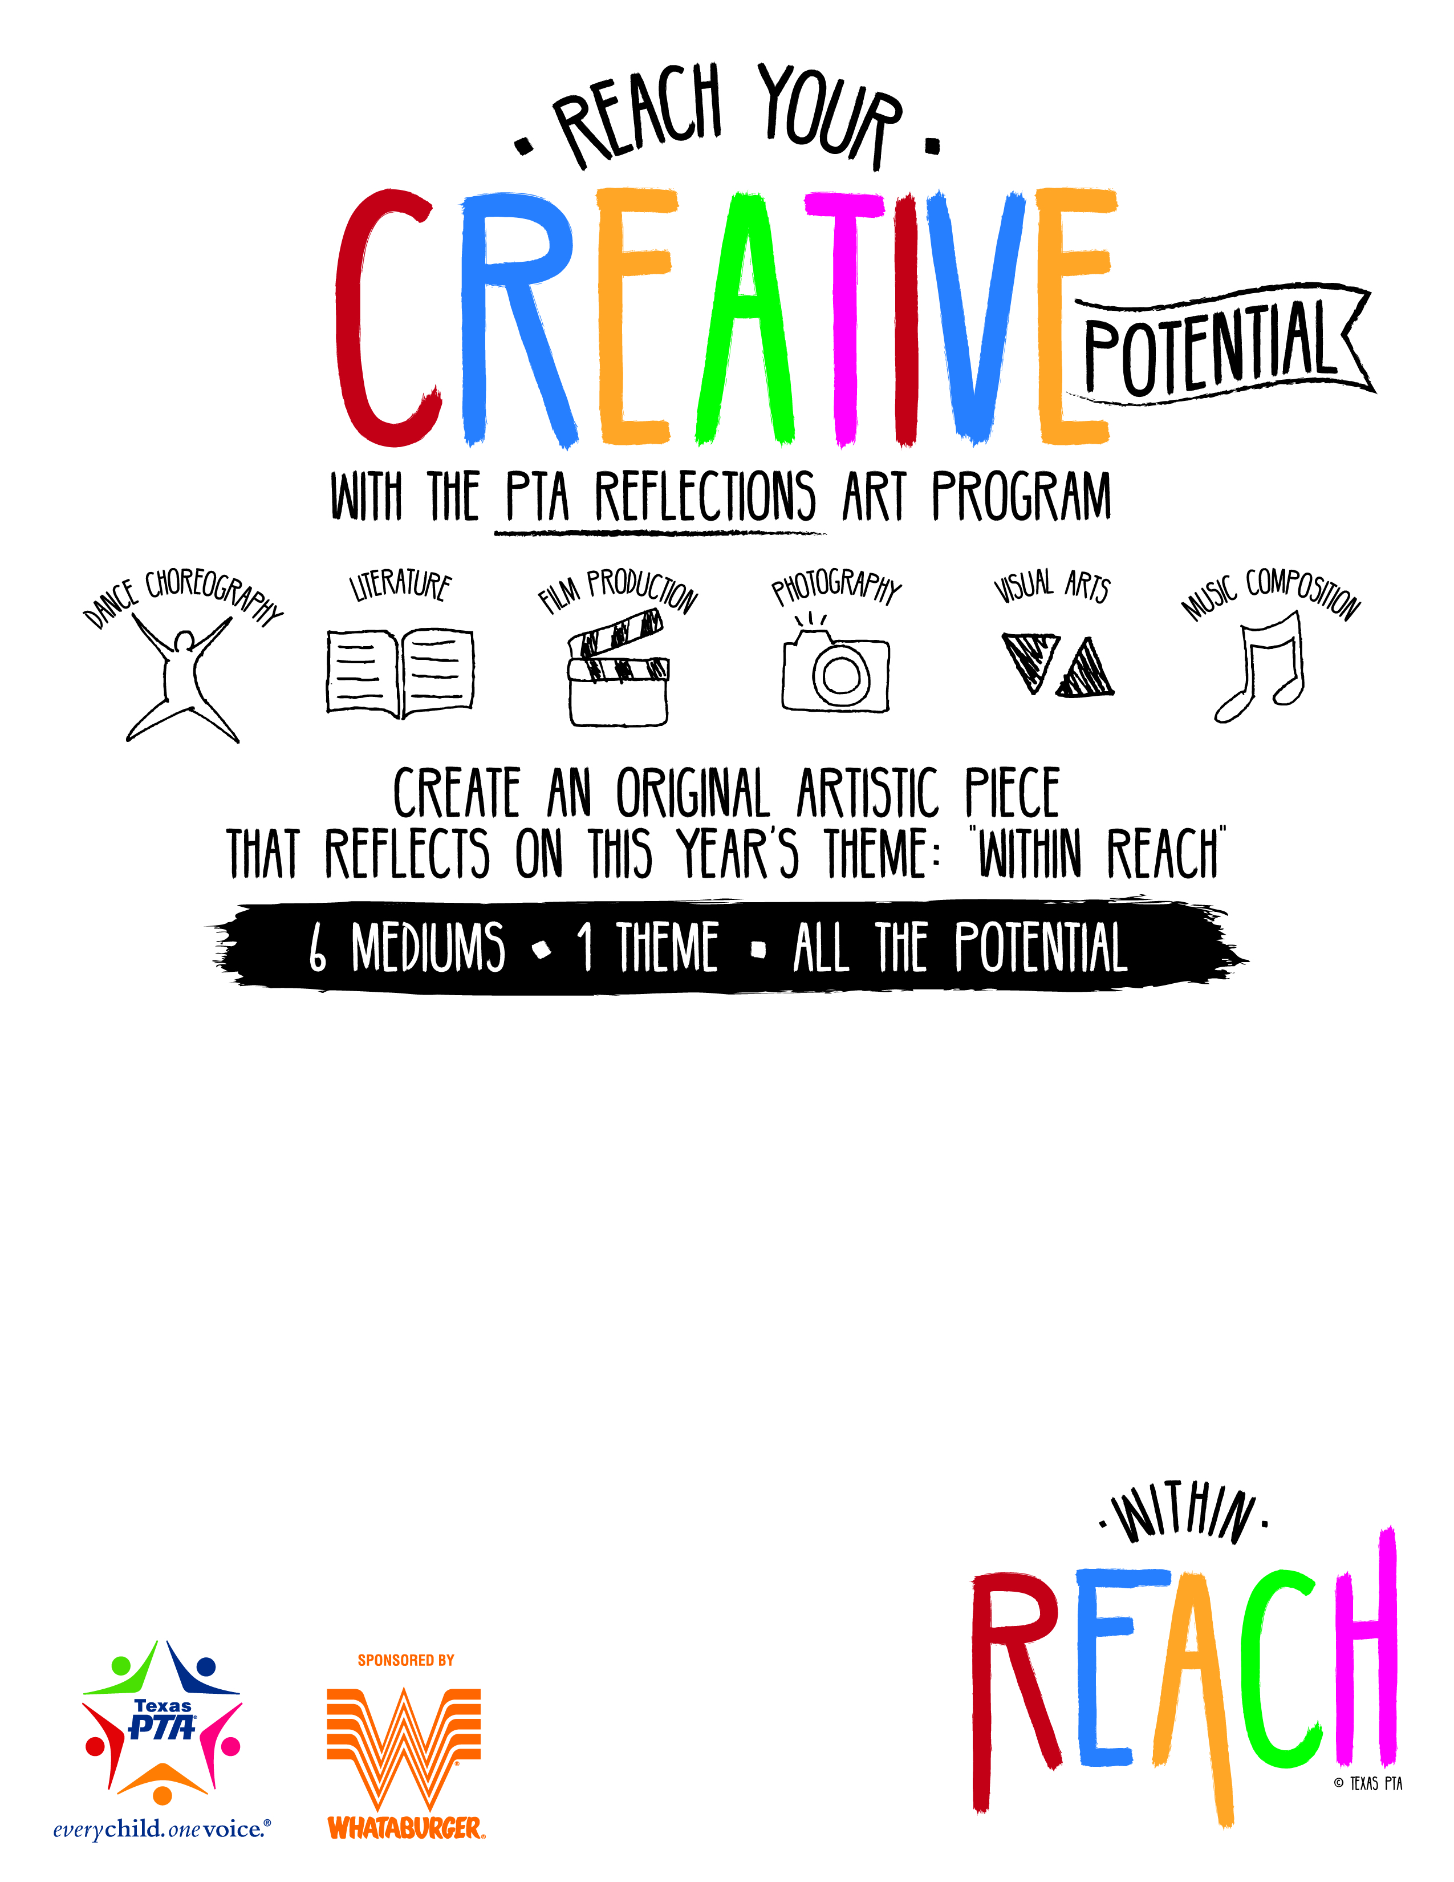
Insert your school’s Reflections program information here.

Suggestions to include;
- Where they can find the forms and guidelines
- Date the entries are due
- Location they should be submitted
- Timeline of events, (Judging, announcements, exhibit, ceremony, etc.)

The arts—and the National PTA Reflections program—support student success and serve as a valuable tool for building strong partnerships in your school community. Celebrate arts learning in your school community with Reflections.

