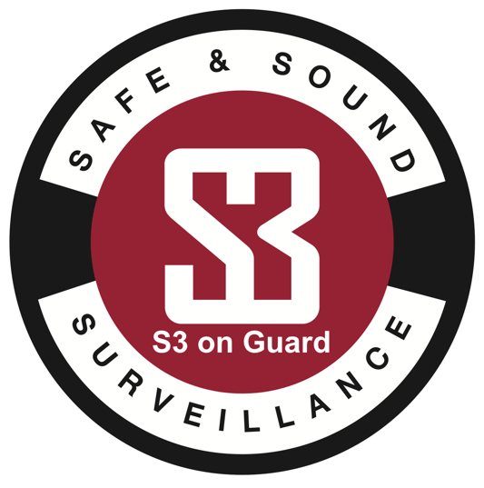
APPLICATION FOR EMPLOYMENT

Safe and Sound Surveillance

dba S3 on Guard

1427 South Main Street * Suite #204 * Greenville, MS 38701

601-456-1211 * info@safesoundsurv.com

GENERAL INFORMATION Application Date
Name (Last) |  | (First) |  |  | (Middle Initial) | Social Security No.  - -
Address |  | (City) |  | (State) | (Zip) | Home Telephone  ( ) -
Date of Birth (MM/DD/YYYY) | If under the age of 18, do you have a work permit? Yes No |  |  |  |  | Other Telephone  ( ) -
E-Mail Address |  |  | Are you legally entitled to work in the U.S.? Yes No
Do you possess a valid driver’s license? Yes No |  |  | Do you have security installation experience? Yes No
Driver’s License Number State |  |  | Are you willing to undergo a background check? Yes No
Have you ever been convicted of a crime, excluding misdemeanors and summary offenses, which has not been annulled, expunged or sealed by court? A yes response does not automatically disqualify your application. If yes, please explain. Yes No

POSITION
Position or Type of Employment Desired |  | Will Accept:  Part-Time  Full-Time  Temporary |  | Shift:  Day  Swing  Graveyard  Rotating
Are you able to perform the essential functions of the job you are applying for, with or without reasonable accommodation? Yes No
If hired, will you be able to work over-time? Yes No | Salary Desired |  | Date Available

EDUCATION AND TRAINING
High School Graduate or General Education (GED) Test Passed? Yes No
If no, list the highest grade completed
College, Business School, Military (Most recent first)
Name and Location | Dates  Attended  Month/Year | Credits Earned |  |  | Graduate | Degree  & Year | Major  or Subject
 |  | Quarterly or  Semester  Hours | Other  (Specify)
 | From |  |  |  | Yes  No
 | To
 | From |  |  |  | Yes  No
 | To
 | From |  |  |  | Yes  No
 | To
 | From |  |  |  | Yes  No
 | To
Occupational License, Certificate or Registration |  | Number |  | Where Issued |  |  | Expiration Date
Occupational License, Certificate or Registration |  | Number |  | Where Issued |  |  | Expiration Date

Languages Read, Written or Spoken Fluently Other Than English

VETERAN INFORMATION (Most recent)
Branch of Service | Date of Entry | Date of Discharge

SPECIAL SKILLS (List all pertinent skills and equipment that you can operate)
(Maximum 1000 characters)

WORK EXPERIENCE (Most Recent First) (Include voluntary work and military experience)
Employer | Telephone Number ( ) - |  | From (Month/Year)
Address
Job Title | Number Employees Supervised |  | To (Month/Year)
Specific Duties (Maximum 1000 characters)

 |  |  | Hours Per Week
 |  |  | Last Salary
 |  |  | Supervisor
Reason For Leaving |  | May We Contact This Employer? Yes No
Employer | Telephone Number ( ) - |  | From (Month/Year)
Address
Job Title | Number Employees Supervised |  | To (Month/Year)
Specific Duties (Maximum 1000 characters)

 |  |  | Hours Per Week
 |  |  | Last Salary
 |  |  | Supervisor
Reason For Leaving |  | May We Contact This Employer? Yes No
Employer | Telephone Number ( ) - |  | From (Month/Year)
Address
Job Title | Number Employees Supervised |  | To (Month/Year)
Specific Duties (Maximum 1000 characters)

 |  |  | Hours Per Week
 |  |  | Last Salary
 |  |  | Supervisor
Reason For Leaving |  | May We Contact This Employer? Yes No
Employer | Telephone Number ( ) - |  | From (Month/Year)
Address
Job Title | Number Employees Supervised |  | To (Month/Year)
Specific Duties (Maximum 1000 characters)

 |  |  | Hours Per Week
 |  |  | Last Salary
 |  |  | Supervisor
Reason For Leaving |  | May We Contact This Employer? Yes No

I certify the information contained in this application is true, correct, and complete. I understand that, if employed, false statements reported on this application may be considered sufficient cause for dismissal.

I hereby acknowledge that I have read and agree to the above statement.

Signature of Applicant  PRINTING YOUR NAME HERE GIVES YOUR ELECTRONIC SIGNATURE | Date

