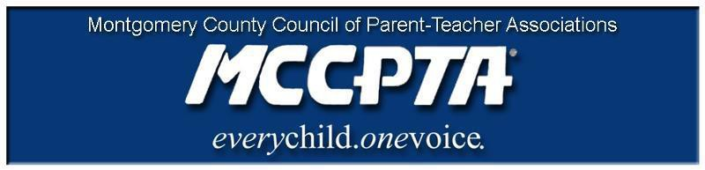
DELEGATES’ ASSEMBLY MEETING AGENDA
Tuesday, September 24, 2019
Carver Center Auditorium

7:00 pm Call to Order

7:00 pm Welcome and Introduction of Officers; Approval of Agenda & April 2019 Minutes

7:15 pm New Business

- MCCPTA Officer Elections
- Legislative Update
- Family Engagement Survey
- MDPTA Bylaws/Meeting
- Celebration of Excellence/MCCPTA Award Winners
- Event Updates
- Summer Area Meetings

Officer Reports Committee Updates Announcements Adjourn

