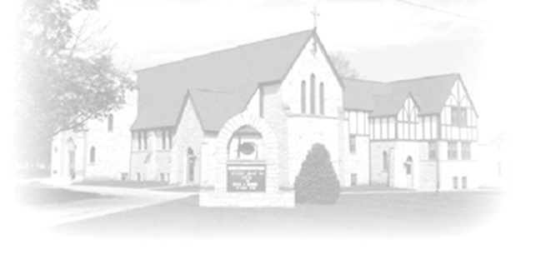 ***Trumpet Minor***

***October 5 & 6, 2024***

*Christ Lutheran Church*

**“A Place Where You are Always Welcome”**

**Services: Saturday 5:30 pm and Sunday 10:00 am**

**Sunday School: 9:00 am**

Office:  815-947-2033

Email: [christlutheran70@gmail.com](mailto:christlutheran70@gmail.com)

Ministers: ALL members of the congregation

***Pastor: Rev. Chrissy Salser*** [***chrissytherev@att.net***](mailto:chrissytherev@att.net) ***815-988-9450***

**ANNOUNCEMENTS**

**ONLINE GIVING:**  Your gift has a big impact on our ministries and those we serve. Scan this code or visit our website to give online today.

**SUNDAY SCHOOL:** Did you know that our Sunday school has more than one class? The kids start in the sanctuary and then move to the nursery, while the adult class meets in the “**Upper room”** (room outside the office). We study the scripture text for Sunday mornings. Come and See! **WE ARE ALSO IN NEED OF SUNDAY SCHOOL TEACHERS TO VOLUNTEER ONCE A MONTH FOR THE CHILDREN.**

**CONFIRMATION:** students in grades 7th & 8th grade and older those who would like to learn more about their faith will gather on the 2nd and 4th Sundays of the month from 11:30 – 1:30. First Class will be September 22. Please sign up online or talk to Pastor Chrissy.

**CONGREGATIONAL SURVEY:** we will then use these results as we look forward to where God may be leading us in the future here in Stockton. For questions ask Pastor Chrissy. **copies are available in back of the church for those who are not able/ comfortable using a computer.** [Christ Lutheran Church Congregation Survey Questions (google.com)](https://docs.google.com/forms/d/e/1FAIpQLScsPy9C0yu5exF8JiGw6wnbMl2ijZPdS3N56EmXFppoKGAg2Q/viewform?fbclid=IwZXh0bgNhZW0CMTEAAR1ODw1j9UBdIKW6qvE_oCQ1RNjOs4HI8k9ljs8bNbmgxMXcltKa0e8Tw88_aem_ATKp4_-UM2UZpXS4oa_6nUCBKJr7EvfFEtcteU99OvgN-HgxFXT7QoK-zOfNU4VAvVx7WtmzL8k8xLt0CeTz7Umi)

**BIBLE STUDY:** starting on Wednesdays at 9 am, we will meet in the narthex weekly to study the scripture readings for the upcoming Sunday. Come for a chance to explore the word together and pray over hose on our prayer list. This will meet every Wednesday unless otherwise noted. Please contact Pr Chrissy if you have any questions.

**WELCA:** will be sponsoring an outing on Thursday October 17th to visit the Jo Daviess Transit and Jo Daviess Workshop in Galena, followed by lunch at a restaurant in Galena. Please sign up in the back of the church.

**Upcoming Events**

* Saturday, October 5- 5:30 pm Worship
* Sunday, October 6- 9 am Sunday School for All ages
* Sunday, October 6 Worship 10:00 am
* October 9- 9 am Bible Study
* October 10- 10 am WELCA ANNUAL Meeting at Bottle Shed
* October 12- Autumn fest at LOMC 50th Anniversary
* October 12- 10 am Dusty Allen (Luke) Baptism
* October 12- 5:30 Worship
* October 13- 9 am Sunday School
* October 13- 10 am Worship
* October 13- 11:30-1:30 Confirmation Class
* October 13- 2pm Aleta Lawer’s 90th Birthday party at Massbach Ridge Winery
* October 15- 7 pm 4h Fellowship Hall
* October 16- 7pm Church Council
* October 17- WELCA trip to Galena
* October 26- Confirmation class in Rockford
* October 31- Trunk or Treat Church parking lot
* November 7, 2024- NISYNOD Pastors-Boundary Training at Christ
* November 18-25- Operation Christmas Child drop off
* November 22-23- Confirmation Retreat at LOMC