CENTER DIRECTOR: NANCY LEE

ASSISTANT DIRECTOR: DEANA DILLON

TELEPHONE: (614) 837-3020 / FAX: (614) 833-6471
HOURS: MON-THURS 8:30 a.m. - 4:30 p.m.
FRIDAYS 8:30 a.m. – 2:30 p.m.
WEB PAGE: http://pickeringtonseniorcenter.org
EMAIL: NLee@pickeringtonseniorcenter.com

A NOTE FROM NANCY
I would like to thank everyone for the sympathy cards and the beautiful flowers we received for my sister, Mary Jane Sheline, who passed on Monday, February 28th. Thank you to the Center for the beautiful flowers they sent.

NOODLE VOLUNTEERS
We will be making noodles on Tuesday, March 29th @ 8:00 a.m.

THE BOOSTER CLUB
Just a reminder that you can donate any amount you would like to our Booster Club. The money donated helps with the purchase of items that we need for our kitchen, office supplies, etc.

We welcome the following new members to our Center and hope they will join us for some of our activities: Nancy Boyd, Martin & Pat Brotzge, Wallie Carpenter, Lillian DeLavo, Terry Emswiler, Mary Massara, John Meighan, John & Barbara Peshek, Lyn Sayre, and Judith Upton.

MEMBERSHIP INCENTIVE PROGRAM

Any member who signs up four new members will receive a $25 gift Card. Tell our office to put your name on the form when you sign up a new member.

VOLUNTEER OF THE MONTH

The Center would like to honor Ray Knight. Ray is a Board Member, helps with getting our newsletters to the post office in Gahanna, and is in charge of building and grounds. He is always ready to help out with anything we ask. Enjoy your reserved parking space for the month of April. Ray will receive a $15.00 gift card. Thanks for all your help!

Upcoming Events

BREAKFAST WITH THE BUNNY

SATURDAY, APRIL 2ND
8:00, 9:30 or 11:00 a.m. seatings

We will be hosting our annual “Pancake Breakfast with the Bunny” with the Pickerington Parks and Recreation Department. Come enjoy breakfast, make a craft, and of course, see the Bunny. Bring a camera to take your own photos.

Ticket information: $6.00 per person. (Children 2 years of age and under are free, but still need a ticket.) Tickets are on sale now through March 31st at the Parks and Recreation Department, 100 Lockville Road. No tickets will be sold at the event.

LIFE LINE SCREENING

THURSDAY / APRIL 7th
Life Line Screening offers a 5-test package to thoroughly check for risk of stroke, cardiovascular disease, and other chronic conditions. Plaque buildup in the arteries can lead to heart disease, an aneurysm, or a stroke. They will screen for the following:

Carotid Artery - plaque build-up is a leading cause of stroke.

Abdominal Aortic Aneurysm – an enlargement or weak area in the main blood vessel that carries blood from the heart to the rest of the body.

Heart Rhythm Screening – an EKG to detect atrial fibrillation, an irregular heartbeat.

Peripheral Arterial Disease – hardening of the arteries in the legs.

Osteoporosis Risk Assessment – for both men and women.

Please call toll-free (888) 653-6434 to register for your screening and receive a $10.00 discount or visit www.lifelinescreening.com/community circle

ECONOMIC UPDATE SEMINAR
THURSDAY / APRIL 14th / 11:30 a.m. -1:00 .pm.
Join Park National Bank’s Trust & Investment Team here at our Center. They will provide an economic update and discuss investing in a turbulent market. Lunch will be provided, so please RSVP. In addition, they are seeking your feedback in future participation of the ever popular “Coffee Club.” Sign up sheet in the office.

EUCHRE TOURNAMENT
SATURDAY / APRIL 23rd

Dean Sigman willl be hosting our 13th Euchre Tournament.
WHERE: Pickerington Senior Center
LUNCH: 12:00 noon, provided by Wesley Ridge
EUCHRE: 1:00 p.m.
COST: $5.00 to be paid in advance
Tickets are on sale in our office now. Open to the public – you do not need to be a member to participate.

LINE DANCING – MONDAYS / 11:15 a.m. - noon

A new session of line dancing will begin April 4th and run for 12 weeks through June 27th, on Mondays from 11:15 a.m. to 12 noon. Classes will continue to offer easy-to-learn dances so that all skill levels can participate. Payment of $12 is due upon registration. You can pick up a form in our office or from Marilyn. Make checks payable to Marilyn Morgan. For additional information contact Marilyn at mnm@columbus.rr.com

WATERCOLOR CLASS
Every Monday from 1-3 p.m.

Join Jenene Warmbier for adventures in watercolor painting. Jenene is a great teacher. No previous training, or talent necessary, just the desire to express yourself with “Paints and Brushes.” You can stop in the office and get a list of supplies you will need for the class.

STRENGTH CLASS
MONDAYS and/or WEDNESDAYS / 10 - 11 a.m.

Come join us in our strength classes lead by Kelley Deibert. The focus is on building upper and lower body strength, stretching, and improving your balance. Bring your own weights. If you need a stretch band Kelley has bands you can purchase for $2.00.

CORNHOLE
EVERY TUESDAY / 11 a.m.
We play Cornhole every Tuesday. On the last Tuesday of each month, we have a tournament with prizes for the winning team. The winning Team for February was Bill Dunnette and Shirley Bowler. Come and join in on all the fun!

TUESDAY AFTERNOON MATINEE
TUESDAY / APRIL 5th / 1:15 pm

Come on over to our Senior Center and enjoy a classic movie with us on our large screen t.v. The movie for April will be “The Bridges of Madison County” starring Clint Eastwood and Meryl Streep. We’ll supply the movie, popcorn, snacks, coffee, and water. You may use our Center’s chairs or bring your own folding chair.

BINGO / APRIL 26th / 1:00 p.m.

We willl be playing Bingo on the 4th Tuesday of April. There will be no potluck this month. Beginning next month, May, we will start playing Bingo on the 2nd and 4th Tuesdays of each month.

CRAFT GROUP
EVERY WEDNESDAY / 10 a.m. – noon

Our craft group offers fun activities for our members, but also raises money for our Center. They provide tray favors for two carry out meals which our Center provides for our shut-in members. Another important fundraising activity they participate in is our Breakfast with Santa, usually held on the first Saturday of December.

SEWING CIRCLE
EVERY WEDNESDAY / 12:30 – 2:30 or 3:00 p.m.

We are starting a sewing circle and would love to have anyone interested in sewing, knitting, crocheting, cross stitch or needlepoint come and participate. We’ll get together to sew and to socialize in our craft room! Bring along your own project and materials and join us!
EUCHRE
EVERY WEDNESDAY / 12:30 p.m.

Come in, join your friends, and play some Euchre. We start playing at 12:30 p.m. The cost is only $2.25, which includes the games and the loner pot. Please be here at least 10 minutes ahead of time to Get signed up so we can start on time at 12:30.
DUPLICATE BRIDGE | BRIDGE
WEDNESDAYS | THURSDAYS
9:30 a.m. | 12:30 p.m.

We’re looking for more members to play Bridge. Anyone interested in joining us, please call the Center and give your name and phone number. The cost to play either Bridge or Duplicate Bridge is $1.00 per week.

TITLE BOXING
THURSDAY / APRIL 14, 21, & 28
Maria Manzo from Title Boxing will lead the class at the Center from 9:15 to 9:30 a.m. Sessions are around the Rock Steady Boxing curriculum which increases the neuroplasticity of the brain to help produce healthy brain cells. The exercises are designed to improve quality of life, have fun, and get results - all at the same time! You can purchase a bag and gloves for $25.00 at the class.

FRIDAY FITNESS CLASS
EVERY FRIDAY / 9:15 – 10:00 a.m.
This is a 45-minute Cardio Class. It’s a total workout. Come see the power you have and make great things happen for your health and well-being. We have plenty of room for you to move and groove to great music with instructor Maria Manzo.

SOCIAL EUCHRE
EVERY FRIDAY / 11 a.m.

This is a relaxed paced Euchre game where we can meet and play cards non-competitively. If you like to play cards for fun and you don’t mind teaching others when needed, then please join us. We welcome anyone who wants to play cards.
GAME ROOM
Our Game Room is open all day, Monday through Friday. We have a shuffleboard table and a dart board. No need to call ahead, just come and enjoy.

SETON MINISTRY

Our members make items which Seton Ministry distributes to the homeless. We would like to thank Eileen Dumier for knitting and crocheting 165 more items to be donated. Great job!

STAYING HEALTHY IN YOUR HOME

The Violet Township Fire Department, Truro Township and the City of Whitehall Division of Fire are collaborating with Mt. Carmel Health Systems to develop a Community Paramedic program to further improve the health and welfare of the communities. The program was launched in January of 2019. For more information you can contact Lt. Postage at (614) 778-5561 or by email at para@violet.oh.us

PICKERINGTON FOOD PANTRY

MOST NEEDED ITEMS
Personal hygiene products - soap - paper towels -toilet paper - toothpaste - toothbrushes – juices - condiments - tomato (paste, sauce or diced) - baking and pantry staples (flour, sugar, salt, baking soda and spices) - peanut butter and jelly – bread - butter.

We have a collection container in our Center’s library. Pease try to help the Food Pantry so they can help people in need. A big thank you to the people who have been donating for years.

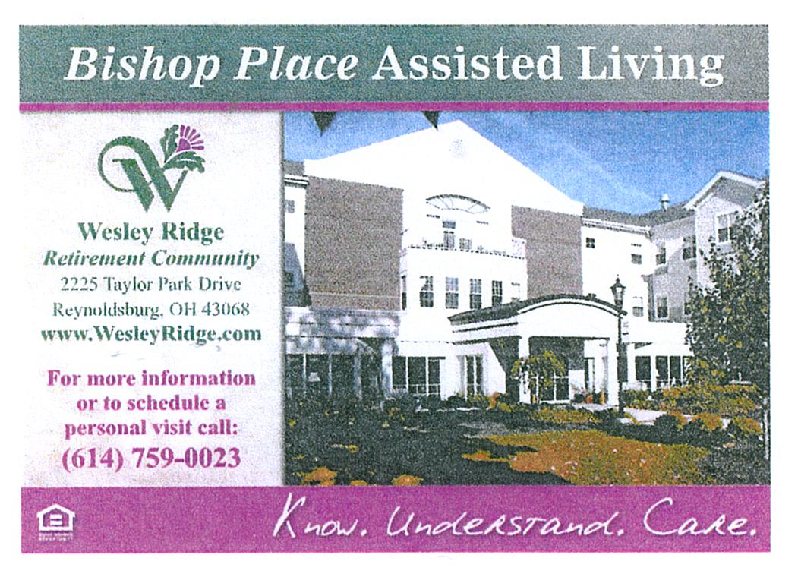
OUR PARKING LOT ENTRANCE & EXIT

Please be sure to follow the arrows designating the entrance and exit to our Center’s parking lot.

“Entrance” and “Exit” signs are now posted in our Center’s parking lot for everyone’s safety and to avoid accidents. As always, be sure to drive slowly in our parking lot.

TRIPS FOR 2022

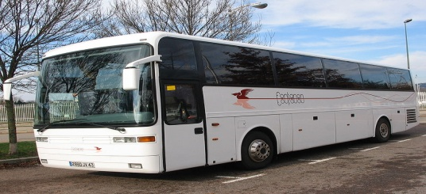

- NEW TRIP -

FRENCH LICK
WEDNESDAY/THURSDAY JULY 19th & 20th

Day 1: Depart the Center at 7:00 a.m. for Patoka Lake, Indiana.

1:00 p.m. We will enjoy a luncheon cruise on a 60-
foot lake boat with indoor and an upper deck viewing area. Lake Patoka is the second largest manmade lake in Indiana.

3:30 p.m. We will enjoy wine tasting and dessert at the Patoka Lake Winery.

4:45 p.m. We will depart for our overnight lodging at the French Lick Resort where we will receive our room keys and a $25.00 voucher for dinner at the resort. The evening is yours to explore the grounds or visit the casino next door.

Day 2: We will enjoy breakfast at the hotel.

9:15 a.m. Luggage out

10:00 a.m. A walking tour of the French Lake Resort dating back over a century. The Resort has hosted hundreds of celebrities over the years. Learn how tomato juice was first created and how gambling (illegal and legal) dominated the scene for years.

11:00 a.m. Depart for Wilstem Ranch where you’ll enjoy a wagon ride to feed the animals. You’ll have your own bucket of feed. We’ll see everything from alpacas to zebras.

1:00 p.m. Enjoy a private barbecue luncheon with entertainment in the Barn at Wilstem.

2:30 p.m. Depart for home

Cost is $534 single, $449 double, and $414 triple. A $200 deposit is due on sign up.

Sign up begins on Monday, April 4th.

LACOMEDIA DINNER THEATRE – THE MUSIC MAN
THURSDAY / APRIL 14th

The motorcoach will leave the center at 8:00am. Be here at least 10 minutes early to get checked in. Please Park on the side or in the back of the building. Waiting List

CRUISING THROUGH THE DECADES
WEDNESDAY / MAY 18th
Join us for a 3-hour cruise and enjoy Mr. Chris and the Cruisers and remember the glory days of rock and roll music. Mr. Chris has promoted for Dick Clark, Chubby Checker, Chuck Berry, and the Grand Ole’ OPRY Stars since 1968. You will enjoy two different sets of 50’s and 60’s music and then music from the 70’s and 80’s. Enjoy a great lunch with beer, wine, and soft drinks for 3 hours. The cost is $135.00. Payment is due before April 15th.

MACKINAC ISLAND, MICHIGAN

JUNE 19 - 22, 2022
This trip includes: 3 Nights lodging, 3 Breakfasts and 3 Dinners.
Day 1: We will be staying in Frankenmuth, Michigan’s “Little Bavaria.” After checking into our lodging, we will enjoy a family-style dinner at the Zehnder’s Restaurant.

Day 2: After breakfast we will check out and spend the morning in Frankenmuth. We’ll visit Bronner’s Christmas Wonderland and other shops in this fascinating Village. After lunch we will head north for our lodging for the next two nights. Dinner is included at a local restaurant.

Day 3: After breakfast we will board a high-speed ferry to beautiful Mackinac Island. Upon arrival we’ll board a horse-drawn carriage for a narrated tour of the Island. Enjoy your day exploring the Island on your own. We’ll return via ferry to the mainland for dinner at a local restaurant, followed by a couple of hours at the Kewadin Shores Casino.

DAY 4: After breakfast at the hotel, we’ll check out and depart for home with fond memories of our visit.

Cost is $728 single and $539 double. $200 deposit due on sign up. Balance is due before May 19th. Cancellation insurance available on sign up.
Space Available

ISLANDS OF NEW ENGLAND
AUGUST 12 – 19, 2022

HIGHLIGHTS:
Providence, Newport, choice of options on tour, lobster dinner, Block Island, Cranberry Bog, Plymouth Rock, Cape Cod, Martha’s Vineyard, Provincetown, Hyannis, and Nantucket. Save $100 if booked before February 12th.

Cost: Single $4,149 - Double $3,349 - Triple $3,319. Flyer available in the office.
NOTES FROM DEANA 😊

REMEMBERING EVERYONE WITH
WARMEST WISHES ON THEIR BIRTHDAY!!

(1) Phyllis Delooff, Dee Robinson, Linda Thompson; (2) Chuck Berry, Deborah Donley, Diane Heimberger, Eric Yruegas; (3) Clover Rogers, Martha Stebelton; (4) Jan Holmes, Nancy Huffman, Suzanne Salisbury, Linda Smith; (5) Bonnie Brusco, Sunny Cook, Alberta Levengood, Mylinda Weber; (6) Marge Kondash, Jerry Parker, Jeanne Postage; (8) Paulette Payne, Krista Pfeifer, Helen St. Cyr; (10) Paula Evans, Rich Houser, Thomas Jones, Dick Smith; (11) Sandy Boldizsar, Patricia Walker; (12) Phyllis Bichard, Mark Boggs, Norma Copley, Claudia Cox, Carol Monhollen, Judy Myers, Bret Rice; (14) Wilma Frank, Ken Hettinger, Carole Pope; (15) Diana Kantz, Rosemary Mans; (16) Jonda Sims; (17) Sue Knorr, Deanna Monroe, Scott Stewart, Freda Sweigert, Theda Sweigert; (18) Christy Barber, Jackie Montgomery; (19) Marcella Hoover, Teresa Pitts; (20) Ann Burke, Melissa Stiles ; (21) Sharon Pletcher, Doloris Shepard; (22) David Fortner, John Hunter, Dean Sigman; (23) Robin Hite, Pamala Ravn, Shirley Robbins; (24) Donna Easley; (25) David Carr, Melba Oard, Paul Still, Jr.; (26) Judy Curtis, Suella Narotski, Mike Sabatino; (27) Betty Lofton, Theresa Pugh, Jenny Quigley, Janice Thomas; (28) Marlene Tedrik, Chris Zang; (29) Deborah Little, Steven Tedrick; (30) Bill Cook, Jeanette Perkins, Joann Smith, Alfrieda Stiles, Doug Wise.

MEMBERS KNOWN ILL

Wilma Arnett – Home, doing better
Grace O’Connell- Home, doing therapy

IN LOVING MEMORY OF
Alice Tuvelle

David Fersch (Linda’s husband)

Robert Fortner (David Fortner’s brother)

Mary Jane Sheline (Clyde’s mother, Nancy’s sister, Deana’s aunt)

EASTER EGGSTRAVAGANZA
TUESDAY APRIL 12th 1-3 p.m.

Join us in celebrating Easter at our Eggstravaganza Party sponsored by Violet Springs, Brookdale Senior Living, and the Center. Fun, snacks, games, and music. Please sign up in the office by April 5th as we are limited to 60 people. If you sign up and can’t attend, please let the office know so we can fill your spot.

WISHING YOU ALL A
HAPPY EASTER!!

This Photo by Unknown Author is licensed under CC BY-SA

