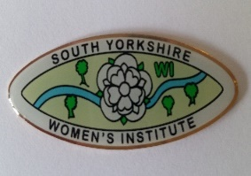
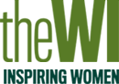
SOUTH YORKSHIRE FEDERATION OF WIs
2020 – CORONAVIRUS PANDEMIC
SURVEY

I am a member of --------------------------------------------- WI

1. What has been your best experience in 2020?

2. What has been your worst experience in 2020?

3. What image/word/sentence best captures your feelings during 2020?

4. What new skills have you learnt this year?

5. Which craft or activity have you started doing again this year?

6. What would you have done differently?

7. Where have you been this year?

8. What are you looking forward to the most in 2021?

Please feel free to include any additional information or enclose any photographic
archive reflecting this year.
Please return this survey by email to southyorksfed@gmail.com or by post to Hall
Cross Cottage, 5 Albion Place, South Parade, Doncaster DN1 2EG by 31 January 2021.

