The Artful Classroom

**Door Sign**

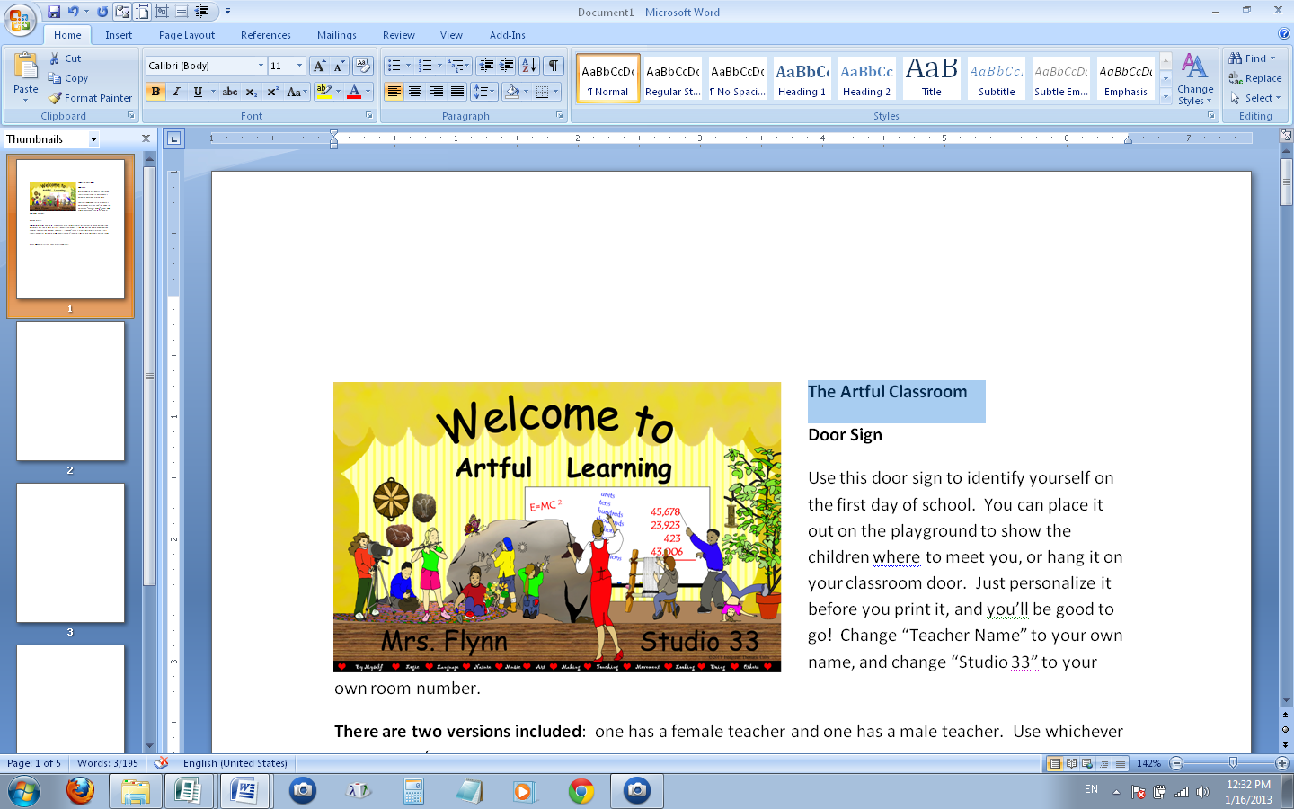

Letter color palette

**Door Sign**

Use this door sign to identify yourself on the first day of school. You can place it out on the playground to show the children where to meet you, or hang it on your classroom door. Just personalize it before you print it, and you’ll be good to go! Change “Teacher Name” to your own name, and change “Studio 33” to your own room number. You can change the color of the wording, too—just highlight the text, go to the Home Menu, and select a new color from the text color palette (see below). You can also change the words “Artful Learning”, too—select and retype.

**There are two versions included**: one has a female teacher and one has a male teacher. Use whichever one you prefer.

**There are two sizes available**: if you have a large format printer (or take the file to a copy shop), you may print this file (Door Sign Ledger Size) on a single piece of 11X17 (ledger sized) paper. (It will look best on photo paper, but you can print it on any type of paper you have.) If you don’t have a large format printer, use the file “Door Sign, Letter Size”. The poster will print on two sheets, and you’ll need to trim the inside margins and tape them together on the back before you laminate them.

**Other Uses**

Laminate the sign, and you can take it with you on field trips to identify meeting areas, or put it in the bus window to make sure everyone gets to the right place. Use it as a signal for everyone to gather by holding it up in the air. It works great for field days, and other school events, too.

Have a wonderful first day and a great school year!

Copyright © 2011 Integreat! Thematic Units. www.thematicteacher.com



Teacher Name

Studio 33

**Learning**

**Artful**



Teacher Name

Studio 33

**Learning**

**Artful**