2018-19 AACCA School Cheer Safety Rules

**Rule changes are in bold type and underlined.** For the current version and rule interpretations, visithttp://www.cheerrules.com

The following rules are written for all elementary, middle school, junior high, and high school cheerleading teams as a minimum standard. Note that elementary, middle school, and junior high programs have a specific set of restricted skills under “F. Tosses”.



**A. Glossary**

**Base:** A person who is in direct contact with the performing surface and is supporting another person’s weight.



**Basket Toss:** A stunt in which a top person is tossed by bases whose hands are interlocked.



**Bracer:** A top person who is connected to another top person.

**Braced Flip:** A pyramid in which the top person performs a hip‐over‐head rotation while not in contact withanyone on the ground.



**Braced Inversion:** A pyramid where a braced top person is in an inverted position, but the hips are not passingover the head.



**Braced Roll:** A pyramid in which the top person performs a hip‐over‐head rotation while in contact with at leastone person on the ground.



**Cradle:** A dismount from a partner stunt, pyramid or toss in which the catch is completed below shoulder heightby a base or bases with the top person in a cradle position.



**Cradle Position:** A face‐up open‐pike position.



**Cupie/Awesome:** A stunt in which both feet of the top person are in one hand of a base.



**Dive Roll:** A forward roll where the feet leave the ground before the hands reach the ground.

**Drop:** Landing on the performance surface from an airborne position.



**Elevator/Sponge Toss:** A stunt in which the top person loads in to an elevator/sponge loading position and isthen tossed into the air.



**Extended Stunt:** A stunt in which the entire body of the top person is extended in an upright position over thebase(s). Chairs, torches, flatbacks and straddle lifts are examples of stunts where the bases’ arms are extended overhead, but are NOT considered to be extended stunts since the height of the body of the top person is similar to a shoulder level stunt.



**Flatback:** A stunt in which a top person is held face up or face down, in a horizontal position, with their hips andshoulders in alignment.



**Foldover Stunt:** An inverted stunt in which the top person bends forward at the waist and is caught on his/herback by multiple catchers while one or both of the top person’s ankles/feet remain in the grip of the base(s) (e.g., yo‐yo, pancake, etc.)



**Hanging Pyramid:** A pyramid in which the top person’s weight is primarily supported by another top person.Examples of hanging pyramids are: a person being suspended between two shoulder stands; a “whirlybird” stunt where one person’s weight is being supported by the legs of a top person in a shoulder sit; and a “diamond head” where two persons are suspended from one shoulder stand.

**Helicopter:** A stunt in which the top person is tossed into the air in a horizontal position and rotates parallel tothe ground in the same motion as a helicopter blade. Prohibited

**Inverted:** A body position where the shoulders are below the waist.

**Loading Position:** Bases support a non‐extended top person under the foot/feet in preparation for a stunt ortoss.

**Log Roll:** A top person in a horizontal position or cradle is popped then twists parallel to the performing surfacebefore being caught by the original base(s) in a horizontal position or a cradle.

**Pyramid:** Connected partner stunts.



**Post:** A person on the performing surface who may assist a top person during a stunt or transition.

**Prep:** A stunt in which one or more bases hold a standing top person at approximately shoulder height.

**Prep Level:** When a top person’s base of support is at approximately shoulder height.

**Prop:** Any object which can be manipulated or used as a base (ex: poms, signs, flags, megaphones, etc.)



**Quick Toss/Partner Toss:** A toss technique where the top person begins the toss with both feet on the ground.



**Released Pyramid Transition:** A pyramid transition in which the top person is connected to a bracer while beingreleased from their bases before being caught in a cradle, stunt or loading position.



**Release Stunt:** A transition from one stunt to another stunt (including loading positions) in which the top personbecomes free from all bases, posts and spotters.



**Spotter:** A person who is responsible for assisting or catching the top person in a partner stunt or pyramid.

**Stunt/Partner Stunt:** One or more persons supporting one or more top persons off of the ground.



**Swing Roll Down:** A stunt in which the top person’s hands/arms and feet/legs are held while swinging forwardand facedown into a roll where the head passes under the hips.



**Switch Liberty:** A stunt in which the top person begins with one foot in a load position, is released from thebases, and then lands in a Liberty on the other foot.



**Tension Drop:** A dismount from a stunt or pyramid where the top person(s) are directed toward the groundwhile their feet are held by the base(s) until just before the landing.



**Tick‐Tock:** A stunt that is held in a static position on one leg, the base(s) takes a downward dip and release thetop person as the top person switches the weight to the other leg and lands in a static position on the opposite leg. The dip may or may not pass through prep level before release.



**Top Person:** A person who is not in contact with the performing surface and is being supported or stabilized byanother person or has been tossed into the air.



**Toss:** A release stunt in which the base(s) begin underneath the top person’s foot/feet, execute a throwingmotion from below shoulder level to increase the height of the top person, and the top person becomes free from all bases, spotters, posts or bracers. Note: This term applies when at least one base is under one or both feet of the top person. For other types of tosses, see “Quick Toss/Partner Toss”.



**Tumbling:** Gymnastic skills that begin and end on the performing surface, including rolls, inverted extended skills(cartwheels, handstands, walkovers, handsprings, etc.), aerials, twists and flips. NOTE: Jumps, leaps and side rolls on the performing surface are not considered to be tumbling.



1. **General**
   1. These rules are to be in effect for all practices, games, competitions and other performances.
   2. Cheerleading squads should be placed under the direction of a qualified and knowledgeable coach.
   3. All practice sessions should be supervised by the coach and held in a location suitable for the activities of cheerleaders (i.e., use of appropriate mats, away from excessive noise and distractions, etc.).
   4. Coaches should recognize a squad's particular ability level and should limit the squad's activities accordingly. "Ability level" refers to the squad's talents as a whole and individuals should not be pressed to perform activities until safely perfected.
   5. All cheerleaders should receive proper training before attempting any form of cheerleading technical skills (tumbling, partner stunts, pyramids and jumps).
   6. Professional training in proper spotting techniques should be mandatory for all squads.
   7. All cheerleading squads should adopt a comprehensive conditioning and strength‐building program.
   8. An appropriate warm‐up routine should precede all cheerleading activities.
   9. Prior to the performance of any skill, the immediate environment for the activity should be taken into consideration including, but not limited to proximity of non‐squad personnel, performance surface, lighting and/or precipitation. Technical skills should not be performed on concrete, asphalt, wet or uneven surfaces or surfaces with obstructions.
   10. Programs should qualify cheerleaders according to generally accepted teaching progressions. Appropriate spotting should be used until all performers demonstrate proficiency of the skill.
   11. All jewelry is prohibited during participation. Religious medals and medical medals are not considered to be jewelry. A religious medal without a chain must be taped and worn under the uniform. A medical alert medal must be taped and may be visible.
   12. Supports, braces and soft casts which are unaltered from the manufacturer’s original design/production do not require any additional padding. Supports/braces and supports/braces that have been altered from the manufacturer’s original design/production must be padded with a closed‐cell, slow‐recovery foam padding no less than one‐half inch thick if the participant is involved in partner stunts, pyramids or tosses. A participant wearing a plaster cast or a walking boot must not be involved in partner stunts, pyramids or tosses.
   13. Squad members must wear athletic shoes (no gymnastic slippers).
   14. When discarding props (signs, etc.) that are made of solid material or have sharp edges/corners, team members must gently toss or place the props so that they are under control.
   15. The use of mini‐trampolines, springboards, spring‐assisted floors or any other height‐increasing apparatus is prohibited for competition or performance. These devices may be used for skill development and practice under the supervision of a coach trained in their use.
   16. Cheerleaders must stand outside the free throw lane lines extended toward the sidelines throughout a basketball game.
   17. Spirit participants must remain outside of the playing area during a 30‐second or less time‐out during a basketball game.
   18. When standing at attention, apparel must cover the midriff extended around the body.

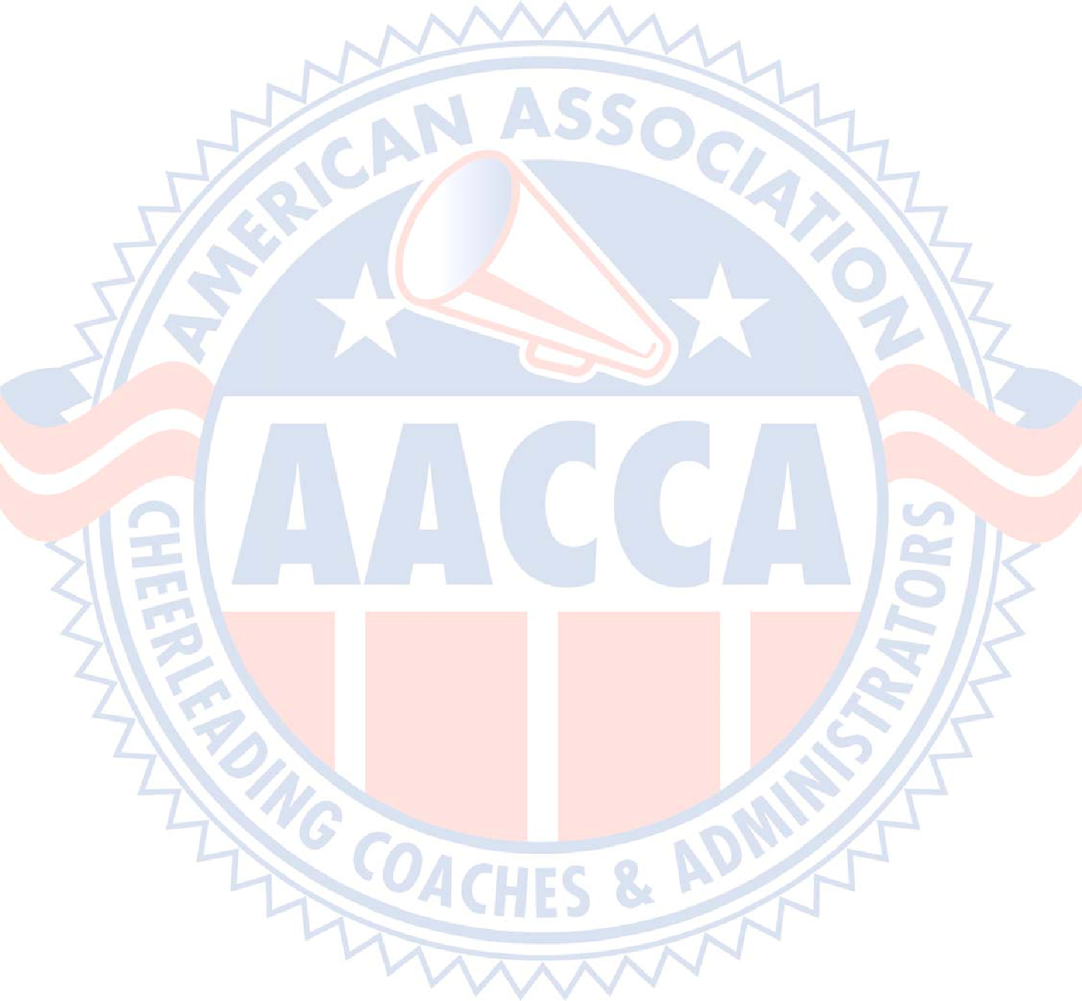

1. **Partner Stunts**
   1. A spotter is required for extended stunts where the top person’s weight is being borne by the base(s). Example: “Show and Go” stunts, where the top person is not in an extended static position, do not require a spotter.
   2. A spotter is required for tosses **to single base shoulder stands and** single base shoulder level stunts in which the feet of the top person are in the hand(s) of the base. (This spotter may assist under the sole of the foot.)
   3. In stunts requiring a spotter, a spotter:
      1. Cannot provide primary support for a top person. Primary support means the majority of the top person’s weight.
      2. Must be in a position to protect the top person’s head, neck and shoulders when coming off a stunt or pyramid or landing in a cradle. In most stunts this is behind or beside the top person.
      3. Spotters must have their attention focused on the top person. Momentarily looking away in order to assess environmental safety factors (poms, signs, another stunt, etc.) is allowed as long as their focus returns to the top person.
      4. May not have their hands behind their back.
      5. May not support under the heel or sole of the top person’s foot in a single based extended stunt. They may hold at the ankle of the top person and/or the wrist of the base or any combination thereof.
      6. May not hold any objects in their hands.
   4. The top person cannot travel over another person from Quick Tosses or Partner Tosses.
   5. The bases of any extended stunt must have both feet in direct weight‐bearing contact with the performing surface.
   6. Bases may not:
      1. Hold any objects in a hand that is supporting the top person.
      2. Assume a backbend, handstand or headstand position.
   7. Partner stunts and pyramids may not pass over, under or through other partner stunts or pyramids.
   8. The total number of twists in a dismount or release from a stunt cannot be greater than 1 1/4 rotations.
   9. Cradle dismounts from partner stunts shoulder height or above to the original base(s) require an additional spotter in position to protect the head, neck and shoulders of the top person.
   10. In all dismounts to catchers who are not the original bases, the following conditions must be met:
       1. The top person must be cradled by two catchers and a head‐and‐shoulders spotter/catcher.
       2. The new catchers must remain close to the original bases.
       3. The new catchers must be in place and not involved in any other skill when the release is initiated.
       4. The top person may not perform any skill (twist, toe touch, etc.) following the release.
   11. In all cradle dismounts, the top person must not hold props that are made of hard material or have corners or sharp edges.
   12. Unless listed below, a release stunt must either be cradled or connected to at least one bracer.
       1. A log roll is legal provided it does not involve more than one complete rotation and the top person is not in contact with a person in a release stunt.
          1. In a single‐base log roll, the top person must rotate toward the base and begin and end in a face‐up position.
       2. In a multi‐base log roll, the top person may begin and end in a face‐up or face‐down position.
   13. A top person in a vertical position at prep level **or above** may be released to a stunt at any level provided the top person remains vertical, and the top person performs no more than 1 ¼ twisting rotations. **Vertical** **releases from an extended position to an extended position may not perform more than a ¼ twisting rotation.** *
   14. A top person in a horizontal position shoulder height or below or in a cradle may be released to a loading position or stunt shoulder height or below.
   15. Legal inversion releases under Rule D.
2. Non‐braced suspended splits in a transition are allowed provided all of the following conditions are met:
   1. The top person must have both hands in continuous contact with a post or with both bases’ hands or,
   2. When transitioning to the split without continuous hand‐to‐hand contact:
      1. There are a total of three bases that support the top person.
      2. At least two of the bases must support under the legs of the top person. The third base may support under the legs or make contact with the hands of the top person.
      3. The top person must have both hands in contact with bases during the split portion of the transition.
3. Extended Straddle Lifts must have an additional spotter for the head and shoulders of the top person (similar position to a Double‐Based Elevator/Extension Prep).
4. Single‐based stunts in which the top person is parallel to the performing surface and the bases’ arms are extended must have a continuous spotter at the head and shoulder of the top person. (i.e. Bird, Side T, Single‐ Based Flatback, etc.)
5. A top person may be moved from a vertical position to a horizontal position (straight body or cradle) provided all the following conditions are met:
   1. The top person maintains contact with at least one original base or spotter.
   2. At least two catchers and/or bases catch the upper body of the top person.
   3. The catchers must be to the side or front of the person(s) moving the top person.
   4. When the catchers are not the original bases, they remain close to the original bases and must be in place prior to the movement to the horizontal position.
   5. When the catchers are not the original bases and the top person begins or passes through an extended overhead position, at least three catchers are required.
6. A single‐base may not be the only primary support for two extended top persons.

If dismounted to cradles, there must be three people for each top person being cradled.

1. Dismounts to the performing surface from shoulder height or above must have assisted landings. This assistance must be sufficient to slow the momentum of the top person. If the dismount involves a skill (e.g. toe touch, twist, etc.) there must be an additional spotter who may, but is not required to, provide assistance.
2. A swinging stunt is legal provided all the following conditions are met:
   1. A downward movement is only allowed from below shoulder height.
   2. The top person is face up.
   3. The top person begins from the performing surface or a stunt that is below shoulder height.
3. A top person must not be in a face down suspended position between bases in which the top person’s torso is suspended below the arms and legs.
4. Single‐based split catches are prohibited.
5. Tension drops are prohibited.



**D. Inversions**

Note: Inversions are partner stunts, pyramids, or tosses in which the top person has her or his shoulders below the waist. In addition to the following rules, all persons involved in an inversion must follow all rules from the Partner Stunt and Pyramid sections.

1. Unless allowed under the rules in this section, a top person must not be in an inverted position. Example: Basket toss flips are not allowed under this section, and are therefore prohibited.
2. An inverted top person may pass through an extended position, but must not begin, end, pause, or stop in a static extended inverted position.
3. Braced inversions in a pyramid that do not flip or roll are allowed provided the following conditions are met:
   1. The inverted top person must have two bases or a base and a spotter.
   2. If the top person is released from the base(s), all of the released pyramid transition rule E‐7 must be met.
4. Braced rolls in a pyramid are allowed provided the following condition is met:
   1. The bracer(s) must have two bases or a base and spotter (Exception: shoulder sits and thigh stands)**.**
5. Braced flips in a pyramid are allowed provided all of the following conditions are met:
   1. The top person begins in a multi‐base loading position, stunt, cradle, or on the performing surface.
   2. The top person maintains continuous hand‐to‐hand/arm contact with two bracers who are in double base preps with a spotter. Each arm of the top person must be connected to a bracer.
   3. The top person is not behind the bracers.
   4. There must be three people involved in the toss and catch of the top person either as a base or spotter. **Any** **new catchers/spotters must be in place when the flip is initiated, remain close to the original bases and are not part of any other skill.**
   5. If the flip ends in a cradle, the bracers may release the top person once she/he begins to descend and is no longer inverted.
   6. The top person ends in a non‐inverted position.
   7. The top person does not perform more than one and one quarter (1¼) flipping rotations and no more than one half (½) twist.
   8. The bases/catchers remain stationary except as necessary for safety adjustments.
6. In all other inversions:
   1. Inversions may be released to the following provided there is a spotter:
      1. **Non‐inverted** dismounts with no more than a ½ turn.
      2. Loading positions below prep level with no more than a ½ turn.
      3. Non‐inverted stunts at prep level or below. Twists not allowed.
   2. In inversions where the base of support begins and remains below prep level, at least one person shall maintain contact with the top person until the top person is no longer inverted or his/her hands are on the performing surface.
   3. Inversions where the base of support begins at or passes through prep level require two people on the performing surface to be in a position to protect the head/neck of the top person, one of whom must maintain contact with the top person’s upper body (waist and above, which may include arms/hands) until the top person is no longer inverted or his/her hands are on the performing surface. The contact shall be sufficient to stabilize/control the top person’s position.

EXCEPTION: A foldover that begins at or below prep level and does not stop in an extended position is allowed without continuous upper body contact.

* + 1. If caught in a cradle, load or stunt by catchers who are not original bases, the new catchers are in place and are not involved with any other skill when the transition is initiated.
    2. The top person must not go directly to an inverted position on the performance surface from a prep or higher.
  1. When the stunt begins in an inversion and goes to a non‐inverted position, the upper body contact may be released before the top person is no longer inverted.



* 1. An inverted top person must not hold objects (poms, signs, etc.) in his/her hands.

EXCEPTION: During a transition from an inverted position on the performing surface to a non‐inverted stunt, a top person can hold objects.

* 1. A Swing Roll Down stunt is not permitted.

1. **Pyramids**

Note: In addition to these specific pyramid rules, all persons and stunts involved in a pyramid must follow all rules from the Partner Stunt and Inversion sections.



1. The top person in a pyramid must receive primary support from a base or be connected to a bracer who is on a base.
2. A bracer may not support a majority of a top person’s weight.
3. In pyramids where one extended stunt braces another extended stunt, the connection must not be hand/arm to leg/foot.
4. Partner stunts and pyramids may not pass over, under or through other partner stunts or pyramids.
5. If a person in a pyramid is used to brace the foot/leg of an extended stunt, that brace must not be supporting a majority of the top person's weight. (To demonstrate this, the foot of the top person’s braced leg must be at or above the knee of their supporting leg.)
6. Hanging pyramids must have a continuous spotter for each shoulder stand involved in suspending another person. Hanging pyramids are not allowed to rotate.
7. In a Released Pyramid Transition the following rules apply:
   1. The skills before and after the release must be legal, including the required spotters.
   2. The top person must be in hand/arm to hand/arm contact with at least one bracer during the entire transition.
   3. The bracer(s) are at prep level or below. The bracer(s) must have two bases or a base and spotter (Exception: shoulder sits and thigh stands).
   4. The top person may not be supporting his or her weight on any other body part of the person(s) assisting (i.e. Shoulders of the bracer).
   5. The released top person and bases make no more than a ¼ turn around the bracer in a continuous movement in which the top person remains above the original base(s).The top person must be continuous in motion and cannot be supported so that they pause during the transition.
   6. **When the catchers are not the original bases, the new catchers are in place when the transition is initiated, remain close to the original bases and are not part of any other skill.**



*For braced inversion pyramids, see Rule D.*



**F. Tosses**



The rules in this section only apply to tosses where someone is under a foot, e.g. basket tosses, elevator/sponge tosses, toe pitch tosses.



1. All tosses in this section are prohibited for Elementary, Middle School, and Junior High cheerleading teams.
2. In all tosses:
   1. No more than four tossers are allowed.
   2. Must be caught in a cradle.
      1. The cradle must include at least three of the original tossers.
      2. One of the catchers must be at the head and shoulders.
   3. The toss may not be directed so that the bases must travel to catch the top person. (The bases can turn/rotate under the toss.)
3. The top person must not land in an inverted position.
4. The top person may not hold any objects (poms, signs, etc.) during the toss.
5. The top person cannot travel over or under another person or through a prop.
6. The total number of twists cannot be greater than one and one quarter rotations.

EXCEPTION: Switch Liberties (also called Giddy Up or Tick Up) are allowed.

1. **Tumbling and Jumps**
   1. Dive rolls are prohibited.
   2. Flips greater than one rotation are prohibited.
   3. Twists greater than one rotation are prohibited.
   4. A forward three‐quarter flip to the seat or knees is prohibited.
   5. Tumbling over, onto, or under a stunt, person or prop is illegal. Rebounding over a stunt, person or prop is illegal.

EXCEPTIONS:

* + 1. Non‐aerial tumbling over a person or prop is allowed. (Cartwheels, rolls and walkovers with poms or over a person are allowed.)
    2. Aerials and standing back tucks with poms are allowed. (Back handsprings with poms are still prohibited.)
  1. A flip that lands in a partner stunt or cradle is prohibited. (Example : A back flip from a tumbling pass into a cradle is prohibited. However, rebounding from a back handspring into a cradle is allowed.)
  2. Landings for all jumps must bear weight on at least one foot. (Example : A toe touch jump to the seat, knees, or landing with both feet back, or to a push‐up position are prohibited.)
  3. Knee drops are prohibited without first bearing weight on the hands.
  4. Drops to a prone position (i.e. pushup) on the performing surface are illegal.
  5. Airborne skills without hip over‐head rotation may not jump from a standing or squatting position backwards onto your neck, shoulders and hands. (This rule only refers to a type of entrance into the “kip‐up/rubber band” skill.)

1. **Specific Surface Restrictions**
   1. The following skills are only allowed on a mat, grass or rubberized track surface.



1. Basket tosses, elevator/sponge tosses and other similar multi‐base tosses.
2. Partner stunts in which the base uses only one arm to support the top person.
3. Twisting tumbling skills (Arabians, full twisting layouts, etc.).

EXCEPTION: Cartwheels, roundoffs and aerial cartwheels are allowed on surfaces other than a mat, grass or rubberized track.



The above safety guidelines are general in nature and are not intended to cover all circumstances. All cheerleading technical skills including tumbling, partner stunts, pyramids and jumps should be carefully reviewed and supervised by a qualified adult coach. Cheerleading jumps, tumbling, and stunts may involve height and inversion of the body and there is an inherent risk of injury involved with any athletic activity. While the use of these guidelines in coordination with the AACCA Safety Course will help minimize the risk of injury, the American Association of Cheerleading Coaches and Administrators makes no warranties or representations, either expressed or implied, that the above guidelines will prevent injuries to individual participants.



I . Might Mite

1. Basket tosses, and similar multi-based tosses are prohibited

**Summary of Changes**

Glossary change: The term “Suspended Roll” has been removed from the glossary. The term is no longer used in the rules, and suspended rolls are covered by the inversion rules based on where the base of support is. A typical suspended roll with a standing base or bases is considered to be a “prep level or above inversion”, so it requires two people, one of whom must be in contact with the top person. In a suspended roll where the base is laying on the ground, the base of support is considered to be “below prep level”, so the one person is sufficient and an additional spotter is not required.



C2. A spotter is already required for single based stands where the top person’s feet are being held. We added toss to shoulders to this rule to require a spotter during a single based toss that lands on the shoulders. Once the top person has safely landed on the shoulders, the spotter is no longer necessary and may leave. If the top person lands in the hands, the spotter is required for as long as the top person is in the hands.



C12c. A top person in a vertical stunt may be released to a vertical stunt from shoulder level or above. The new allowance for initiating the release from above shoulder level will allow extended “high to high” release skills such as a tick‐tock as well as “high to low” or “high to load”. However, if the release is from extended back to extended, the top person may not twist more than ¼ rotation. This would allow a lib, release to arabesque, but not a high to high release full around.

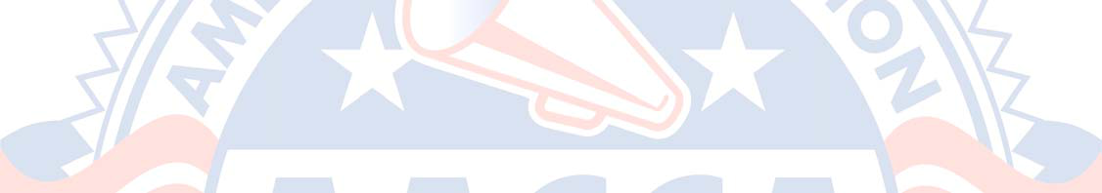

D5d. In braced flips, we removed the requirement that the catchers must be the original tossers. This will allow any combination of three people to be under the throw and the catch. It could be one or two new people or an entirely new set of three. However, these new catchers must be in place when the flip is initiated.



D6a1. The term “non‐inverted” was added to clarify that an inversion cannot release to an inverted dismount.

D6b. In low level inversions, we removed the requirement that the base had to be in contact with the upper body. In low inversions, the top person is very low to the ground, and body contact in general is sufficient since the top can put their hands down to the floor easily.

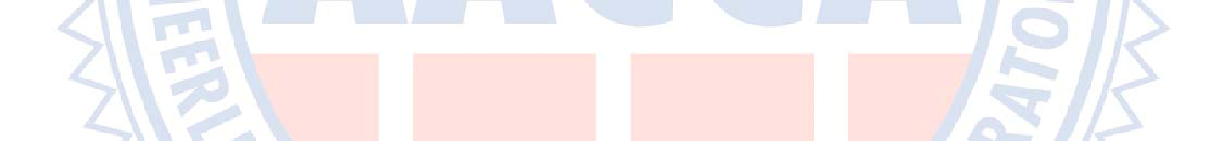

E7f. Braced releases can now go to other catchers, or have new catchers involved in the catch. Any new catchers must be in position when the release is initiated. They can still go no further than ¼ turn around the bracer.



For further interpretation, videos of skills will be uploaded throughout the year at cheerrules.com

