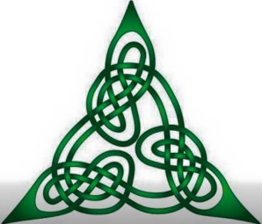
Tampa Bay Tartan Ball
www.TartanBallTB.com PO Box 10218 Tampa, FL 33679

Sponsorship Information:
Please provide information as it will appear in our sponsorship promotions of the event:
Company
____________________________________________________________________
Contact Name: Phone: Email:
____________________________________________________________________
Web Address URL:
____________________________________________________________________
Street Address City State Zip
____________________________________________________________________

Yes, I would like to be a proud sponsor of the Tampa Bay Tartan Ball
(Please select your sponsorship level)
- Platinum Bar Sponsorship: $500.00
- Platinum Photo Booth Sponsorship: $500.00
- Gold Marketing Sponsorship: $400.00
- Silver Table Top Sponsorship: $375.00

Please make check out to Tampa Bay Tartan Ball and mail or email the form and logo to
TBTB
PO Box 10218
Tampa Bay, FL 33679
Or Hostess.Tampabay.TartanBall@gmail.com

Tampa Bay Tartan Ball
www.TartanBallTB.com PO Box 10218 Tampa, FL 33679

Platinum Bar Sponsorship: $500
Maximum of Two (2), which includes:
- Company Logo on the bar area during the event serving continuously.
- Company Logo and URL displayed on high traffic producing website for the entire year leading up to the 2018 event
- Two Tickets to the event and Recognition including announcements.

Platinum Photo Booth Sponsorship: $500
Maximum of One (1) sponsor, which includes:
- Company Logo on the Photo booth during the event, each single guest or couple to receive one complimentary photo.
- Company Logo and URL displayed on high traffic producing website for the entire year leading up to the 2018 event
- Two Tickets to the event and Recognition including announcements.

Gold Marketing Sponsorship: $400
Maximum of One (1) sponsor, which includes:
- Company Logo on ALL table tops during the event.
- Company Logo and URL displayed on high traffic producing website for the entire year leading up to the 2018 event
- Recognition at the event, including announcements.

Silver Single Table Sponsorship: $375
Sponsor, which includes:
- Company Logo on one table top during the event.
- Company Logo and URL displayed on high traffic producing website for the entire year leading up to the 2018 event
- Two Tickets to the event and Recognition including announcements.

