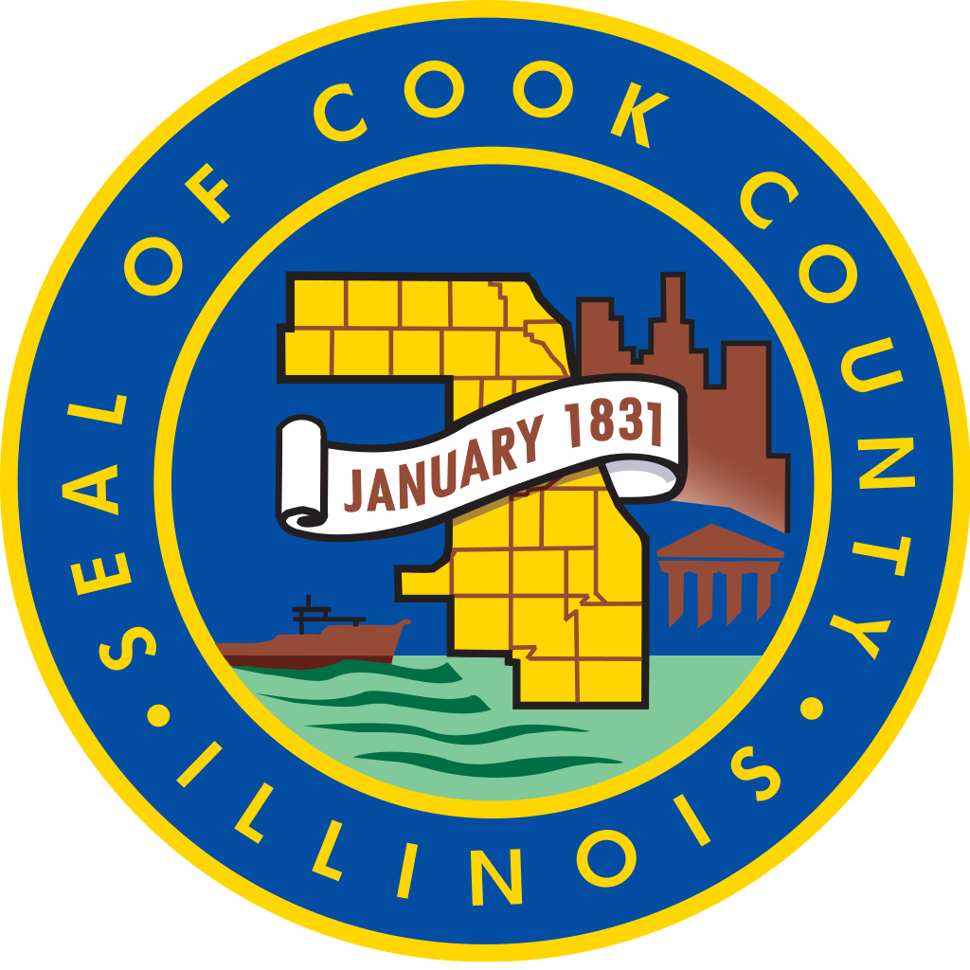

Cook County Commission on Social Innovation
Minutes

Thursday, October 20, 2016 4:00 PM CC Board Room
118 N. Clark, RM 569, Chicago, Illinois 60602

ATTENDANCE
Present: Marc Loveless, Mike Hobbs, Marc Lane, Jesus Garcia, Reggie Greenwood, Mark McHugh, Carrie Thomas, Valerie Leonard, Michael Jasso, Wendy Raymer, John Yonan, Howard Males, Eric Weinheimer, Pam Rodriguez, Ald. Sue Sadlowski Garza.

Absent: K sujata, David Doig, Harold rice, Emile Cambry, Victor Dickson, Eugene Williams, Maria Kim

MINUTES

4:10 PM
Opening Remarks by the Chair – Comm. Garcia.

4:16 PM
Remarks from Vice Chair Lane:
The first of three capacity building workshops will take place on October 27 that will deliver information to non-profit leaders and staff on social enterprise; where Valerie Leonard will be honored as a social innovator. Approval of the workshop and honoring of Leonard: Motion by Males, seconded by Jasso, passed unanimously.

4:19 PM
Guest Speaker
Richard Harnish
Metropolitan High Speed Rail Association on Cross-Rail Chicago and its Metra Electric proposal. Recommended the County can play the role of convener to expand and coordinate services with other jurisdictional authorities on transportation.

4:30 PM
Discussion on Metra Electric with the agreement that a resolution be drafted asking for a feasibility study.

4:45 PM
Committee Reports
Carrie Thomas reported for Human Capital
Valerie Leonard reported for Social Capital
Eric Weinheimer reported for Intellectual Capital
Wendy Raymer reported for Financial Capital
Reggie Greenwood reported for Public Capital

5:15 PM
Chair proposed having a meeting of the committee chairs in November in lieu of a commission meeting. Motion was made by Marc Loveless, seconded by Ald. Sadlowski Garza, passed unanimously.

5:30 PM
Adjournment
Motion by Wendy Raymer, seconded by Marc McHugh, passed unanimously.

