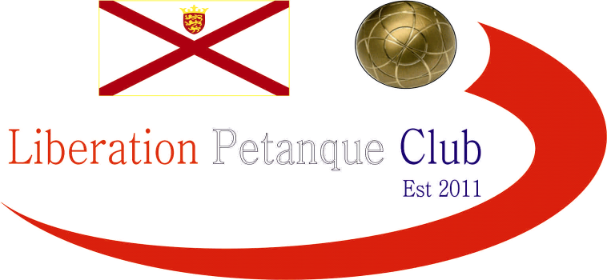

2020
Liberation Mixed Doubles Open
The third successive tournament to have a new name on the trophy as Matt Pinel was this time partnered by Cassie Stewart, with Alice unable to play.
With Swiss expert Toby on a day off 😊. The fixtures were drawn using fixture list.com with 4 random rounds and the top four going through to the Semi-finals.
Matt started off well with Cassie beating Paul Harris and Nicky MainDonald 13 – 3, the was the same score for Callum & Jean Stewart over Sophia Harrison & Tom Le Sueur. A big win also for Christine Eccles & Paul Waters over Kevin Daly & Venessa Nash.
A good win in a competitive match for Gary Cowburn & Wendy Ritzema against Brigitte Ibitson & Ross Payne who have finished 1st, 2nd and third in this competition previously.
Lorna Limbrick was hoping to transfer her singles form into the competition with partner Mark Nicol and they did win the first match against Geoffroy & Janet 13 – 7.
Round 2 saw some incredibly close matches as Christine & Paul just beat Laurent & Karolina 11 – 10 and Mark & Lorna survived a scare against Matt Hutchings & Mo De Gruchy 13 – 10.
Cassie & Matt beat Gary & Wendy 13 – 11 and Paul & Kat beat Callum & Jean 13 – 10. There was a great result for Sophia & Tom winning 13 – 4 against Geoffroy & Janet.
Not many close matches in round three though as Derek 7 Joy Hart made it three from three win a comprehensive 13 – 4 win over Gary & Wendy effectively ending their hopes of a top 4 finish.
Mark & Lorna and Matt & Cassie and Christine & Paul all with three from three with Callum & Jean and Ross & Brigitte both winning to keep some hope of going through.

Callum & Jean played well to beat Brigitte & Ross but finished 5th place as all teams with 4 wins went through, with only 3 points in points difference separating the top three
1st Derek & Joy Hart 4 Wins +28
2nd Cassie Stewart & Matt Pinel 4 Wins +27
3rd Lorna Limbrick & Mark Nicol 4 Wins +25
4th Christine Eccles & Paul Waters 4 Wins +18
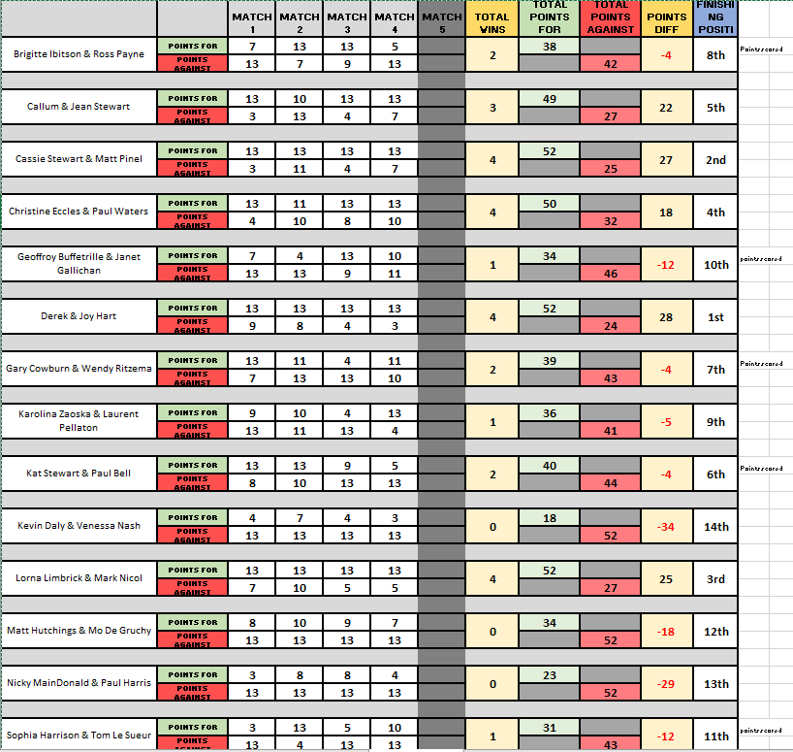
In the Semi-Finals Derek & Joy could not convert their top ranked position into a final place as Christine & Paul shone through with a very good performance winning 13 – 8.
The semi-final between Lorna & Mark and Cassie & Matt would have had many expecting a close match but it weas far from it as Lorna & Mark won 13 – 3.
Third place went to Cassie & Matt who recovered to beat Derek & Joy but only just 13-11.
The final saw Lorna & Mark repeat their semi-final score line, as they lifted the title with a 13 – 3 win over Christine & Paul.
Congratulations and thanks to all those who took part and special thanks to Matt Pinel for running the tournament and Callum & Ross for their support.
Pictured, Winners Lorna Limbrick & Mark Nicol.
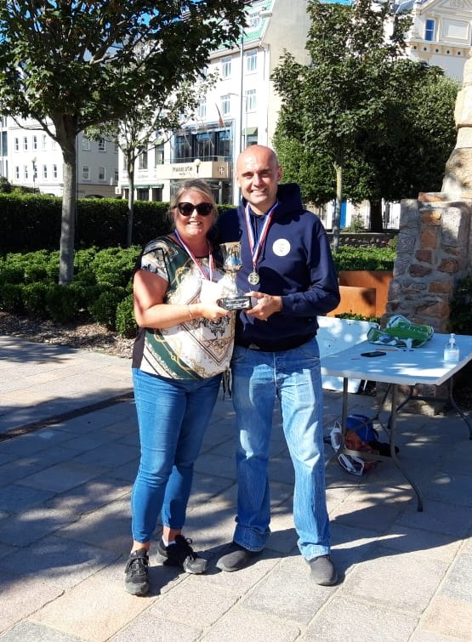

Club email address - liberationpc@gmail.com

Club Website - www.liberationpetanque.co.uk

Kind Regards

Toby Northern

Chairman

Liberation Petanque Club

SPONSORED BY

