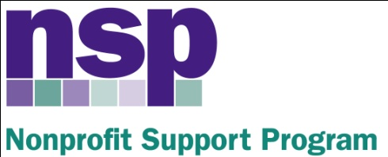

Hartford Foundation for Public Giving
Nonprofit Support Program
Building Evaluation Capacity (BEC) Program
Class of 2017, Session 4

March 9, 2016

AGENDA

e-Surveys, Record Review, Quantitative Data Analysis Basics

8:30 – 8:45 | Review
8:45 – 9:30 | Electronic Surveys (Details + Activity)
9:30 – 9:45 | Pre-Post Surveys
9:45 – 9:55 | BREAK
9:55 – 10:30 | Record Reviews (Details + Activity)
10:30 – 10:40 | Analysis Basics
10:40 – 11:40 | COA Survey Analysis Activities
11:40 – 11:55 | Final Survey Activities
11:55 – 12:00 | WRAP UP Q/A
HW: INITIAL THOUGHTS, Q 1, 4, 5,
Work on surveys and record review protocols for your project; begin to think through the administration and analysis plan. DUE 4/15

Anita Baker
Evaluation Services
www.evaluationservices.co

