REGULAR MEETING
SEPTEMBER 15, 2022
The Regular Meeting of the Town Board of the Town of Hampton, County of Washington and the State of New York was held at the Town Hall, 2629 State Route 22A, Hampton, New York, also via Zoom on the 15th day of September 2022.

PRESENT: David K. O’Brien------------Supervisor
Donald Sady----------------- Councilman
Tamme Taran----------------Councilwoman
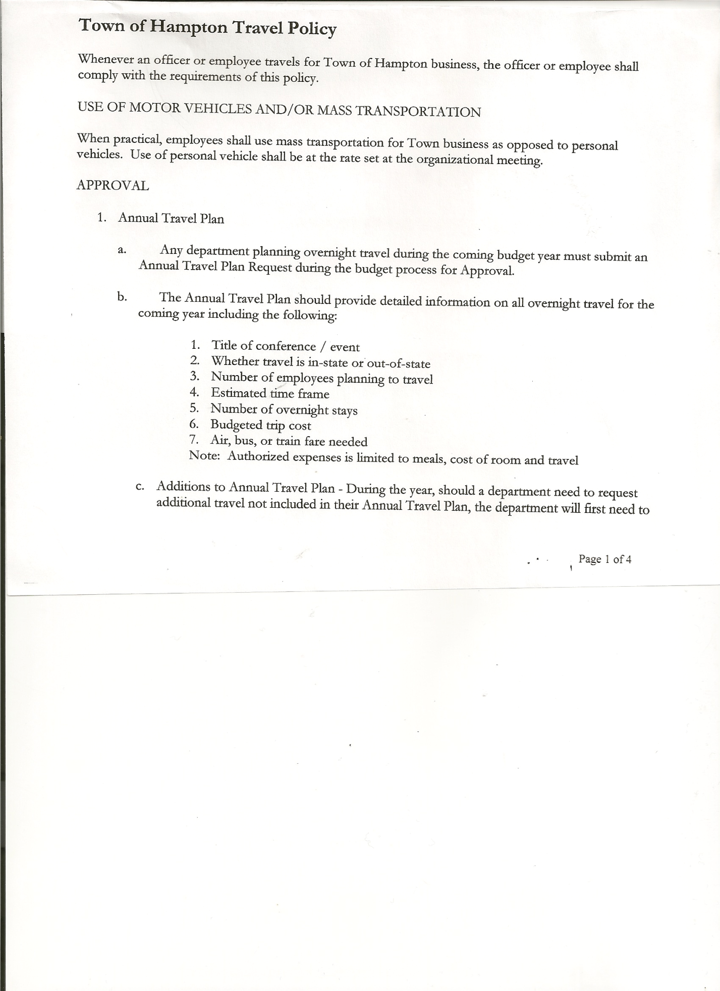
Michael Pietryka------------Councilman
Andrea Sweeney------------Councilwoman
Rebecca Jones---------------Town Clerk
Camilla Shaw----------------Tax Collector/Deputy Town Clerk
Tyler McClure---------------Highway Superintendent

Planning Board Member (s):…Bonnie Hawley, Chair; Matthew Pratt and Richard Cole
Others present at the Town Hall: Artie Pratt and Leonard Reed

The Regular Meeting was called to order by Supervisor O’Brien at 7:30pm, followed by the Pledge of Allegiance. Location of Fire Exits were given. Quorum of board members present.

RESOLUTION NO. 66-2022
APPROVAL OF THE MINUTES
On a motion of Councilman Sady, seconded by Councilwoman Sweeney, the following resolution was ADOPTED: AYES 5 O’Brien, Sady, Taran, Pietryka, Sweeney
NAYS 0
RESOLVED, that the Regular Town Board Meeting Minutes for August 18th, 2022 are approved.

PERMITS/SUBDIVISIONS
Discussion regarding previous subdivision approved for Bruce Jones. The application needs to be revoked. Survey provided was not to be used for Subdivision. The following resolution was introduced.
RESOLUTION NO. 67-2022
SUBDIVISION NULLIFIED
On a motion of Councilwoman Taran, seconded by Councilman Sady, the following resolution was ADOPTED: AYES 5 O’Brien, Sady, Taran, Pietryka, Sweeney
NAYS 0
RESOLVED, that The Town of Hampton nullifies the subdivision of the property owned by Bruce Jones, Tax ID 72.-1-1.2. This was nullified due to an improper document cited as a survey was presented for the subdivision. On September 13th, 2022, Supervisor O’Brien called Matt Steves of Van Dusen & Steves surveying firm who said that he did the map and specifically told the client that the provided map was not a proper survey and could not be used for subdivisions.

Richard Cole, Dog Control Officer gave his report…no new complaints, follow-up with William Jones, Low Hampton has not contacted Judge Sady, a second ticket may be issued.

Camilla Shaw, Tax Collector….. no activity. Submitted Bank Statement to the Board for review and signatures.

TOWN BOARD MEETING
SEPTEMBER 15, 2022 PAGE 2

Bonnie Hawley, Chair Planning Board…copy of the minutes of their meeting held September 14th, 2022 are attached. Next meeting is planned for October 12th, 2022.

Tyler McClure, Highway Superintendent submitted his report, copy of which, is attached.
The following resolution is in response to Tyler’s info/request to purchase a 9ft dumping
rack body to replace the body stolen off the ’93 Ford F-350. Pete Turunen has it for sale for $3000.00, not installed.
RESOLUTION NO. 68-2022
PURCHASE 9’ DUMPING RACK BODY
On a motion of Councilman Pietryka, seconded by Councilwoman Taran, the following resolution was ADOPTED: AYES 5 O’Brien, Sady, Taran, Pietryka, Sweeney
NAYS 0
RESOLVED, to purchase the above rack body from Pete Turunen for $3000.00

SUPERVISOR’S REPORT/ COUNTY UPDATES/ COMMUNICATIONS

RESOLUTION NO. 69-2022
APPROVAL OF SUPERVISOR’S MONTHLY REPORT
On a motion of Councilman Sady, seconded by Councilwoman Taran, the following resolution was ADOPTED: AYES 5 O’Brien, Sady, Taran, Pietryka, Sweeney
NAYS 0
RESOLVED that, the Supervisor’s Monthly report be accepted as submitted for AUGUST
07/31/22 08/31/22
ACCOUNT BALANCE RECEIPTS DISBURSEMENTS BALANCE
General Fund $101,247.45 $ 979.91 $ 12,114.75 $ 90,112.61
Highway Fund $297,451.94 $ 7.52 $ 16,642.45 $ 280,817.01
Equipment Reserve $114,941.13 $ 2.93 $ 0.00 $ 114,944.06
Fire #1 $ 22,081.50 $ 0.00 $ 0.00 $ 22,081.50
Fire #2 $ 5,202.00 $ 0.00 $ 0.00 $ 5,202.00
Cemetery $ 1,762.41 $ .74 $ 0.00 $ 1,763.15
Totals $542,686.43 $ 991.10 $ 28,757.20 $ 514,920.33
All Board Members present signed Supervisor’s Report.

NEW BUSINESS

The Tentative Budget for 2023 was presented to the Town Board

RESOLUTION NO. 70-2022
BUDGET WORKSHOP
On a motion of Councilman Sady, seconded Councilwoman Sweeney, the following resolution was ADOPTED: AYES 5 O’Brien, Sady, Taran, Pietryka, Sweeney
NAYS 0
RESOLVED, to set a Special Meeting for a Budget Workshop to be held on Tuesday, October 4th, 2022 at 6:00pm at the Town Hall.

TOWN BOARD MEETING
SEPTEMBER 15, 2022 PAGE 3

RESOLUTION NO. 71-2022
TOWN HALL USE
On a motion of Councilman Sady, seconded Councilwoman Taran, the following resolution was ADOPTED: AYES 5 O’Brien, Sady, Taran, Pietryka, Sweeney
NAYS 0
RESOLVED, to approve the request of Rebecca Jones to use the Town Hall on Sunday, September 18th, 2022 from 2 to 4pm for a Baby Shower.

RESOLUTION NO. 72 -2022
AUDIT OF CLAIMS
On a motion of Councilwoman Taran, seconded by Councilman Sady, the following resolution was ADOPTED: AYES 5 O’Brien, Sady, Taran, Pietryka, Sweeney
NAYS 0
RESOLVED that the bills have been reviewed by the Town Board and are authorized for payment in the following amounts.
General Fund No. 118 through No. 126 $ 7,588.33
Highway Fund No. 86 through No. 103 $ 22,064.96
Total both funds $ 29,653.29

The Town Clerk’s report for August 2022 was submitted to the Board. The Town Clerk had Board Members review and sign bank reconciliation statements for the Town Clerk Account and Special Clerk Account dated August 31, 2022.

RESOLUTION NO. 73-2022
MEETING ADJOURNED
On a motion of Councilwoman Taran , seconded by Councilman Sady, the following resolution was ADOPTED: AYES 5 O’Brien, Sady, Taran, Pietryka, Sweeney
NAYS 0
RESOLVED that the meeting adjourned at 8:05pm.

Respectfully submitted,

Rebecca S. Jones, RMC
Town Clerk

