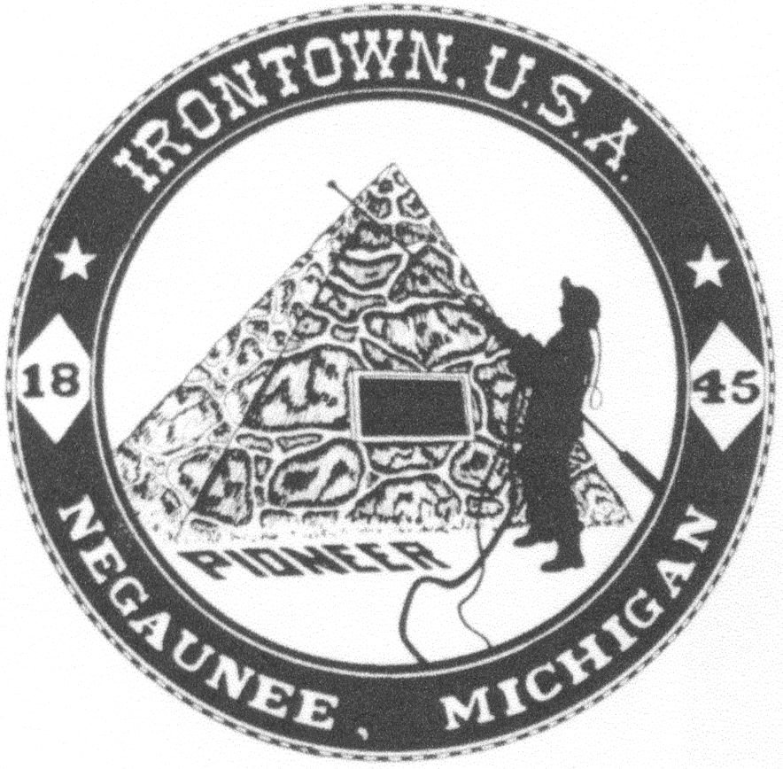 **Negaunee Irontown Association**





# P.O. Box 128 Negaunee, MI 49866 Phone: 906-486-8084

**www.negauneeirontown.com**

On behalf of the Negaunee Irontown Association, we are proud to once again put on Pioneer Days from July 6th through July 14th.

Pioneer Days is put on solely by individual memberships and business sponsorships. It is the continued support of organizations such as yours that enables Irontown to offer these community events. We look forward to providing another great community celebration this year.

Please consider one of the following sponsorship levels to assist us in our mission:

**TITLE SPONSOR - $500 or more**

* Recognition in Pioneer Days TV and radio advertising
* Your logo in our Irontown letterhead for Pioneer Days correspondence
* Your banner at any Pioneer Days event you choose
* Your name on our Pioneer days promotional posters
* An ad in our Pioneer Days brochure
* Ability to have booth/ table at two events
* Recognition on our Web site and Facebook

**MAJOR SPONSOR - $250 or more**

* Your banner at any Pioneer Days events you choose
* Your name on our Pioneer Days promotional posters
* An ad in our Pioneer Days brochure
* Ability to have booth/ table at one event
* Recognition on our Web site and Facebook

**PATRON - $100 or more**

* Your name mentioned in our Pioneer Days brochure
* Recognition on our Web site and Facebook

**SPONSOR – Less than $100**

* Recognition on our Web site and Facebook

If you would like to be included in any print material for Pioneer Days 2018, the deadline is Friday, May 25, 2018.

We thank you for your support in the past and hope you will consider helping us put on the festivities again this year. Thank you for your consideration.

Sincerely,

Ann Ducoli

Irontown President

**Please mail the following information with your donation and business card or logo.**

**Name_____________________________________________**

**Business __________________________________________**

**Address __________________________________________**

**City _____________________ State _________ Zip _______**

**Phone __________________________**

**Email ___________________________**

**Please make your check payable to “Negaunee Irontown Association”**

**Mail to:**

**Negaunee Irontown Association**

**P.O. Box 128**

**Negaunee, MI 49866**

**Thank you!**