How to Write a Target Market Analysis

Steps
1 Identify your target market. It is difficult to meet everyone's needs with a single product or service. Identifying your target market will help you use your resources more wisely as you market your company to a specific, manageable group of people. Here is a sample list:

  - List all potential consumers. Include individual buyers, as well as other businesses and middlemen who re-sell your product to others.
  - Segment your audience. Split them up into different groups of consumers, such as small business owners, office supply stores, or young families.
  - Determine who will benefit from your product or service the most. This is your target audience. Though you do not exclude other potential consumers from your marketing, focus your marketing campaign on this group.

2 Describe your target market demographically. Demographic characteristics include age, gender, marital status, family size, income, education level, occupation, race, and religion.
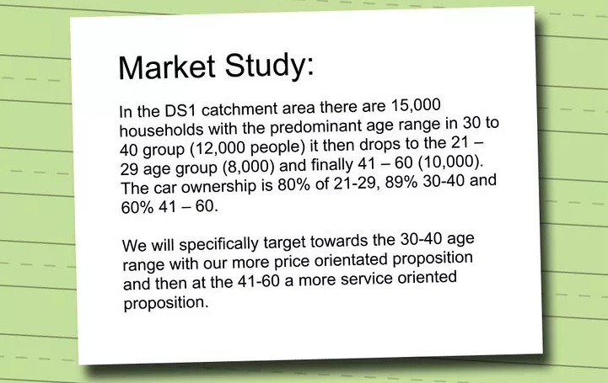
  - Demographic information can often be found online as a compilation of different reports the central government runs. Check government websites (i.e. Census Bureau, ministries of Commerce, etc.)
  - For businesses, demographic information includes where the business is located, how many branches they have, their annual revenue, number of employees, industry, and how long the business has been running.

3 Describe your target market psycho-graphically. Psycho graphic information tells you about your audience's attitudes, beliefs, emotions, and values. It includes your target market's family stage, hobbies and interests, type of entertainment they engage in, and lifestyle.
  - Psychographic information is often found through surveys or focus groups. Though you can set these up yourself, it would be beneficial to hire a marketing research firm to help you structure the surveys, word questions carefully, and engage with focus groups in an effective way.
  - For businesses, psychographic information can include the company's values or motto, how they wish to be seen by their own customers, and how formal or informal their work environment is.

4 Describe your target market behavioristically. Behavioristic information helps you understand why someone purchases one product or service over another. It includes how often your target market buy the product, how much or how many they buy, if there was a specific occasion for using it, and how long it took them to decide to buy that product.
  - Determine how important brand or company loyalty is to your target market.
  - Find out if your audience most heavily values convenience, a good price, or quality.
  - Discover how your target market usually pays for your product or service via market surveys.
  - Ask if your customers prefer face-to-face interaction or an online store.

5 Compile your results. This is your target market analysis, an in-depth look at the lifestyle and characteristics of your customers. Though you want to keep the information organized, format it in the way that works best for you and your organization.
  - Consider using graphs to help your organization visualize different numbers and percentages.
___________________________________
Source: Wiki How To do Anything / n/d
Retrieved from: http://www.wikihow.com/Write-a-Target-Market-Analysis

