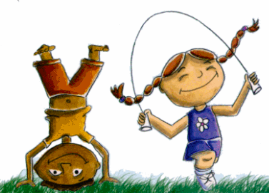
Kidz Connect Child Care Center LLC
1830 Freemansburg Ave. Easton Pa 18042
P. 610-258-5439
Email: staff@kidzconnectccc.com
Website: www.kidzconnectccc.com
Mark Your Calendars for 2021 Center Closings
Kidz Connect Child Care Center LLC will be closed on the following dates:
1). | New Years Day | Friday, January 1, 2021
2). | Good Friday | Friday, April 2, 2021
3). | Friday before Memorial Day | Friday, May 28, 2021
4). | Monday Memorial Day | Monday, May 31st , 2021
5). | Friday Before Independence Day | Friday, July 2, 2021
6). | Monday After Independence Day | Monday ,July 5, 2021
7). | Friday Before Labor Day | Friday, September 3, 2021
8). | Labor Day | Monday, September 6, 2021
9). | Wednesday Before Thanksgiving | Wednesday, November 24th 2021
10). | Thursday Thanksgiving Day | Thursday, November 25, 2021
11). | Friday After Thanksgiving | Friday, November 26, 2021
12). | Monday after Christmas | Monday, December 27, 2021
13). | Tuesday after Christmas | Tuesday, December 28, 2021
14). | Wednesday after Christmas | Wednesday, December 29, 2021
15). | Thursday After Christmas | Thursday, December 30, 2021
16). | Friday New Years Eve. | Friday, December 31, 2021

-Kidz Connect Child Care Center LLC

