Tai Chi & Qi Gong
Linda Gabriel, Ph.D., OTR/L

- Background
Tai Chi originated as a marial art in China about 1000 years B.C. It was a closely guarded “family secret” and passed down from Master to worthy desciples. There are several lineages (types). Unlike other martial arts, the emphasis in Tai Chi is on redirecting energy and gaining an advantage by yielding. It was origianlly called Tai Chi Chuan (now just Tai Chi) and there are a variety of simplified types of tai chi.
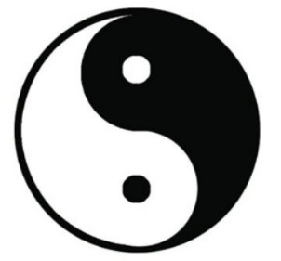

Tai Chi & Qi Gong are based on the concept of yin and yang, a central concept in traditional Chinese medicine, philosophy, and science. Yin and Yang describes how contrary forces are complementary, interconnected and interdependent.

Everything has both yin and yang components (in differing proportions).

Examples of YIN: non-doing, empty. Examples of YANG: doing, full.

While doing Tai Chi, your attention is directed the parts of the body that are DOING or active and the parts that are NOT DOING or are more relaxed. “Non-doing defines doing. Every piece of doing requires the strong presence of non-doing to anchor it (Corrigan, 2006, p. 4).

Qi or chi (depending on the translation) means essential life force or energy. The purpose of cultivating Qi (focus of Qi Gong) is to move it through the body (focus of Tai Chi). I consider the two to be functionally the same for class purposes.

- Slow, continuous movements …
- helps slow thoughts and promote mental relaxation and focus. Slowing the mind and focus creates mindfulness, which reduces the stress response (fight or flight) and increases relaxation response (rest and digest).
- gives your brain more time to notice subtle changes in your alignment, stability, and center of gravity.
- requires more strength and balance.
- makes you more aware of the muscles and joints and allows time for them to respond.
.
- Fluids and Creating Space
Water is soft and yielding, but can carve through stone.
The human body is about 70% fluids. Fluids are in vessels and tissues,
and surround every organ and structure, bringing oxygen and nutrients
and removing waste.

In Tai Chi, muscles and joints are “soft” to allow space for energy and fluids.

- Body Mechanics
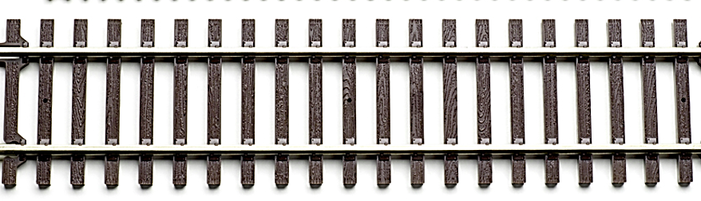
Feet are hip width apart with toes pointing forward.  Or in bow stance (below) | Joints are “soft” not stiff. Body sinks slightly. | Think of your tailbone having an anchor pulling down.  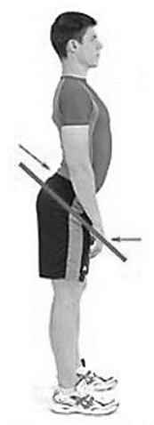  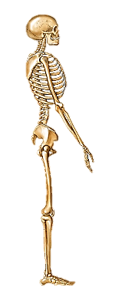 | When you bend your knees, your knees  should not extend past your toes.
 | 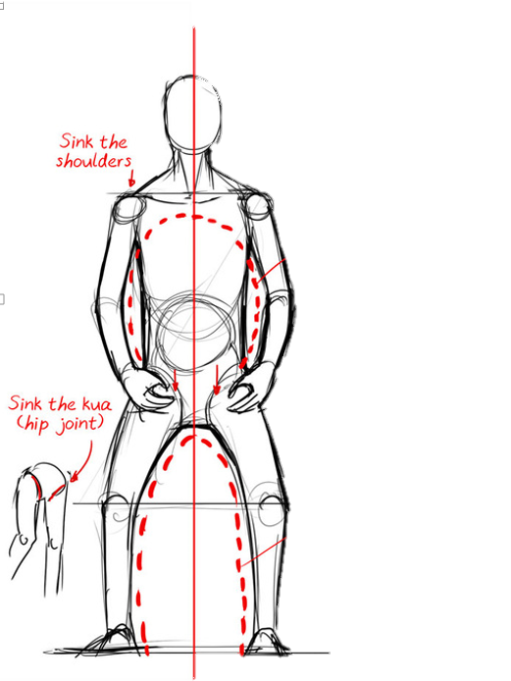 | NOT | 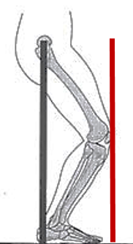
Image from http://brisbanechentaichi.weebly.com/skill-knowledge.html used with permission.
The Eight Active Ingredients Tai Chi (Wayne & Fuerst, 2013)

- Awareness (mindfulness and focused attention)
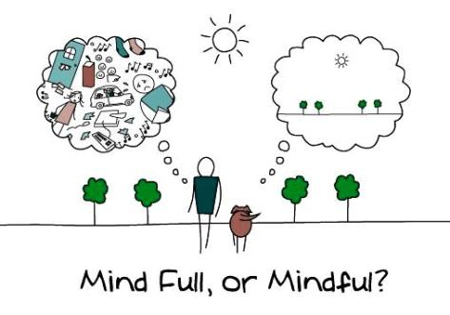
Invite your mind to suspend concerns and anxieties.
Don’t try to actively control or judge your thoughts,
just be aware of them.
- Intention (belief and expectation)
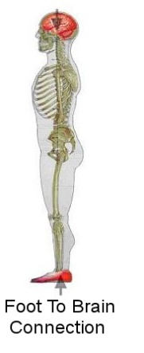
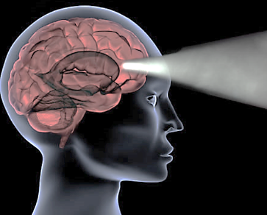
"Our Intention Creates Our Reality" - Wayne Dyer
- Structural Integration (integration between biomechanical and
physiological systems)
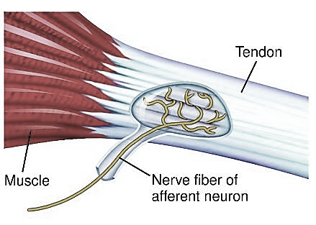
- Active Relaxation (Meditation in motion) Invite your body’s
muscles to relax. While keeping your skeleton in alignment,
feel your muscles soften and let go of tension. Use your
skeleton for support.
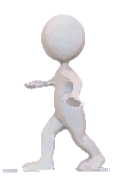
Relax the body to relax the mind.
Relax the mind to relax the body.
- Strengthening and Flexibility
(including balance)

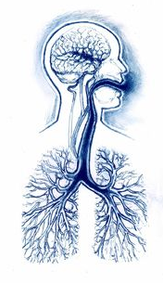
7. Social Support (benefits of being part of a group)

6. Natural and Freer Breathing
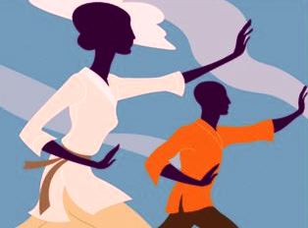
(distribution of oxygen & helps
regulate the nervous system)

- Embodied Spirituality
(greater awareness of self and the universe).
References
Corrigan, C. (2006). The Tao of Holding Space. Creative Commons. https://archive.org/details/TheTaoOfHoldingSpace
Wayne, P. (2013). The Harvard Medical School Guide to Tai Chi. Boston: Shambala
Yu, T. and Johnson, J. (1999). T’ai Chi Fundamentals: Health care professionals and instructors manual. Madison, WI: Uncharted Territory Publishing.

