ISSUE
October 2022

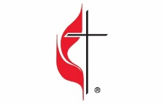
In This Issue
Pg. 1 Pastor’s Corner Pg 7, 8 Keeping You Informed
Pg 2, 3, 4, 5 Save the Dates Pg 9 Calendar for October 2022
Pg 6 Bible Studies & Small Groups Pg 10 Church Information
This month I would like to share my thoughts on what is happening in the denomination surrounding disaffiliation. Specifically, from a scriptural point of view. First there is a lawsuit in the Florida Conference. The lawsuit — filed by 106 churches in Florida’s Bradford County Court — asks the court to rule the trust clause “invalid on its face” or enable the congregations to revoke the trust so the churches can withdraw with their buildings. My first thought is how did it come to this? That local churches would feel they have to sue in order to be able to leave the denomination. The first scripture that came to mind is, 1 Corinthians 6:1-6 Paul writes, “If any of you has a dispute with another, do you dare to take it before the ungodly for judgment instead of before the Lord’s people? 2 Or do you not know that the Lord’s people will judge the world? And if you are to judge the world, are you not competent to judge trivial cases? 3 Do you not know that we will judge angels? How much more the things of this life! 4 Therefore, if you have disputes about such matters, do you ask for a ruling from those whose way of life is scorned in the church? 5 I say this to shame you. Is it possible that there is nobody among you wise enough to judge a dispute between believers? 6 But instead, one brother takes another to court—and this in front of unbelievers!” So let me go back to my original question, how did we get to the point of suing in order to leave United Methodist Church and my answer is to quote Billy Joel, “It’s always been a matter of trust.” There are an increasing number of congregations who feel that they can’t trust the leadership in the Conferences of the United Methodist Church. Almost immediately after the General Conference of 2019 various conferences in the United States clearly stated that they would not enforce the more traditional definitions on Human Sexuality nor enforce the stricter penalties for violations for performing same sex marriages.
After the postponement of General Conference until 2024 several Bishops and leaders of the Centrist and Progressive wings of the United Methodist Church revoked their support of the Protocol of Reconciliation and Grace through Separation. With a sunset deadline of December 2023 on paragraph 2553 coming soon and financial requirements like the ones below for Carson City to disaffiliate congregations believe that their only option is to litigate for better terms of separation.
CARSON CITY UMC
Preliminary Costs of Disaffiliation as of 8-22-2022
Unfunded Pension Obligation $155,100.00
Equity Component* (2x Ministry Shares) $23,798.00
2022 Conference Ministry Shares $ 5,831.00
2023/2024 Conference Ministry Shares* $17,848.50
2022 District Ministry Shares tbd
2023/2024 District Ministry Shares* tbd
Unpaid Benefit Billings & Health Insurance $0.00
2022 / 2023 Benefit Billings & Health Insurance* tbd
Total Cost of Disaffiliation $202,577.50
* Amounts may change once a final disaffiliation date is determined.

Now returning to 1 Corinthians 6 Paul goes on to write in verses 9-10, “ Or do you not know that wrongdoers will not inherit the kingdom of God? Do not be deceived: Neither the sexually immoral nor idolaters nor adulterers nor men who have sex with men nor thieves nor the greedy nor drunkards nor slanderers nor swindlers will inherit the kingdom of God.” How did we get to this point? Because Pastors and Elders and Bishops all forgot Jesus’ answer to the question of the greatest commandments in Matthew 22:36-40 “Teacher, which is the greatest commandment in the Law?” 37 Jesus replied: “‘Love the Lord your God with all your heart and with all your soul and with all your mind.’[a] 38 This is the first and greatest commandment. 39 And the second is like it: ‘Love your neighbor as yourself.’40 All the Law and the Prophets hang on these two commandments.” That’s how we got to this point.

IM 3rd Meal needs volunteers to pack meals. Monday thru Friday from 9-11am. CCUMC will be doing our Fill the Pew again this year. We will be collecting every Sunday throughout October 2, 9, 16, and the 23rd. You can also drop off goodies during office hours, Mon thru Thu from 9:00 am to Noon. The following items are needed:
Cheerios, 100% juice boxes, Peanut butter, Grape Jelly, Lunch size brown paper bags,
Granola bars, Rice Chex cereal, Pretzels, Goldfish crackers, Snack size applesauce cups.
Monetary donations will also be accepted. Please consider donating to this worthwhile cause. They are currently feeding over 700 children every day. Please do not bring bread. It smashes too easily and will spoil prior to our delivery to IM 3rd meal. Thank-you

Young adult discernment retreat set, Oct 21-22
Are you a young adult who is unsure about the next steps in your career? Have you reached a crossroads and need help weighing the options and figuring out what to do? Are you seeking God’s will and need spiritual guidance as you wait and listen for the Holy Spirit? Christianity has a practice of discernment that can support young adults who yearn to hear the Holy Spirit’s guidance, who are looking for direction in life and vocational changes, or who are seeking clarity and God’s will in matters of faithful living. Learn more by watching this video. Young adults, ages 20 to 30, are invited to a discernment retreat on October 21-22. Participants will learn the ancient Christian form of seeking clarity so that individuals and groups can make a discovery that leads to future action and a hoped-for outcome that is best for them. The resource that will guide the retreat is The Way of Discernment by Stephen V. Doughty and Marjorie J. Thompson. This retreat is centered on recent graduates, those in post-grad fellowship programs, those doing internships/student teaching, graduate school students, and those working full-time. There is no cost to participants, as this is sponsored by the Michigan Conference. The two-day retreat will take place at the St. Francis Retreat Center, DeWitt, MI, which is in the greater Lansing area. More details will be made available after registration. The retreat will begin on Friday, October 21 (evening arrival) and end on Saturday, October 22 (6 pm departure). All materials, bedding, and food will be provided. Register by completing this online form (click the link).
Following the retreat, participants will be invited to join a monthly discernment cohort on Zoom to continue discernment and support one another (this is not required to attend the retreat). Young adults can also receive monthly one-on-one coaching or spiritual direction. Questions about the retreat can be sent to Lisa Batten, Young Adult Initiatives Coordinator, at lbatten@michiganumc.org or 517-347-4030 x4078.

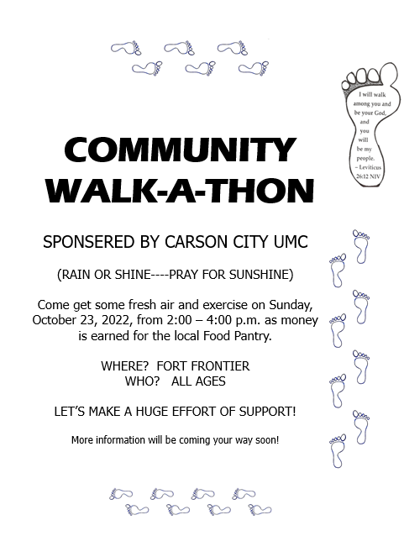

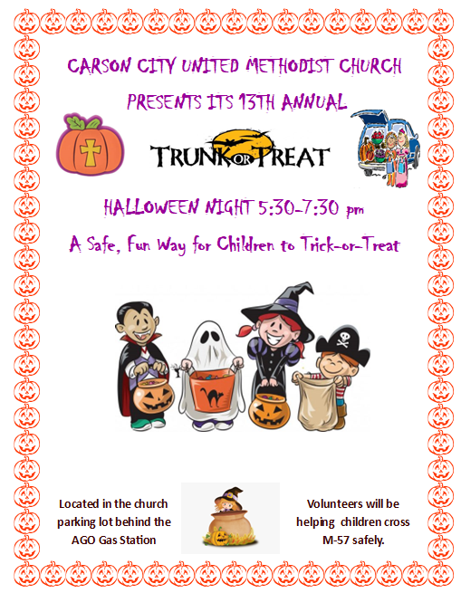
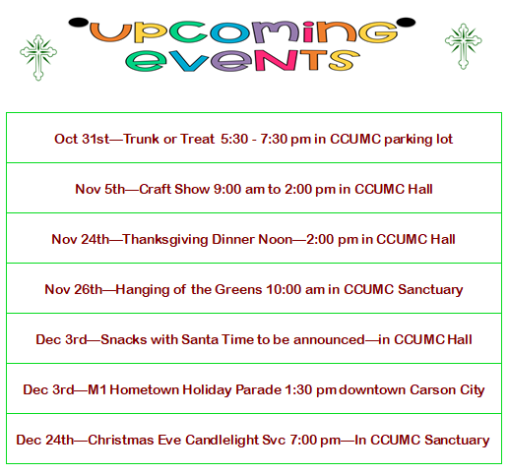

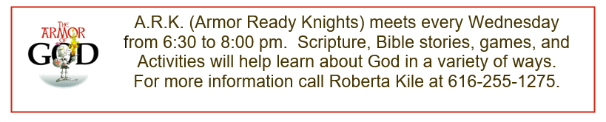
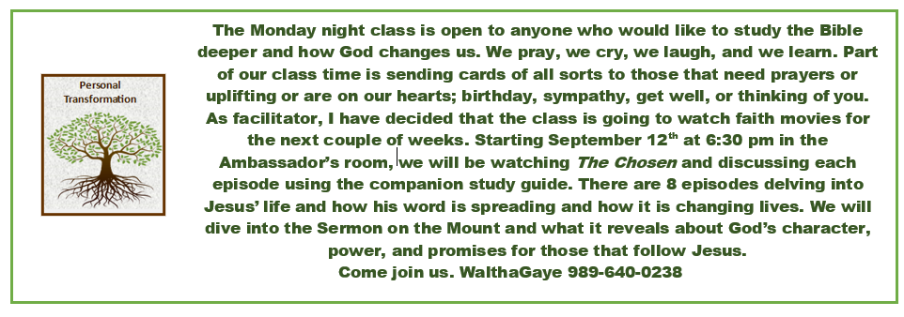
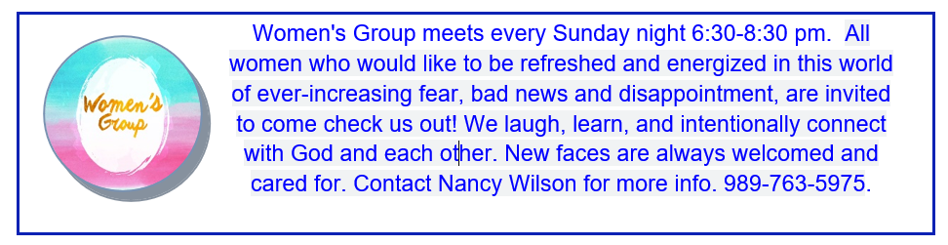
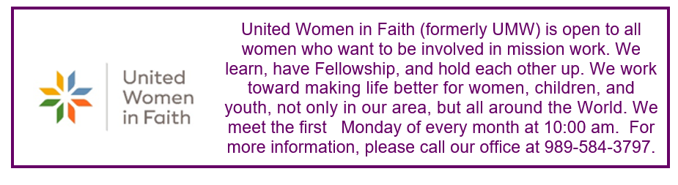

World Communion Sunday: Sunday, October 2nd is World Communion Sunday. United Methodist congregations join many Christian churches across the globe for this celebration of unity among churches across the world. On the first Sunday in October, United Methodist congregations join many Christian churches across the globe in celebrating World Communion Sunday. World Communion Sunday began at Shadyside Presbyterian Church in Pittsburgh, Pennsylvania in 1933. The Rev. Hugh Thompson Kerr and his congregation sought to demonstrate the interconnectedness of Christian churches, regardless of denomination. Rev. Kerr appropriately chose the sacrament of Holy Communion to symbolize this unity. In 1940, the Federal Council of Churches of Christ in America, which included all of the predecessor denominations of The United Methodist Church, adopted World-Wide Communion Sunday. United Methodists believe in an open table, anyone may receive communion. Our Book of Worships says, “All who intend to lead a Christian life, together with their children, are invited to receive the bread and cup.” In United Methodist Churches around the world, a special offering is collected on World Communion Sunday to fund scholarships for seminarians. One half of the proceeds is for World Communion Sunday Scholars administered by the General Board of Global Ministries. The remaining one half is for the Ethnic Scholarship Program and the Ethnic In-Service Training Program, which are administered by the General Board of Higher Education and Ministry.

Charitable Giving: It is that time of year when we get the tithing or offering envelopes ready for 2023. If anyone wants a record of their giving and doesn’t do the electronic giving, please let Paula Wiles or WalthaGaye Leavitt know. By using the envelopes, we keep track of your giving and can give you an end of year statement.

Thanksgiving Dinner: It is time to start thinking about Thanksgiving and the free Community Thanksgiving Dinner. It takes many hands to put this on. Serving and making sure the steam table pans are full on the day of the dinner are the areas of most need. So, Thursday, if you can devote and hour or two from about 10 to about 2pm, please let WalthaGaye know.

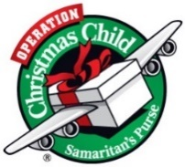
OCC Shoebox: Lauren Monroe will be handling the OCC Shoebox for 2022. Thank you, Lauren. Collection week is November 14-21. Deadline will be November 13th. We pray to God you're passionate to help this year, because it takes all of us to meet the growing. For more information, please contact Lauren at 989-619-1351 or go to OCC website. here:https://www.samaritanspurse.org/what-we-do/operation-christmas-child/

Church Elevator Updates: The elevator at the church is still temporarily out of service and parts will be ordered soon. Once it is up and running, we will notify everyone.

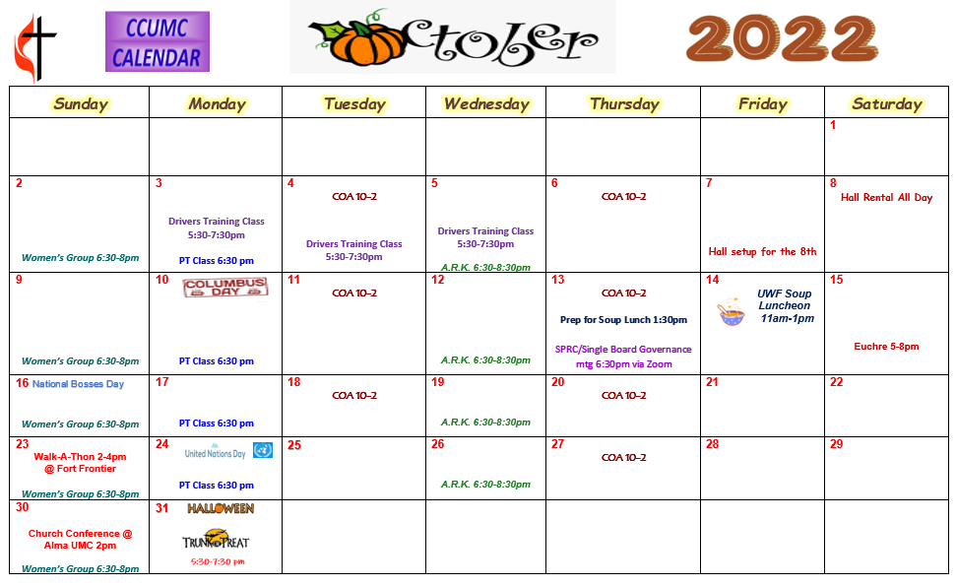

Schedule’s subject to change – contact office for more information”

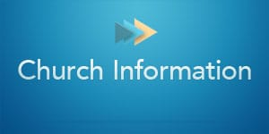
Stay connected! Follow us on:

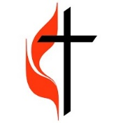
Join Us Each Sunday

Worship Services 10:30 am

(masks are optional)

Carson City United Methodist Church
Phone: 989-584-3797
Email: carsoncityumc@gmail.com
Website: carsoncityumc.com
Office Hours: Monday to Thursday, 9:00 am-Noon
After hours by appointment
Pastor: Ian McDonald (906) 322-5318
Secretary: Bonnie Seaman (989) 763-1674

Online giving available: Website: http://www.carsoncityumc.com/donate.html

Weekly Sunday Bulletin now available on our website
at www.carsoncityumc.com

